

PAVANE

Graduation Project



By:

|  |  |
| --- | --- |
| Ahmed Sameh | Omar Lotfy |
| Marina Magdy | Kamal Osama |
| Moataz Bahaa | Ahmed Samir |
| Ibrahim Saad | Sherif Ahmed |
| Abdelhady Mohamed |  |

Under Supervision of

Dr Mohamed Mostafa

Contents

**Introduction……………………………………………………………3**

* 1. Introduction to project…………………………………………….4
  2. Organization profile……………………………………………….5

1.3 Purpose of the project……………………………………………..5

1.4 Problem statement…………………………………………………6

1.5 Solution of these problems………………………………………...6

**System requirement and analysis………..……………………………7**

2.1 Project proposal………………………………………………...…8

2.2 Software requirement specification……………………………….8

**Used software…………………..………..……………………………18**

3.1 Node.js…………………………………………………………...19

3.2 Express.js………………………………………………………...19

3.3 Mongo DB……………………………………………………….20

3.4 Flutter…………………………………………………………….20

3.5 TensorFlow……………………………………………………....21

3.6 React.js…………………………………………………………...23

3.7 Unity……………………………………………………………..24

**Mobile app…………………..………..……………………………….26**

**Admin and Brand dashboards….…………………..………..………36**

5.1 Tools and methodology…………………………………………..37

5.2 Admin dashboard………………………………………………...38

5.3 Brand dashboard…………………………………………………57

5.4 Space for improvement…………………………………………..70

**Backend…………………..………..…………………………………..71**

6.1 Node.js…………………………………………………………...72

6.2 Repository pattern………………………………………………..73

6.3 Backend system design…………………………………………..74

6.4 API contract and API documentation……………………………81

6.5 Improvements……………………………………………………82

**Fitting room….…………..………..…………………………………..84**

7.1 Clothing & avatar 3D model generation…………………………85

7.2 User interface…………………………………………………….86

7.3 Backend…………………………………………………………..86

7.4 Client privileges………………………………………………….86

7.5 Functional requirements………………………………………….87

7.6 Non-Functional requirements……………………………………88

7.7 Diagrams…………………………………………………………88

**Recommender system.…..………..…………………………………..91**

8.1 Data………………………………………………………………92

8.2 Architecture overview……………………………………………96

8.3 Deployment……………………………………………………..104

8.4 Pipeline…………………………………………………………105

8.5 Space for improvement…………………………………………107 **Conclusion and references.……...…………………………………..109**

9.1 Conclusion…………………………...…………………………110

9.2 References………………………………………………………110

**Part 1**

**Introduction**

* 1. **Introduction to project**

Welcome to the documentation for PAVANE! Our revolutionary clothing application is designed to enhance the online shopping experience by leveraging machine learning recommendation systems and advanced 3D modeling techniques. With our app, users can effortlessly find the products they need and try them on virtually using a 3D model. Say goodbye to the frustrations of ill-fitting clothes and uncertainty of online shopping. Let's dive into the world of personalized fashion with the Clothing App!

In today's digital age, shopping for clothing has transitioned from physical stores to online platforms. However, this shift presents its own set of challenges. Customers often struggle to navigate through vast catalogs and find the items that truly match their preferences and style. Additionally, the inability to try on clothes before making a purchase can lead to disappointment and dissatisfaction.

To address these issues, PAVANE introduces a cutting-edge solution that combines the power of machine learning recommendation systems and 3D modeling technology. By harnessing these advancements, we aim to provide a seamless and immersive shopping experience that caters to each individual's unique needs.

The core feature of our app is the intelligent recommendation system. Through sophisticated algorithms and analysis of user behavior, the system learns about individual preferences, and style choices. It then generates personalized suggestions, guiding users towards clothing items that align with their taste. This ensures that users can effortlessly discover new and exciting pieces while saving time and effort in the search process.

But the innovation doesn't stop there. Our app goes a step further by offering a virtual try-on experience. By leveraging advanced 3D modeling techniques, users can visualize how the selected clothing items will look on themselves. This feature allows for accurate assessments of fit, style, and overall appearance, reducing the uncertainty associated with online shopping.

By integrating user profiles and wishlists, PAVANE enhances personalization and convenience. Users can create profiles, save their preferences, and maintain wishlists of favorite items, making future shopping experiences even more tailored and efficient.

With PAVANE, we aspire to redefine the online clothing shopping landscape. We believe that technology should empower users, providing them with personalized recommendations, and virtual try-on experiences. We invite you to explore the rest of this documentation to discover the full range of features and functionalities that our app offers. Step into a world of effortless fashion with PAVANE!

* 1. **Organization Profile**
     1. **Range of expertise**
* Flutter Developer
* Frontend Developer
* Machine Learning Developer
* 3D Modeling Artist
* Unity Developer
* User Interface and User Experience Designer
* Backend Developer
  + 1. **Services**

Our App provides personalized product recommendations based on user preferences, an extensive catalog of clothing items, virtual try-on capabilities using 3D modeling, user profiles and wishlists, a convenient shopping experience, a secure platform, and continuous updates for an improved user experience.

For brands, we provide a new platform that helps them display their products and reach customers in a more disappointing way.

* 1. **Purpose of the project**

The purpose of PAVANE is to offers to the clothing Brands an opportunity to showcase their products. Also, Customers benefit from the wide range of items available on the platform. There are two main features that both Brands and Customers benefit from, which are, the presence of a Recommendation System that suggests items to customers based on their preferences, and the availability of a 3D space environment that offers a unique experience in viewing the items. The main strategy of PAVANE is increasing the consumption rate of the customers.

* 1. **Problem statement**
* The customers take a lot of time to find the right clothes.
* There are a lot of options in front of the customer that led to distraction.
* There is no way to try clothes while shopping online.
* Decrease the sales rate at brands.
  1. **Solution of these problems**
* By contracting with the largest number of brands so that we provide all their products in one place to save customer time.
* Using of machine learning to build a recommendation system to recommend products to the customer according to his style.
* We provide a 3D space environment that offer a unique experience to try the clothes in it.
* Introduce an online platform to display their products and a dashboard to help them manage their products and some other futures.

**Part 2**

**System requirement and analysis**

After analyzing the requirements of the task to be performed, the next step is to analyze the problem and understand its context. The first activity in the phase is studying and understanding the requirements and domain of the system. This serves as a basis of giving the functional specifications and then successful design of the proposed system.

Understanding the properties and requirements of the system is more difficult and requires creative thinking, improper understanding of the system can lead to diversion from the solution.

**2.1 Project proposal**

After the Corona pandemic, everyone began online shopping and buying their needs through websites or applications that display all the products they need, including clothes. Due to increasing the size of the market, each brand started to build its online platform to show case its products which made it more time consuming for customers to find clothes that match their preferences. In this project, we will work on designing and building an online platform that has multiple brands that the customer needs with the addition of a 3D model feature so that the customer can see the clothes on a 3D model.

**2.2 Software Requirement Specification**

**2.2.1 Introduction**

**2.2.1.1 Purpose**

The Purpose of this document is to identify the Software Requirements Specification (SRS), The project scope, characteristics and Features of PAVANE Software.

**2.2.1.2 Intended audience**

Developers / Testers / Sponsors

**2.2.1.3 Scope**

* Customers interested in clothing and fashion. This software aims
* to suggest clothes from different Brands to users based on their preferences and interests. Users also can search and filter the items.
* Clothing Brands Benefits comes from showcasing their collections and products, where PAVANE is considered a marketing platform for their items.
* Admins will have the overall control on the platform.

**2.2.2 Overall description**

**2.2.2.1 Product perspective**

PAVANE is an online platform that offers clothing Brands an opportunity to showcase their products. Also, Customers benefit from the wide range of items available on the platform. There are two main features that both Brands and Customers benefit from, which are, the presence of a Recommendation System that suggests items to customers based on their preferences, and the availability of a 3D space environment that offers a unique experience in viewing the items. The main strategy of PAVANE is increasing the consumption rate of the customers.

**2.2.2.2 User needs**

* + - Cheap subscription
      * Customer will be charged for <30 LE> monthly after enjoying a free trial.
      * Brands will be charged for <5000 LE> monthly.
    - Marketing
      * The platform provides an inexpensive marketing opportunity for brands.
      * Due to competitiveness in the market encourages the brands to utilizes this marketing platform.
    - Customer satisfaction
      * Customers will be able to browse items from all brands and see all the available discounts in one app.
      * recommendation of suitable items for the customer's taste from various brands.
      * Announce him with the latest offers, and collections.
      * Fitting room that allows user to try on the outfit on 3D model.

**2.2.2.3 User classes and characteristics**

**2.2.2.3.1 Customers**

* + - * Characteristics
        + Name
        + Date of birth
        + Phone Number
        + Email
        + Password
        + Location
        + Gender
        + Image
        + Account type (Standard, Premium)
      * Privileges
        + View all brands and view their items, collections, and categories
        + Rate brands, items, and collections
        + Like brands, items, and collections
        + Upgrade to a higher plan
        + Edit his profile data
        + Use fitting room

**2.2.2.3.2 Brand**

* Characteristics
  + Name
  + Categories
  + Phone Numbers
  + Email Password
  + Image
  + Items
  + Collections
  + Sales
* Privileges
  + Add, Edit, Delete, and View items
  + Add, Edit, Delete, and View collections
  + Add, Edit, Delete, and View offers
  + Add, Edit, Delete, and View sales
  + view statistics and analysis
  + subscribe for fitting room

**2.2.2.3.3 Super admin**

* Characteristics
  + Email
  + Password
  + Name
* Privileges
  + Full access on all users including brands and customers
  + View statistics and analysis
  + Add, Edit, and Delete users (customers, admins, brands)
  + Add, Edit, and Delete (brands, customers, items, collections and offers).
  + Add, Edit, and Delete advertisement

**2.2.2.4 Design and implementation constrains**

**2.2.2.4.1 Tools and technologies**

* Flutter
* React.js
* Node.js with express
* Python
* TensorFlow extended
* Mongo DB
* Blender
* Marvelous designer
* Substance painter
* Substance designer

**2.2.2.4.2 Policies**

* Developers must write documentations.
* The source code is the business owners’ property.

**2.2.2.4.3 Language of the platform**

* English

**2.2.2.5 Assumptions and dependencies**

**2.2.2.5.1 Commercial third parties**

* Payment gateway
* Firebase
* Vercel
* Heroku server
* Mongo atlas
* AWS S3
* Unity engine

**2.2.3 Functional requirements and screens**

**2.2.3.1 Customer**

* Register
  + Name
  + Email
  + Password
  + Confirm password
  + Gender
  + Date of birth
* Login
  + Email
  + Password
  + Login by Facebook or Google
* Forget password
  + Email
* Home
  + Notifications
  + Search bar
  + Advertisement
  + Popular items
  + Popular brands
  + Popular collections
  + Top categories
  + Navigation bar
* Navigation bar
  + Home
  + Library
  + Fitting Room
  + Profile
* Library
  + Fitting room (items added to fitting room)
  + Likes
  + For you
* Profile
  + Setting
  + Customer name
  + Customer image
  + Personal data
  + Likes
* Settings
  + About
  + Terms and conditions
  + FAQ
  + Contact us
  + Subscription
  + Log out
* Fitting room
  + 3D model
  + Items added
* Item details
  + Images
  + Name
  + Rating
  + Reviews
  + Price
  + Description
  + Categories
  + Brand name
  + Section for similar items
  + Add to fitting room button
  + Like button

**2.2.3.2 Super admin dashboard**

* Login
  + Email
  + Password
* Navigation bar
  + Admins
  + Brands
  + Items
  + Collections
  + Sales
  + Categories
  + Customers
* Customers
  + Display all Customers
  + Add, Edit and Delete Customers
* Admins
  + Display all admins
  + Add, Edit and Delete admins
* Brands
  + Display all Brands
  + View all items, collections, and categories
* Items
  + Display all items
  + Add, Edit and Delete items
* Collections
  + Display all collections
  + Add, Edit and Delete collections
* Categories
  + Display all categories
  + Add, Edit and Delete categories

**2.2.3.3 Brand dashboard**

* Login
  + Email
  + Password
* Navigation bar
  + Items
  + Categories
  + Collections
  + Advertisements
* Items
  + Display all items
  + Add, Edit and Delete items
* Collections
  + Display all collections
  + Add, Edit and Delete collections

**2.2.4 Non-Functional requirements**

**2.2.4.1 Portability**

The Platform is well suited to be used whether on a mobile phone or a website, especially the Customer App. The Admins’ and Brands’ Dashboards can be used on a mobile phone web browser but are well suited for wide screens devices.

**2.2.4.2 Security**

All System Users must be Authorized for Privileges. A Customer can’t acquire the privileges of a Brand or an Admin, and so on. All private data must be secured and unavailable for any other users.

**2.2.4.3 Usability**

The Platform must be well suited for all users and easy use.

**2.2.4.4 Availability**

The Platform must be available 99% of the year.

**2.2.5 Preliminary schedule and Project Management Strategy**

**2.2.5.1 Delivery schedule**

* The system analysis and design must be delivered by the end of October 2022.
* An MVP must be delivered by the end of 2022.
* The final version must be delivered by the end of May 2023.

**2.2.5.2 Project management strategy**

* PAVANE project must be developed within an agile framework.

**Part 3**

**Used Software**

**3.1 Node.js**

Node.js is a powerful and popular JavaScript runtime environment that allows us to run JavaScript code on the server-side. It offers several advantages for our backend application:

1. **JavaScript Everywhere:** With Node.js, we can use the same language (JavaScript) for both the frontend and backend development. This eliminates the need for context switching between different languages, improving development efficiency and code maintainability.
2. **Scalability and Performance:** Node.js follows an event-driven, non-blocking I/O model, making it highly scalable and efficient in handling concurrent requests. It can handle many users and provide fast response times, As Pavane has a lot of requests from customers and brands for example customers’ requests recommendations subscriptions and the brands requests such as adding items data and collections.
3. **Vibrant Ecosystem:** Node.js has a vast and active community, which means we have access to a wide range of libraries, frameworks, and tools. This ecosystem enhances developer productivity, code reusability, and enables us to leverage existing solutions for building robust and scalable applications.

**3.2 Express.js**

Express is a popular web application framework for Node.js. It provides a minimalistic and unopinionated approach, allowing us to build a customized backend for our eCommerce application. Here's why we chose Express:

1. **Flexibility:** Express offers a lightweight and flexible framework, allowing us to design our backend architecture based on our specific requirements. It doesn't impose strict conventions, enabling us to choose the best practices and libraries that suit our application's needs.
2. **Routing and Middleware:** Express simplifies the process of defining API endpoints and handling HTTP requests. It provides a robust routing system and middleware support, allowing us to handle authentication, input validation, and error handling efficiently. This promotes code organization and reusability.
3. **Community Support:** Express has a large and active community. It offers extensive documentation, tutorials, and a wide range of third-party middleware and plugins. This community support ensures that we have access to resources and solutions to address various challenges in our eCommerce application development.

**3.3 Mongo DB**

MongoDB is a popular NoSQL database that offers several advantages for our backend application:

1. **Flexible Document Model**: MongoDB uses a flexible document model (JSON-like documents) to store data. This allows us to handle complex and evolving data structures in our application, such as item information and customer profiles, without strict schema constraints.
2. **Scalability and Performance:** MongoDB is designed for scalability and can handle large datasets and high traffic loads. It supports horizontal scaling by allowing data to be distributed across multiple servers or shards. This ensures that our application can handle increasing data volumes and user loads without
3. **Rich Querying Capabilities:** MongoDB provides powerful querying capabilities, including support for complex queries, indexing, and aggregation pipelines. This allows us to retrieve and manipulate data efficiently, providing fast and responsive APIs for our application.

**3.4 Flutter**

Flutter was chosen as our frontend for the mobile application, Flutter is an open-source User Interface toolkit developed by Google that allows developers to build high-quality, cross-platform applications for mobile.

Benefits of using Flutter as the mobile’s application frontend framework:

1. **Fast development:** Flutter offers a hot reload feature, which allows developers to see the changes made to the code in real-time without restarting the app. This significantly speeds up the development process, making it easier to iterate and experiment.
2. **Beautiful and responsive UI:** Flutter uses its own rendering engine to create visually appealing and highly customizable UIs. It provides a rich set of pre-built widgets that can be easily customized to match the desired design aesthetics. Flutter's UI is also responsive and provides a smooth user experience across different devices and screen sizes.
3. **Performance:** Flutter apps are compiled into native code for each platform, which makes them highly performant. Flutter's rendering engine eliminates the need for a JavaScript bridge, resulting in faster UI rendering and reduced app startup times.
4. **Dartprogramminglanguage:** FlutterusestheDartprogramming language, which is easy to learn and has a clean syntax. Dart comes with features like a just-in-time (JIT) compiler for fast development cycles and an ahead-of-time (AOT) compiler for optimized production builds.
5. **Access to native features and APIs:** Flutter provides access to a wide range of native features and APIs through its rich set of plugins. This allows developers to leverage platform-specific capabilities seamlessly and integrate with device functionalities like camera, GPS, sensors, etc.

**3.5 TensorFlow**

TensorFlow was chosen as the machine learning framework for developing the AI model built on python programming language, TensorFlow is an open-source machine learning framework developed by Google. It provides a flexible and comprehensive set of tools and libraries for building and deploying machine learning models.

Benefits of using TensorFlow as the machine learning developing framework:

1. **Flexibility:** TensorFlow offers a wide range of APIs and tools that cater to different levels of abstraction and expertise. Developers can choose from high-level APIs like Keras for quick and easy model development or low-level APIs for fine-grained control and customization.
2. **Neural Networks and Deep Learning:** TensorFlow provides extensive support for neural networks and deep learning models. It offers a variety of pre-built layers, activation functions, and optimization algorithms, making it easy to construct and train complex models for tasks like image recognition, natural language processing, and sequence modeling.
3. **ModelDeployment:** TensorFlowsupportsseamlessmodel deployment across different platforms and environments. It provides tools like TensorFlow Serving for serving models in production, TensorFlow Lite for deploying models on mobile and embedded devices, and TensorFlow.js for running models directly in web browsers.
4. **ComputationalGraph:** TensorFlowrepresentscomputationsasa computational graph, enabling efficient execution and optimization of computations. It allows for automatic differentiation, facilitating gradient-based optimization algorithms commonly used in training neural networks.
5. **Visualization and Debugging:** TensorFlow includes TensorBoard, a powerful visualization tool that helps in visualizing and monitoring model training and evaluation. It enables developers to track metrics, visualize the computational graph, and debug their models, improving the understanding and performance of the models.

**3.5.1 TensorFlow Extended**

TensorFlow Extended (TFX) is an end-to-end machine learning (ML) platform developed by Google. It is an open-source framework built on top of TensorFlow, an popular deep learning library. TFX provides a set of tools, libraries, and components that streamline the entire ML workflow, from data ingestion to model deployment.

**3.5.2 TensorFlow Recommenders**

TensorFlow Recommenders is an open-source library developed by Google that provides tools and components for building recommendation systems using the TensorFlow framework. Recommendation systems are widely used in various industries to personalize and enhance user experiences by suggesting relevant items or content.

TensorFlow Recommenders simplifies the process of building recommendation models by offering high-level abstractions and pre-built components. It allows developers to focus on the modeling and experimentation aspects rather than implementing low-level details.

**3.6 React.js**

React.js is a JavaScript library used for building user interfaces (UIs) for web applications. It was developed by Facebook and is widely adopted by developers due to its efficiency and flexibility. Here are some key aspects and advantages of React.js:

1. **Component-based architecture:** React.js follows a component-based approach, where the UI is divided into reusable components. These components encapsulate the UI logic and can be easily composed to build complex user interfaces. This modular structure improves code reusability, maintainability, and allows for easier collaboration among developers.
2. **Virtual DOM (Document Object Model):** React.js introduces a virtual representation of the DOM, which is an in-memory representation of the actual HTML DOM. When there are changes in the application's state, React efficiently updates only the necessary components in the virtual DOM. It then calculates the difference between the previous and new virtual DOM states (referred to as the "diffing" process) and updates the actual DOM only with the required changes. This approach minimizes the number of direct manipulations to the DOM, resulting in better performance and faster rendering of UI updates.
3. **Declarative syntax:** React uses a declarative syntax, which means you describe how your UI should look based on the application's state. Instead of manually manipulating the DOM to achieve the desired UI, you specify what the UI should be like, and React takes care of updating the DOM accordingly. This simplifies the development process, enhances code readability, and reduces the chances of introducing bugs.
4. **Efficient rendering:** React optimizes the rendering process by updating only the components affected by state changes. This approach avoids unnecessary re-rendering of the entire UI, resulting in improved performance.
5. **Wide ecosystem and community support:** React.js has a large and active community, which means there are abundant resources, libraries, and tools available for developers. This ecosystem provides various extensions, components, and patterns that can be used to enhance development productivity.

**3.7 Unity**

Unity is a popular cross-platform game development engine that allows developers to create interactive and immersive 2D and 3D games, simulations, and other interactive experiences. It provides a wide range of tools, features, and a visual editor that simplifies the game development process. Here are some advantages of using Unity:

1. **Cross-platform development:** Unity supports multiple platforms, including Windows, macOS, Linux, iOS, Android, Xbox, PlayStation, and more. Developers can build their games once and deploy them on various platforms, saving time and effort in porting or rewriting code for different platforms.
2. **Visual editor and intuitive workflow:** Unity offers a powerful visual editor that allows developers to create scenes, design levels, and manipulate game objects visually. The editor provides an intuitive interface and workflow, making it accessible to both experienced and beginner developers. It also supports drag-and-drop functionality, asset importing, and real-time previews, enabling rapid prototyping and iteration.
3. **Extensive asset store and ecosystem:** Unity has a vast ecosystem and an asset store where developers can find a wide range of ready-to-use assets, scripts, plugins, and tools. This ecosystem saves development time by providing pre-built components and resources that can be easily integrated into projects.
4. **Scripting languages:** Unity supports multiple scripting languages, including C# (the most commonly used), JavaScript, and Boo. This flexibility allows developers to choose a language they are comfortable with and leverage their existing skills.
5. **Powerful 2D and 3D capabilities:** Unity provides robust features and tools for creating both 2D and 3D games. It offers physics simulation, animation systems, particle effects, lighting, audio, and a powerful scripting API to create complex and visually appealing experiences.
6. **Community and documentation:** Unity has a large and active community of developers who actively contribute to forums, tutorials, and resources. This community support makes it easier to find solutions to common problems, learn from others, and get assistance when needed. Unity also provides extensive documentation and tutorials to help developers get started and explore advanced features.
7. **Performance optimization:** Unity offers various performance optimization tools and features, such as built-in profiling tools, asset bundling, and platform-specific optimizations. These tools help developers identify and address performance bottlenecks, ensuring that games run smoothly across different devices.
8. **Integration with third-party tools:** Unity seamlessly integrates with numerous third-party tools and services, including popular content creation software, version control systems, analytics platforms, ad networks, and more. This integration simplifies the development workflow and enhances productivity.

**Part 4**

**Mobile App**

The mobile app target is to allow the user to view many items in a short period of time. This high consumption rate benefits both parties, where viewing the brand items improves the marketing of the brand, and on the other hand the user gets to know the trendy items and new styles.

In the mobile app we start with the splash screen that reflect our identity in the project.

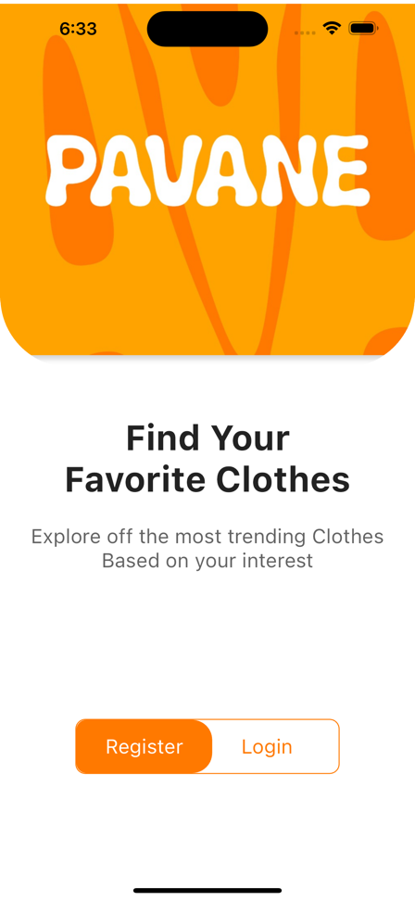

Then you will navigate to the screen where you can choose login or signup based on whether you have a previous account or not.

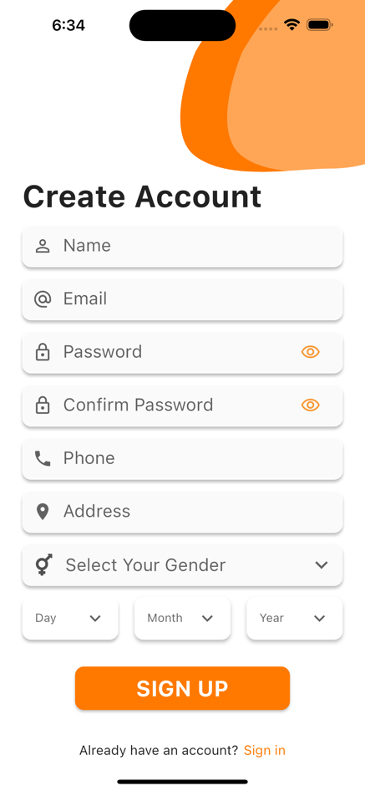If you do not have an account, then you will go to the account creation page that you enter your data such as name, email, password, phone number, address, date of birth and type, then click on sign up to create your account.

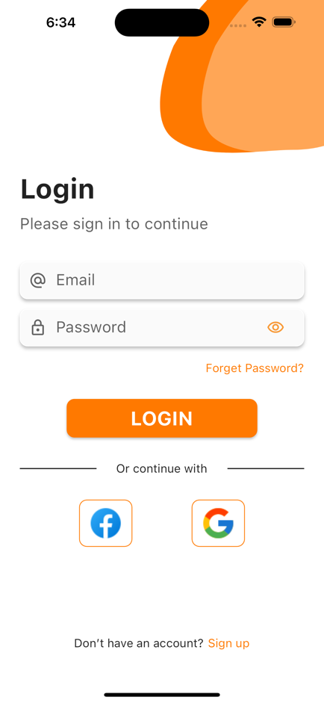

After that, we go to the login page where you enter your email and password to start the login process, or alternatively, you can log in through Google or Facebook.

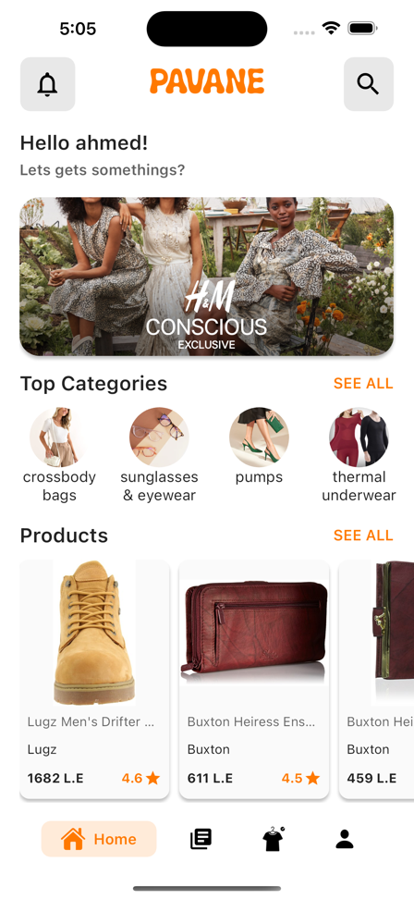After login we navigate to home screen it has 3 sections:

1. **App bar:** That contains app name, notification button, and search button.
2. **Body:** that contain advertisements, top categories, random product, popular brands, popular collections, sales, brands, and collections.
3. **Bottom navigation bar:** Home tab, Library tab, Fitting room tab, and Profile tab.

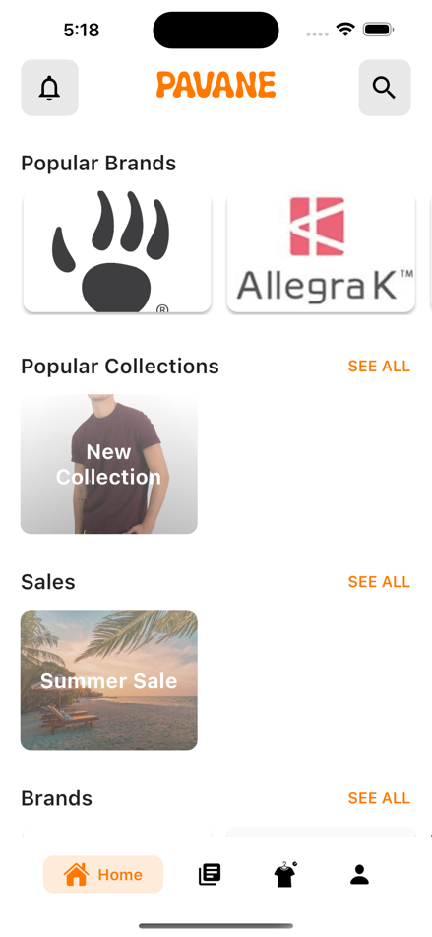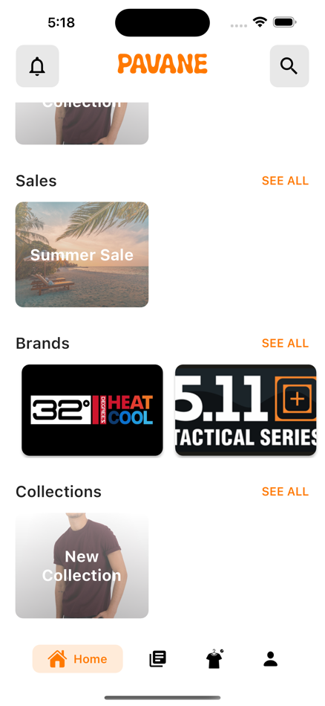

The second tab in the bottom navigation bar is library screen, it contains 3 sections:

1. **Fitting room:** This section contains products that you have added to try them on 3D Model in the fitting room.
2. **Likes:** This section contains the liked items, collections, and brands.
3. **For you:** This section contains the result of machine learning recommendation system model that based on your style.

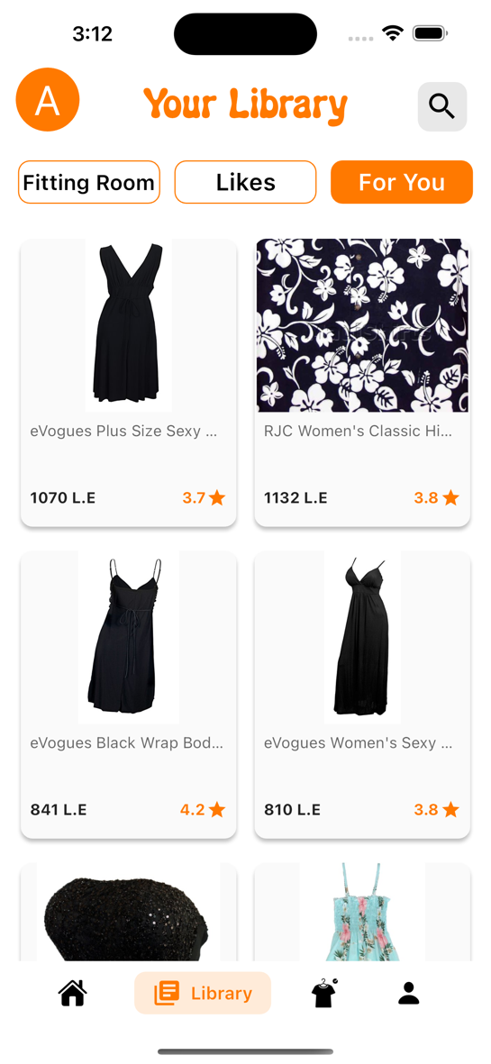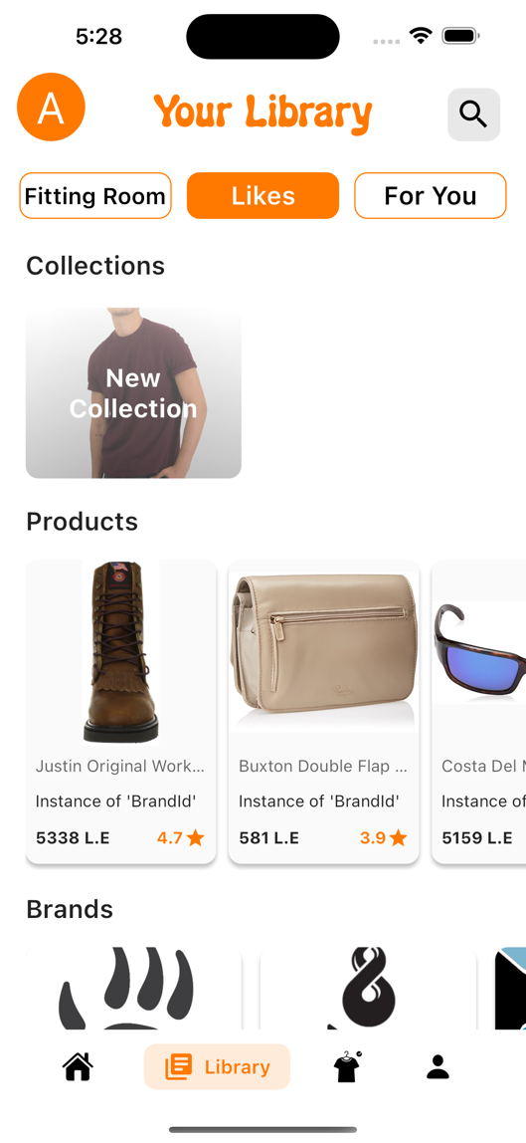

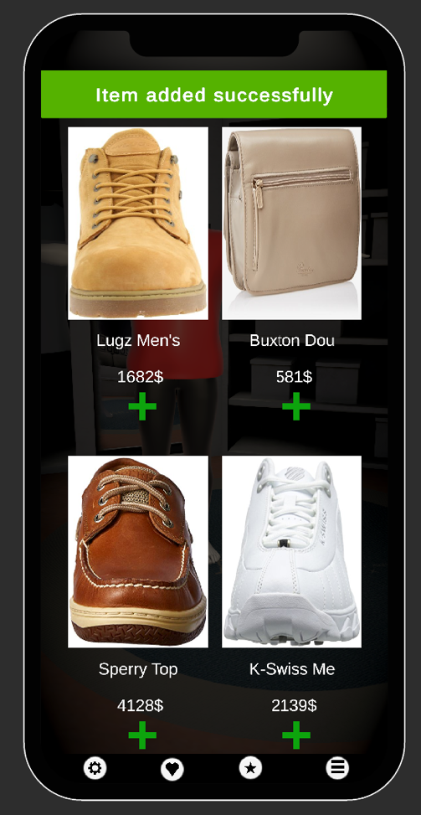The third tab in the bottom navigation bar is fitting room screen, where we provide a 3D space environment that offer a unique experience to try the clothes in it.

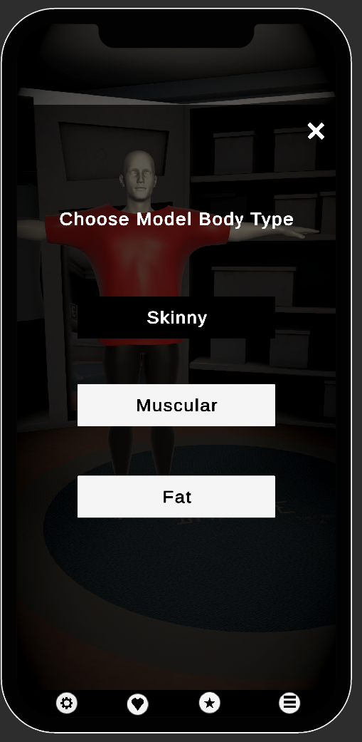

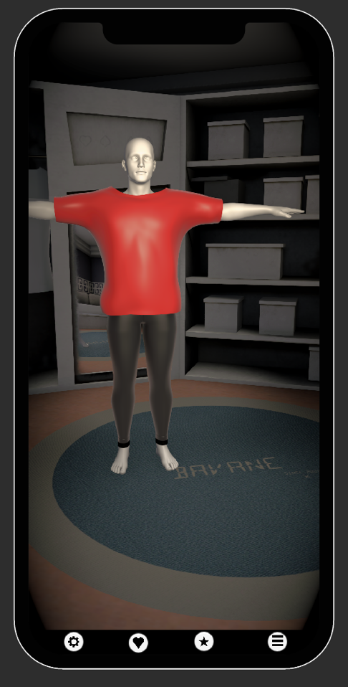

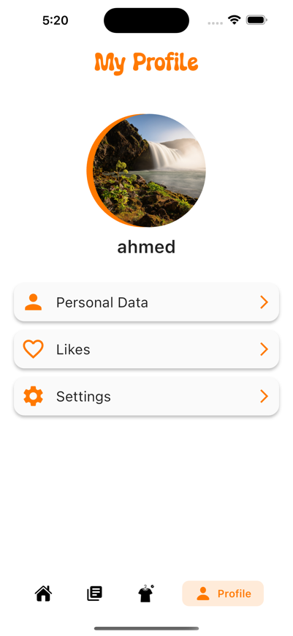The fourth tab in the bottom navigation bar is profile screen, it contains your image, and name.

And there are three buttons the first is to navigate to personal data screen where you can view and edit your data.

The second button is likes that navigate to the likes screen where you can view your liked items, collections, and brands.

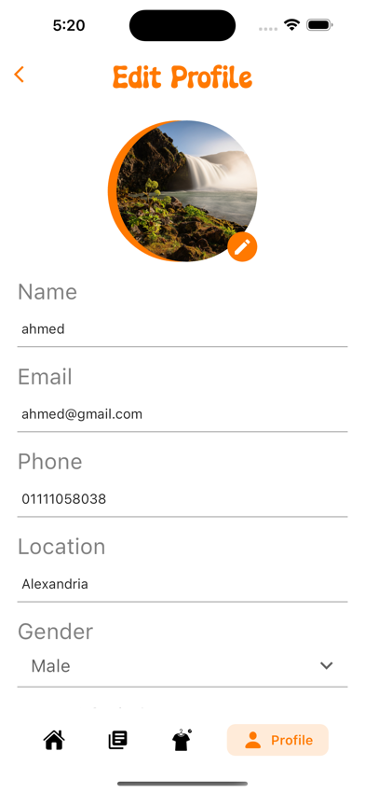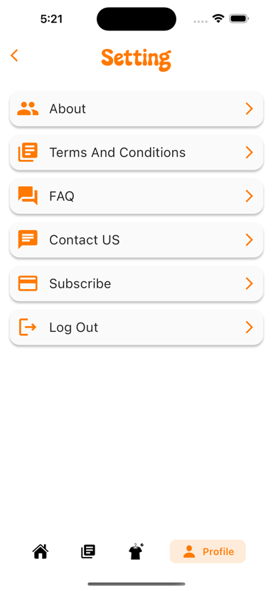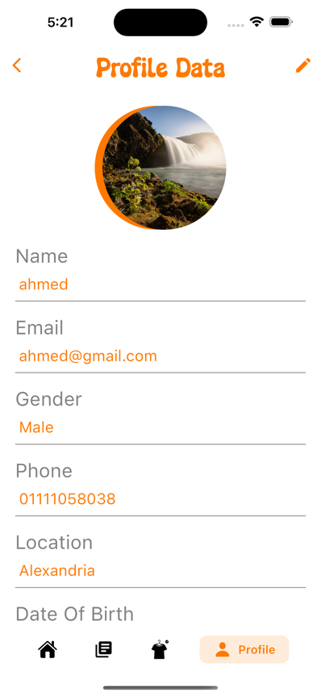The third button is settings that navigate to the settings screen where you can log out, subscribe, and other things.

When you create a new account for the first time you can enjoy using Fitting Room only three times for free, but what if you want to sustain it even more?

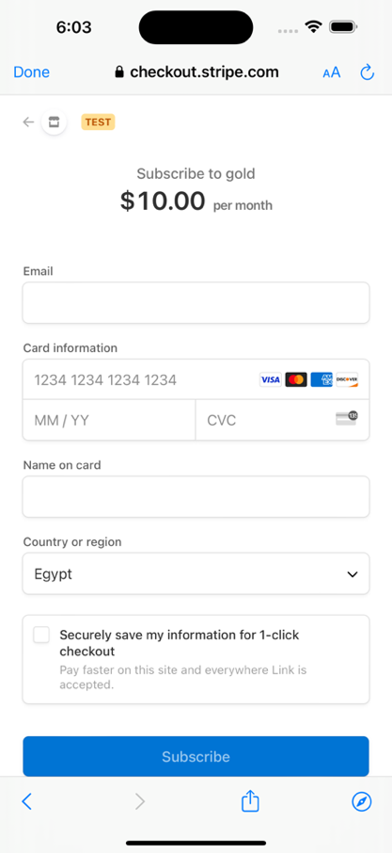Here we move to the subscription point that can be accessed via the settings page here you will pay a monthly subscription for the ability to use the fitting room.

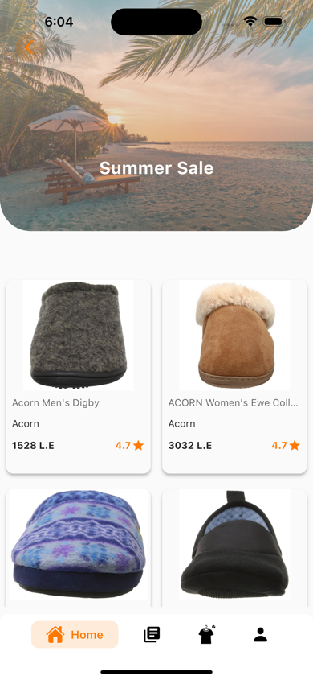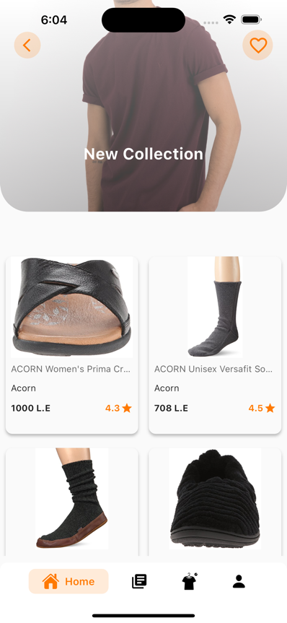Let's quickly return to the home screen, where among the sections of this page was the following collections section and sales section, which are a group of products related to such as that they have a discount or belong to a unified season.

And here we can view the products inside this collection or sale.

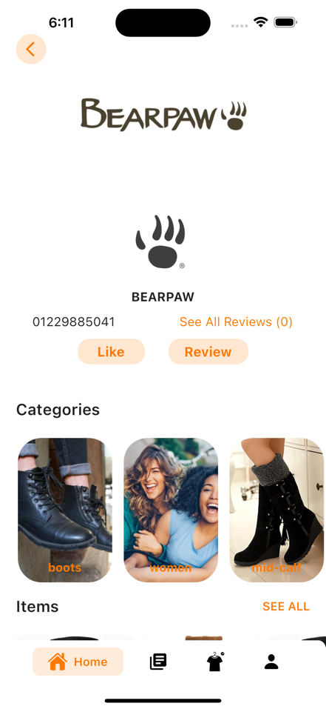In the home screen when you press on any brand you while navigate to brand profile screen.

In this screen you will find a lot of things:

1. The brand data (name, image, cover, phone, number of reviews)
2. The categories that this brand have.
3. The items of this brand

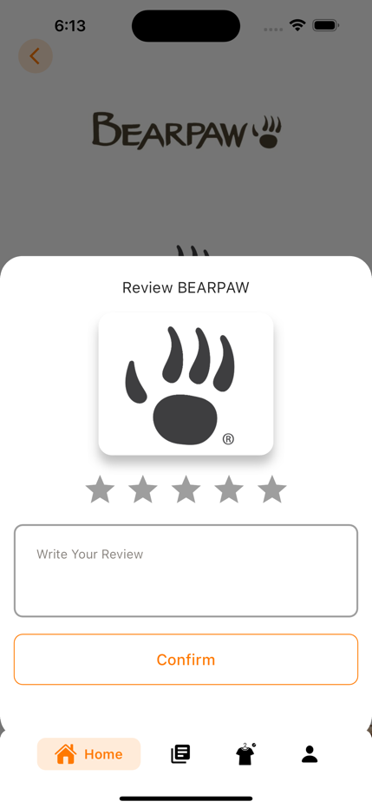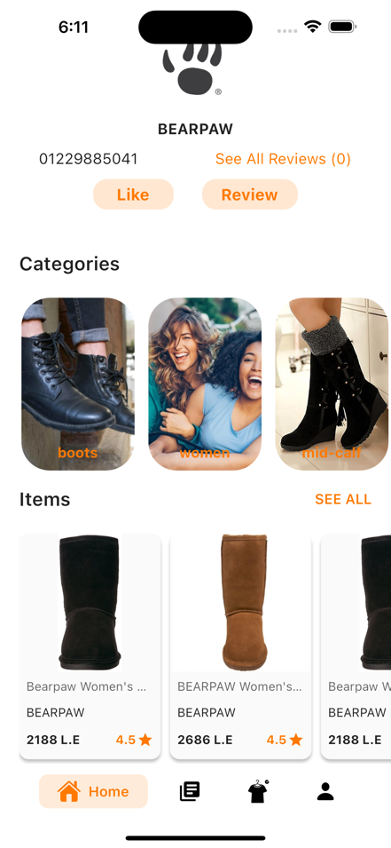And, you can add a rate and review for this brand.

Finally, when you press on any item you will navigate to item details screen.

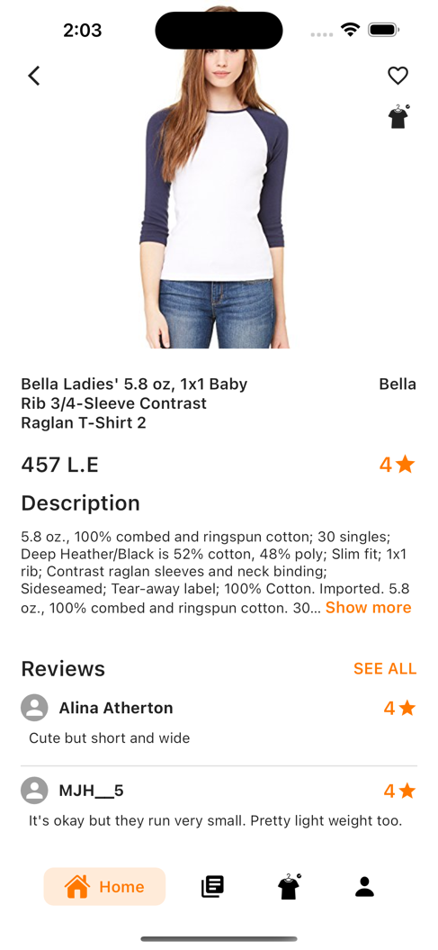You will find:

1. item data (images, name, brand name, price, description).
2. all rates and reviews on this item.
3. some similar items.

And, you can add your own rate and review.

And two buttons:

1. Add to liked list button
2. Add to fitting room button

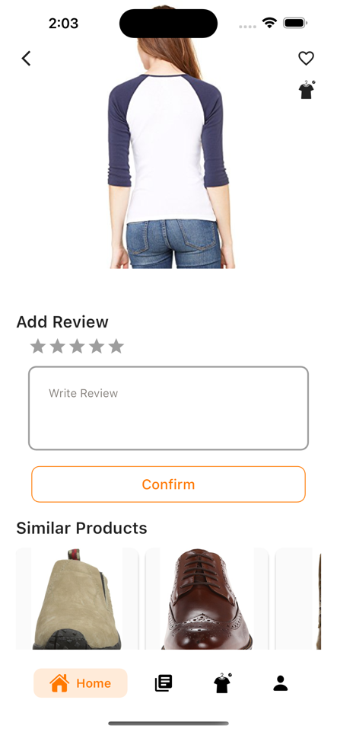

**Part 5**

**Admin and Brand Dashboards**

A dashboard is a visual representation of key data, metrics, and information that provides a consolidated view of various aspects of a system, process, or business. It is typically designed to present data in a concise and easily understandable format, allowing users to quickly grasp the overall performance or status of a particular area or set of operations.

The main purpose of a dashboard is to provide real-time or near-real-time insights and enable users to make informed decisions based on the presented information. Dashboards are often used to monitor and analyze data from multiple sources, such as databases, APIs, or external systems, and present it in a unified interface.

With the advancements in technology and the availability of data visualization tools and libraries, it has become increasingly accessible for developers and organizations to create and customize dashboards according to their specific needs, allowing for better data-driven insights and informed decision-making.

**5.1 Tools and methodology**

The front end of the admin dashboard and brand dashboard was built using react.js.

To build it as a single page application using the routes which are provided by react.js, to benefit from the pros of the virtual DOM, JSX, react hooks, react ecosystem, and reusable components.

Third parties used while building admin and brand dashboards:

1. react-router-dom: making the routes of the application and navigation between pages.
2. react-redux: for state management.
3. Axios: for making HTTP requests.
4. jwt-decode: for decoding the token.
5. react-images-uploading: for making multi-image upload.
6. array-move and react-easy-sort: to rearrange the images while adding or deleting images in items.
7. react-infinite-scroll-component: for making infinite scroll pagination
8. react-js-pagination: regular pagination
9. react-rating: rating stars
10. react-toastify: making the toast popup notification about status updates, like brand added, item deleted, and so on.
11. node-sass
12. multiselect-react-dropdown
13. joi: input validation.

**5.2 Admin dashboard**

An admin dashboard, also known as an administration dashboard or simply an admin panel, is a specialized type of dashboard designed specifically for administrators or system operators to manage and control various aspects of a system, application, or website. It provides a centralized interface that allows administrators to monitor, configure, and maintain the system effectively.

Admin dashboards typically offer a range of features and functionalities that enable administrators to perform administrative tasks, access and manage data and make necessary adjustments to the system. Some common features of admin dashboards include:

1. **User Management:** Admin dashboards often provide the functionality to manage user accounts, roles, and permissions. Administrators can create, edit, delete, and manage user accounts, as well as assign specific access levels and permissions to different user roles.
2. **Content Management:** Admin dashboards may include features for managing and organizing content within a system. This can involve creating, editing, and deleting content, organizing it into categories or sections, and applying content-related settings.
3. **Data Management:** Admin dashboards often provide tools and interfaces to manage and manipulate data within the system. This may include importing or exporting data, performing bulk operations, running database queries, and generating reports or analytics based on the available data.
4. **Configuration and Settings:** Admin dashboards allow administrators to configure various system settings and parameters. This can involve customizing the appearance and behavior of the system, defining system-wide settings, managing integrations with other services, and setting up notifications or alerts.

To use the admin dashboard, you need to log in with an email and a password.

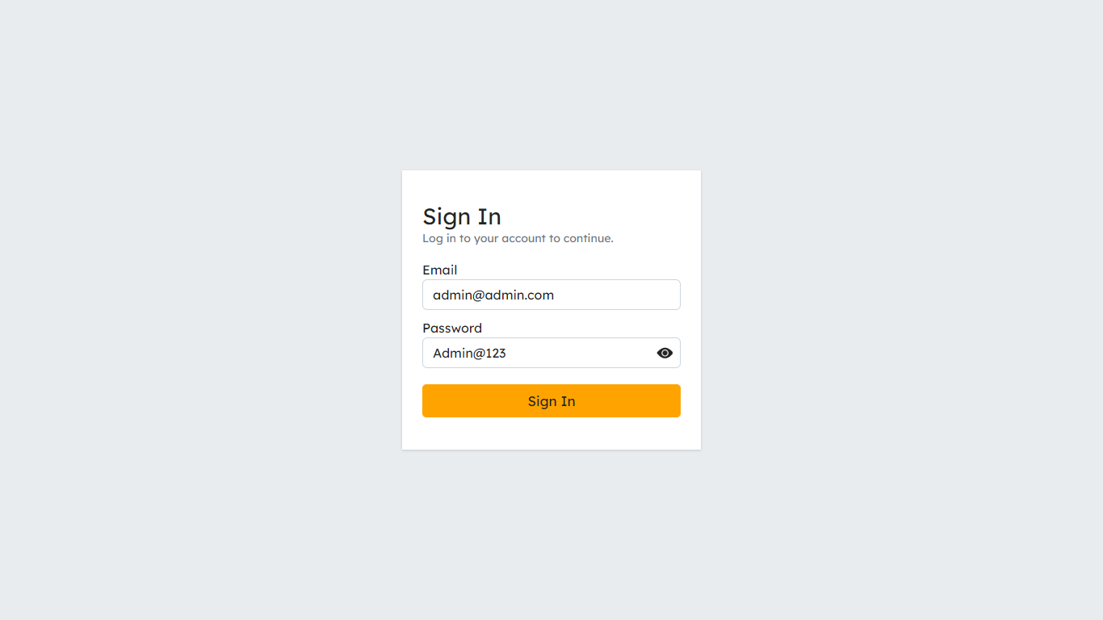

After the login you will find that there are many actions that you can take:

1. **Admins**

* List all admins.

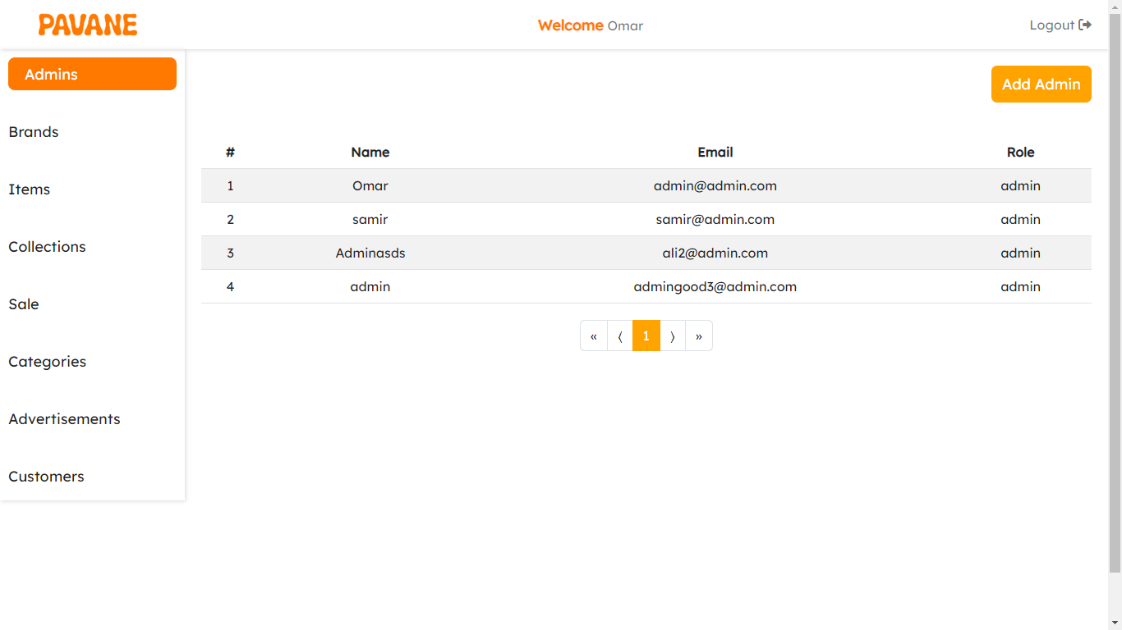

* 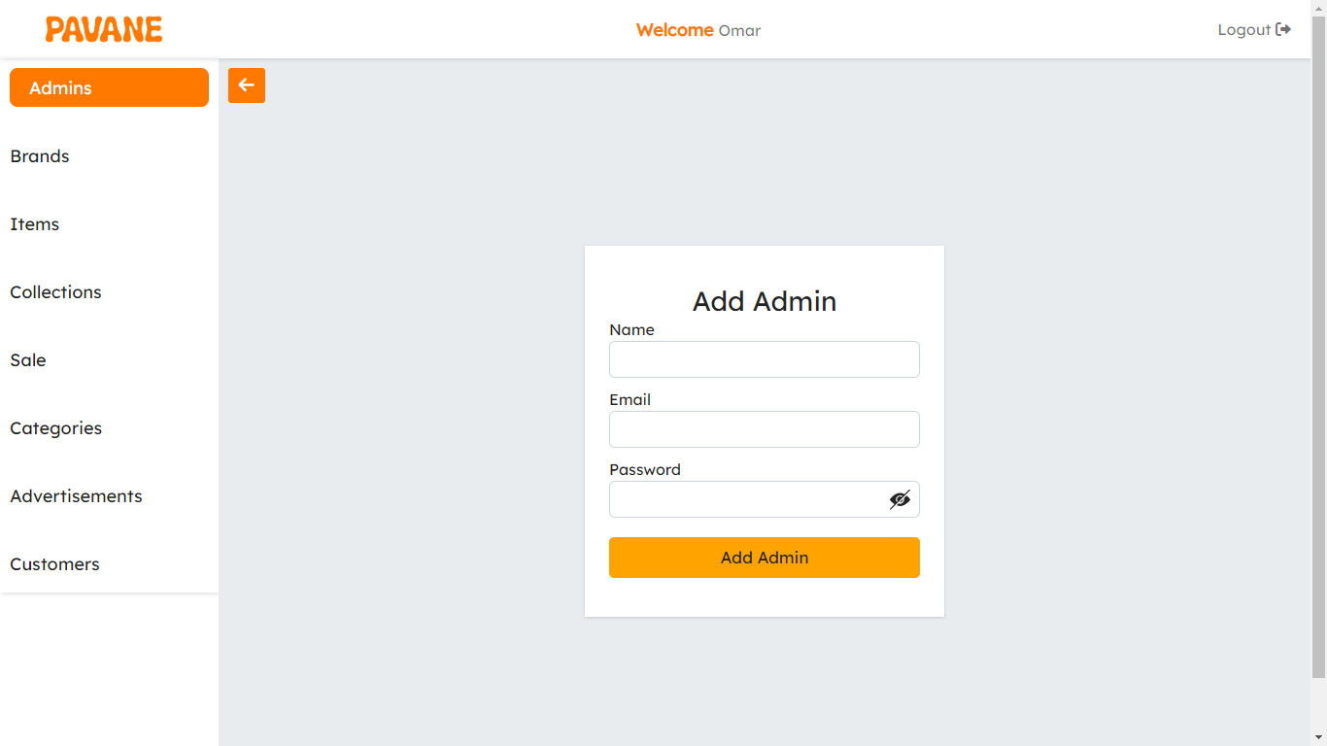You can add a new admin to the system: add a name, email, and password.
* 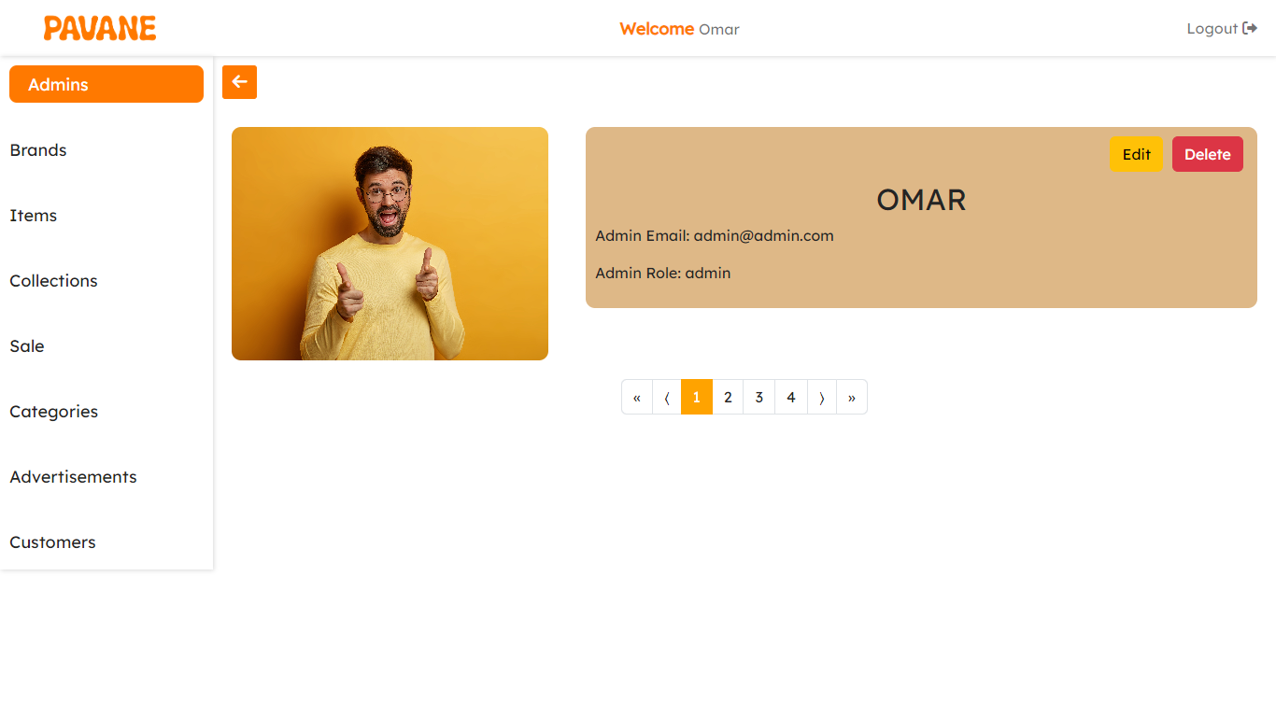Edit or even delete an admin.

1. **Brands**

* List all brands in the system, filter them by top brands (Most liked brands by the customers), and search for brands by name.
* 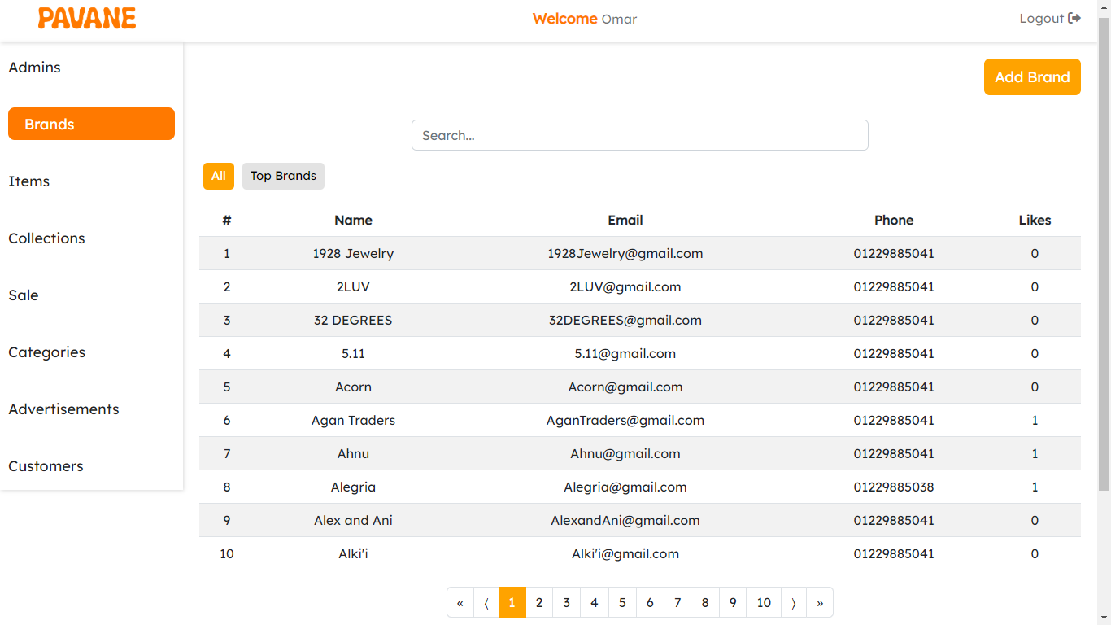Pagination to keep the performance and user experience up.
* You can add a new brand to the system: add a name, email, password, and phone, select categories to the new brand, add a cover image, and add an image to the new brand.

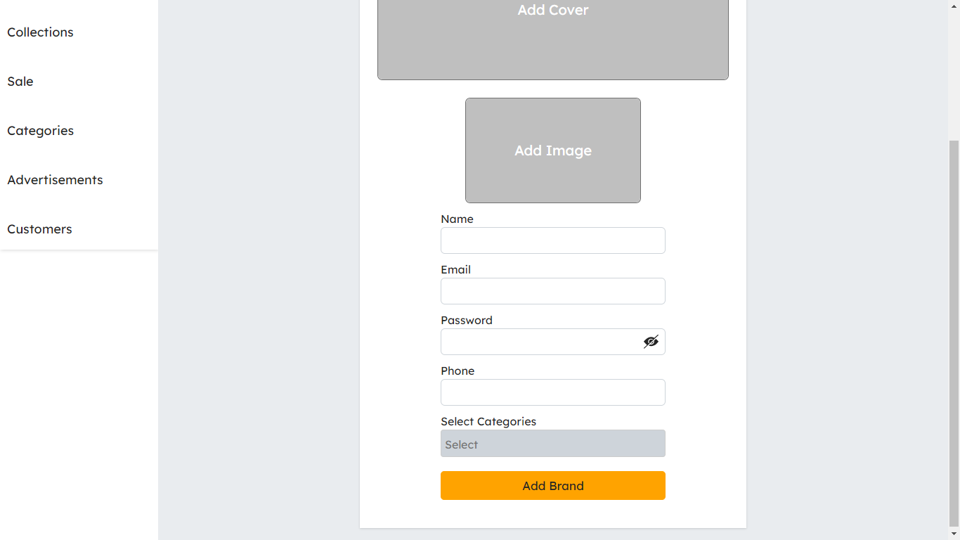

* View a specific brand and view its items.
* 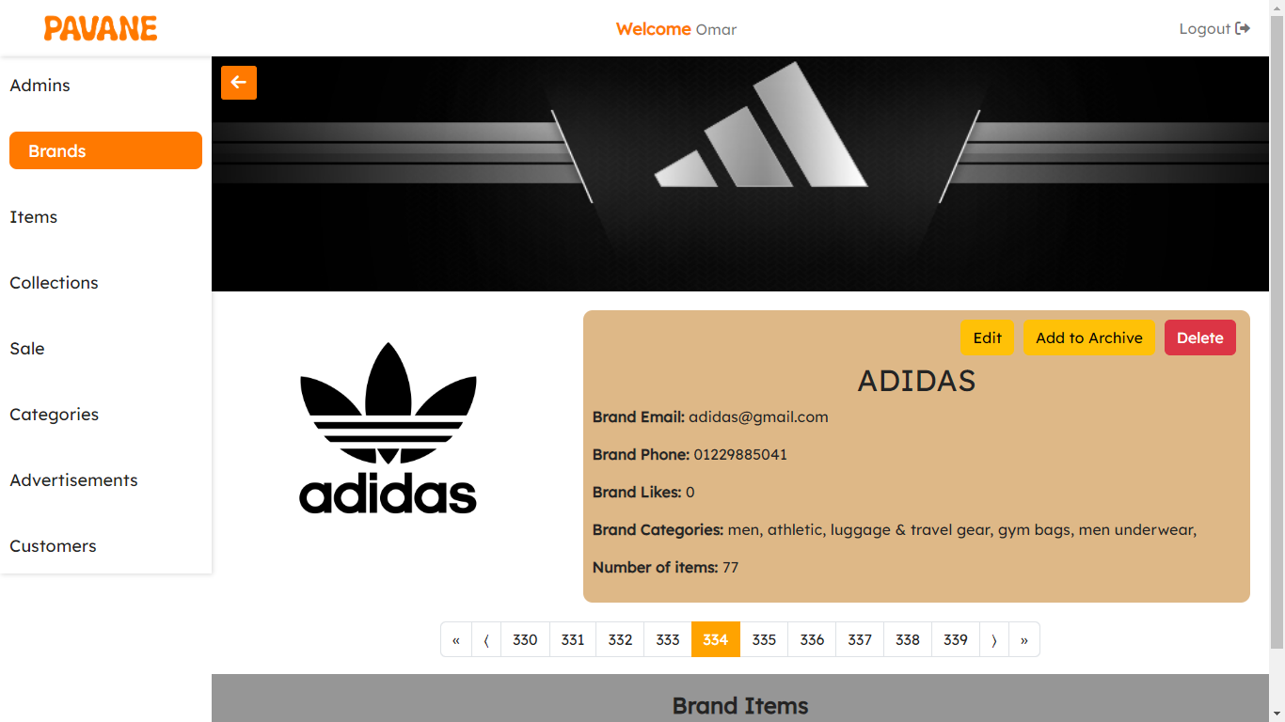Edit brand data, add to the archive, remove from the archive, or even delete the entire brand.

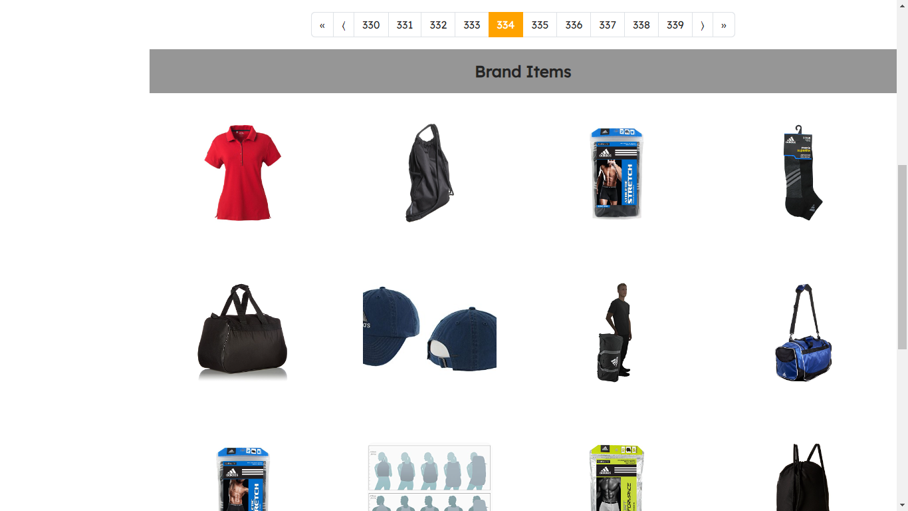

1. **Items**

* List all items in the system, filter them by top items (Most liked items by the customers), and search for items by name.
* Pagination to keep the performance and user experience up.

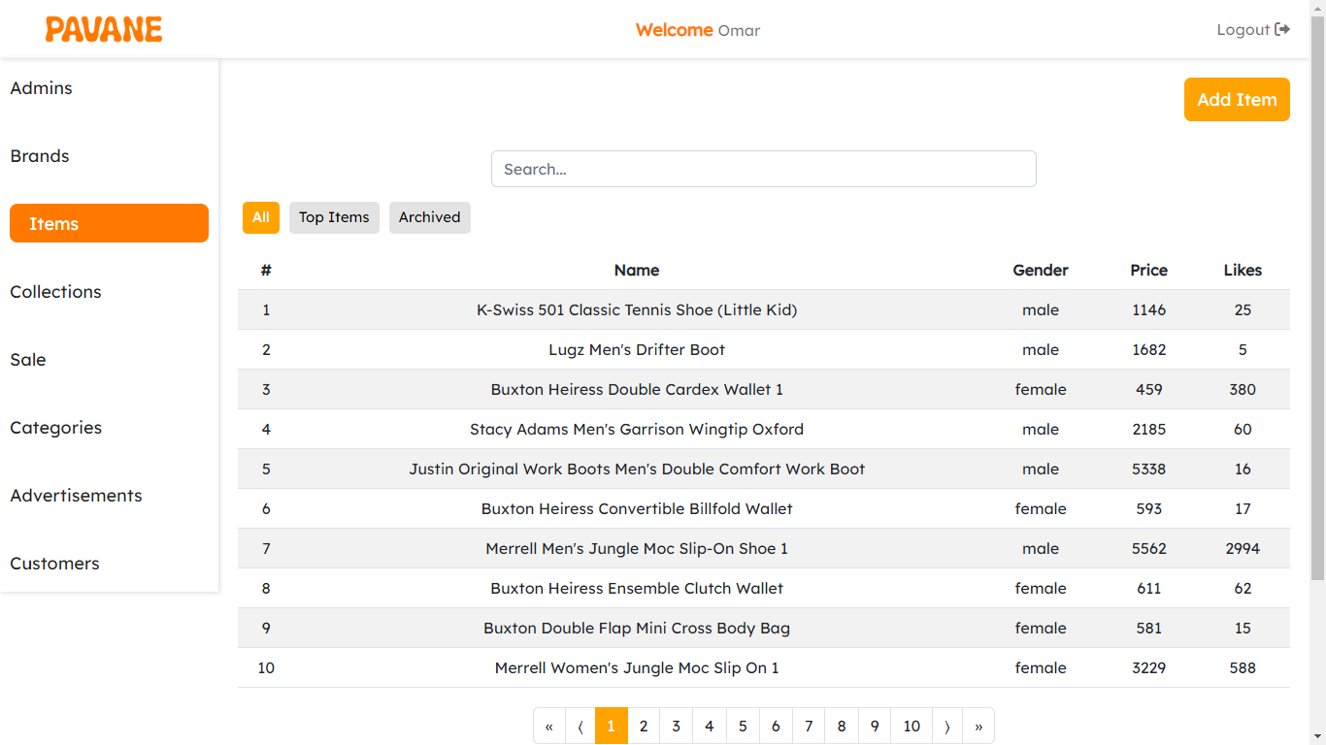

* You can add a new item to the system: add a name, description, price, discount, target gender, whether it for adults only or both adults and kids, sizes, colors, categories, and brand this item is in, add a cover image, and add multiple images.

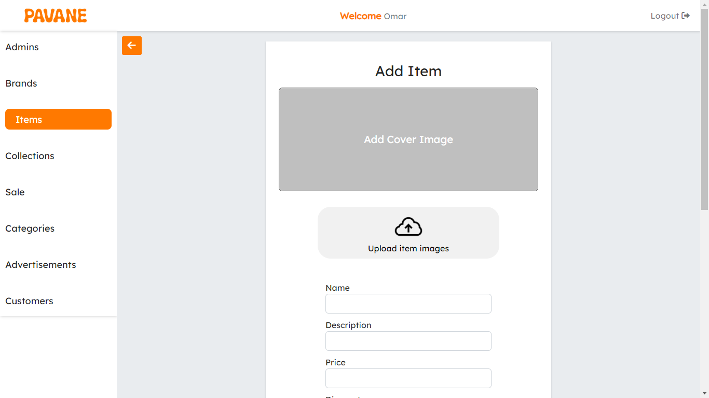

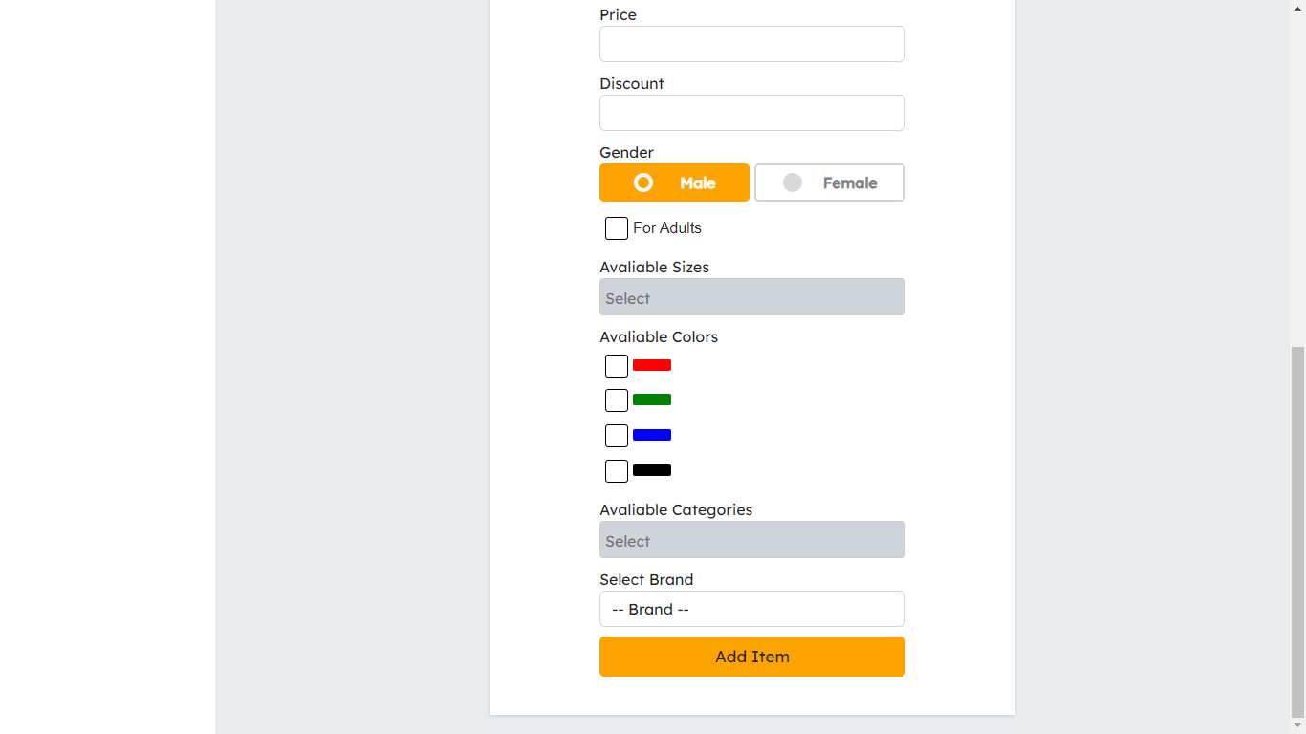

* View a specific item and view the customers' reviews on it.
* Edit item data, add to the archive, remove from the archive, or even delete the entire item.

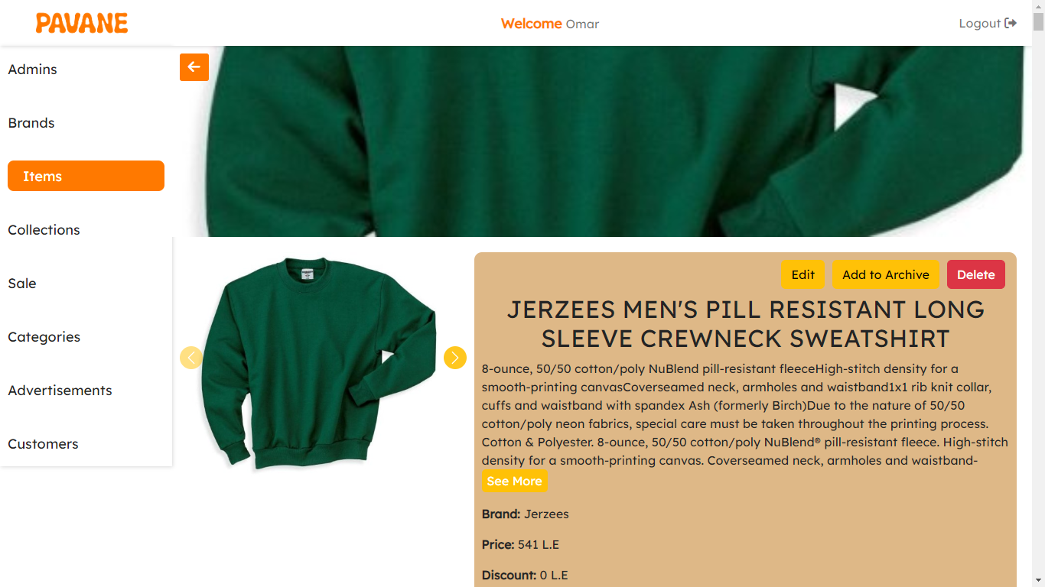

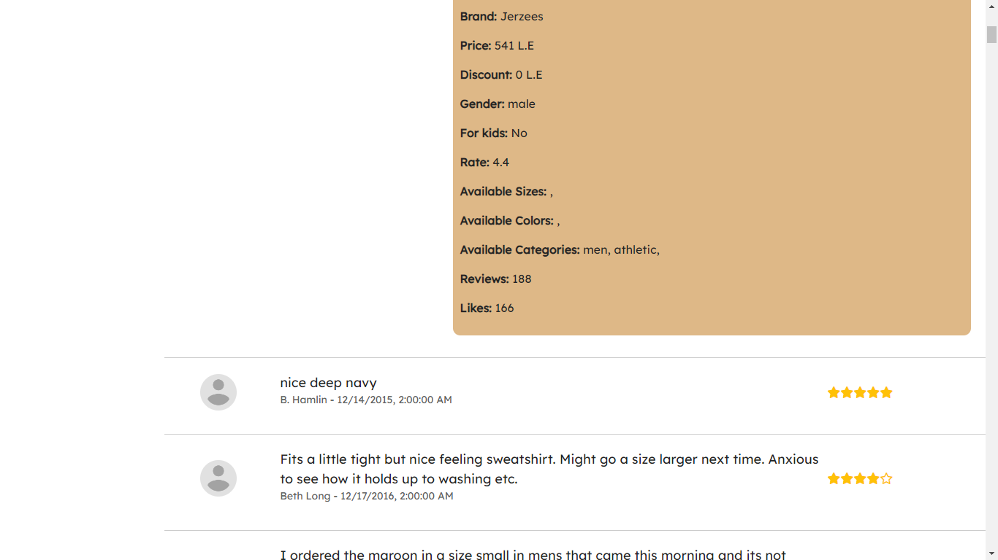

1. **Collections**

* List all items in the system, filter them by top collections (Most liked collections by the customers), and search for collections.
* Pagination to keep the performance and user experience up.

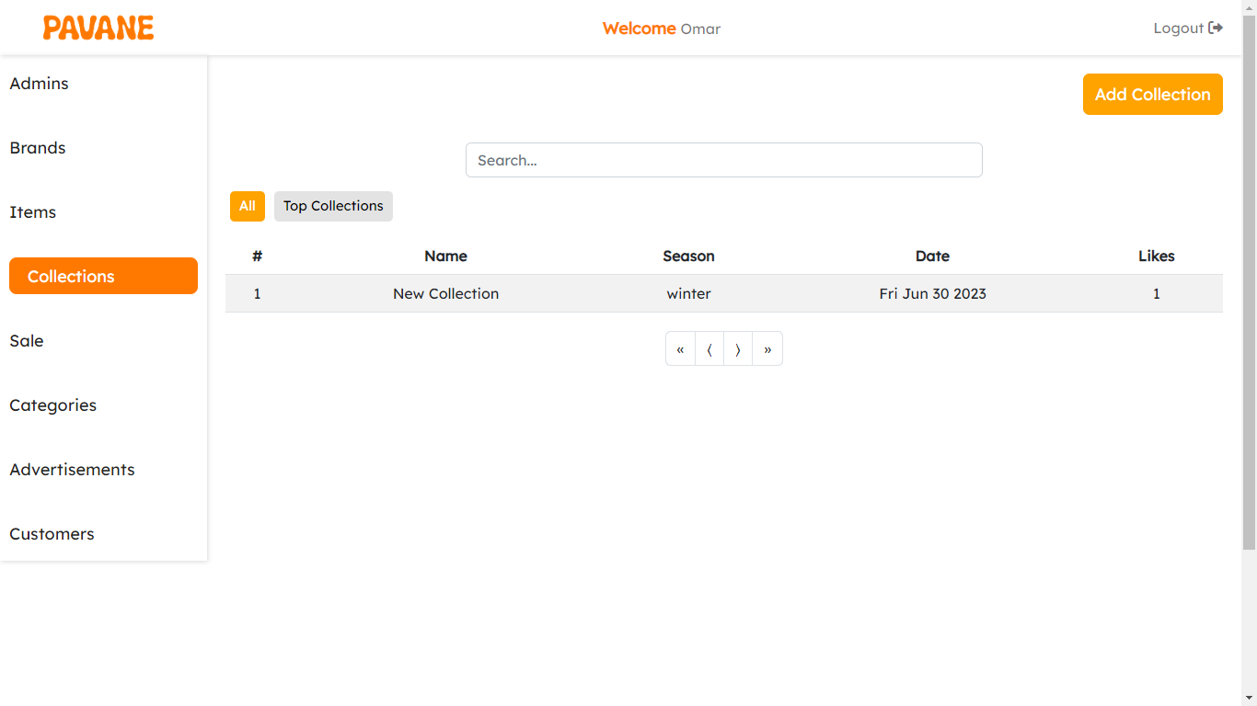

* View a specific collection and view its items.
* Edit collection data, add to the archive, remove from the archive, or even delete the entire collection.

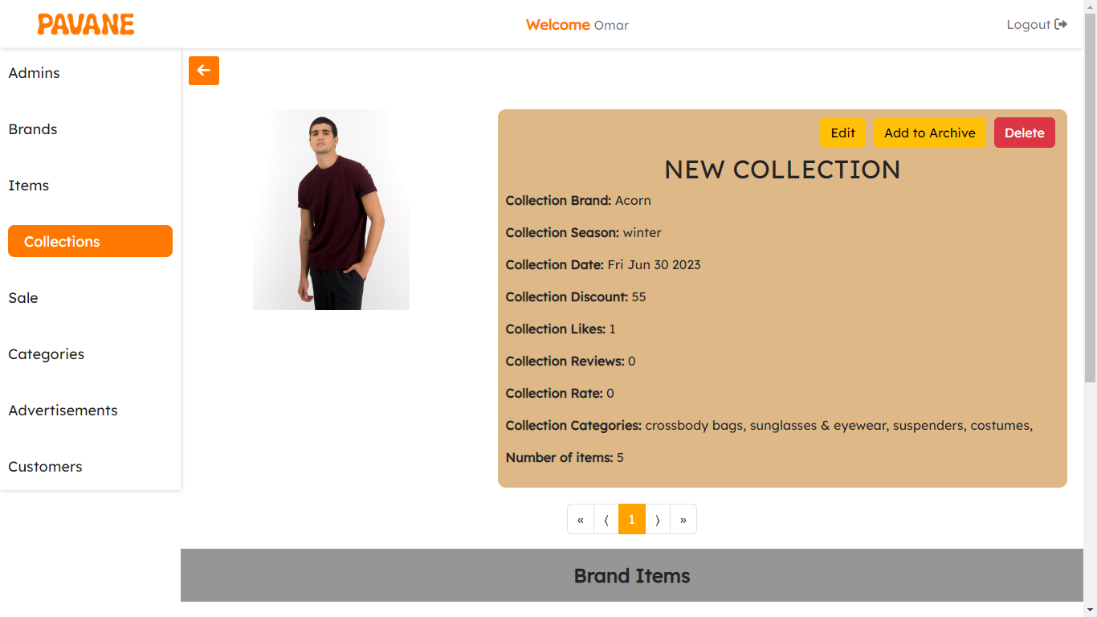

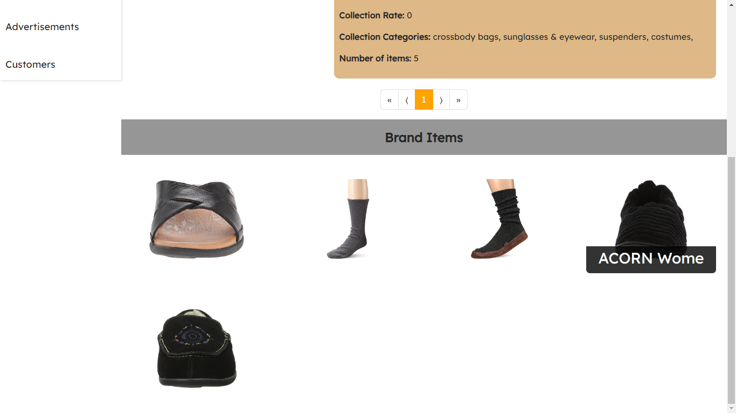

* You can add a new item to the system: add a name, season, date, discount, categories of this collection, and items in this collection, and add an image to the new collection.

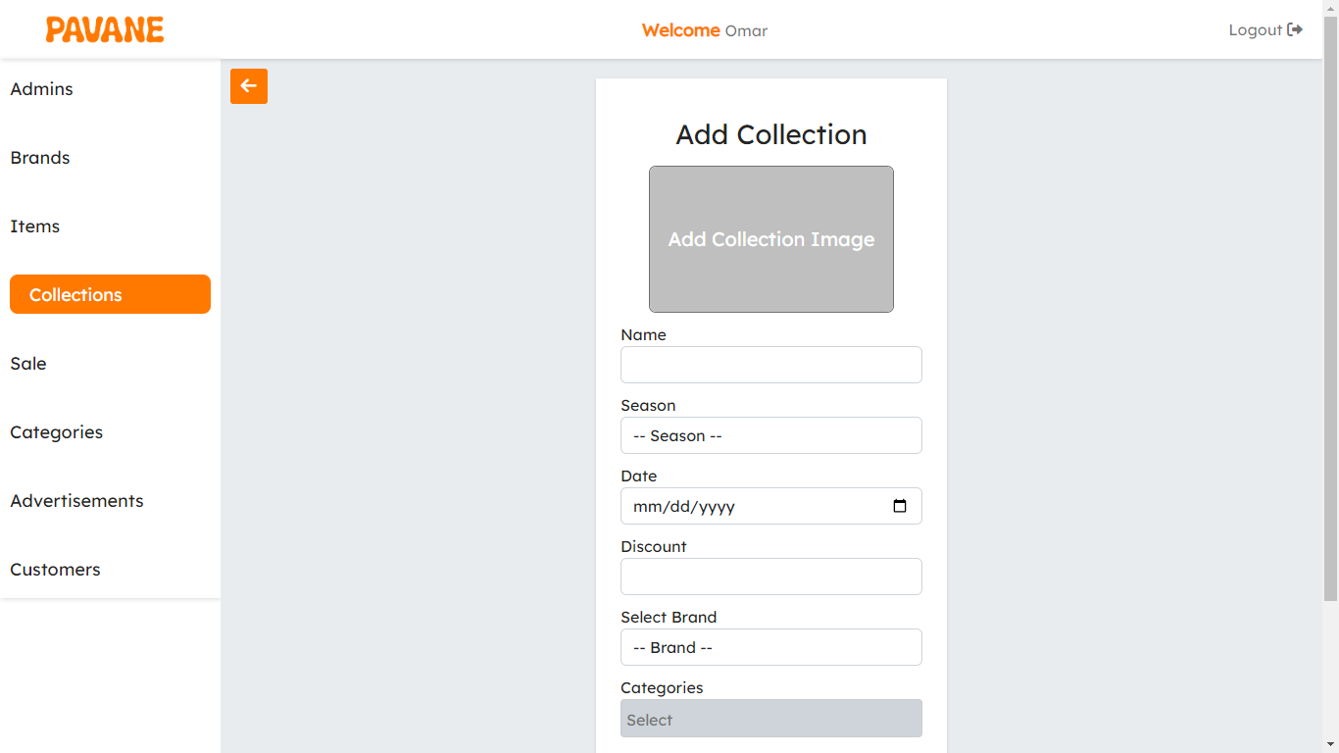

1. **Sales**

The same as the collection the only difference is that the sale doesn’t have rates or reviews.

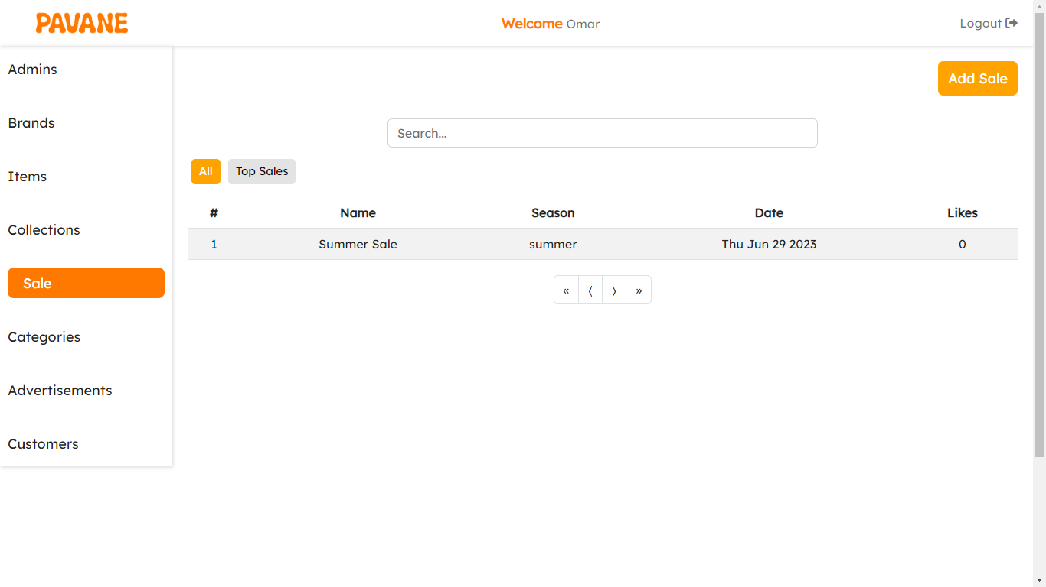

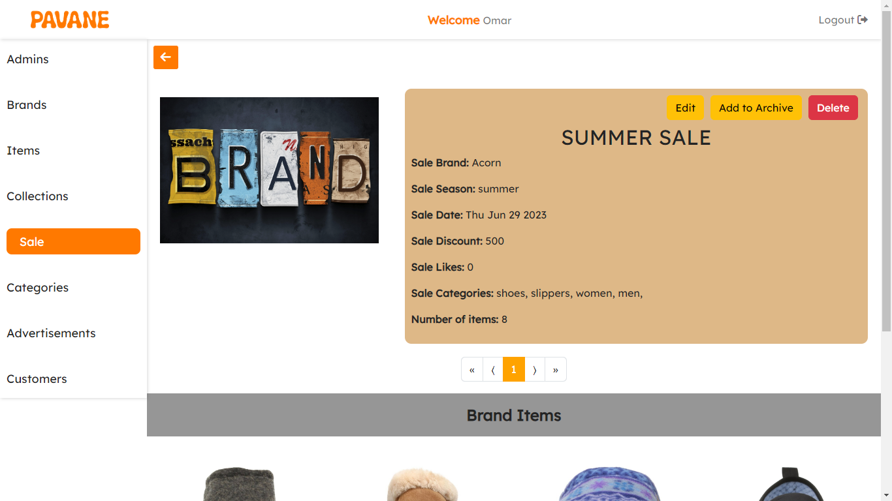

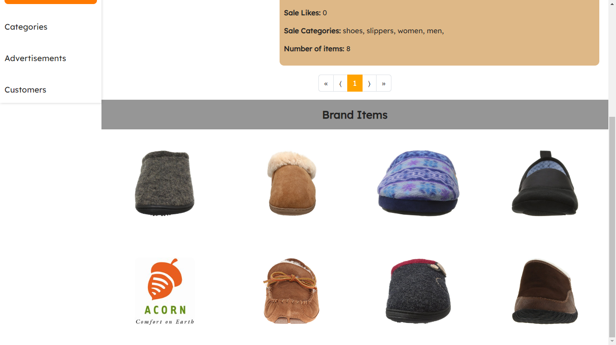

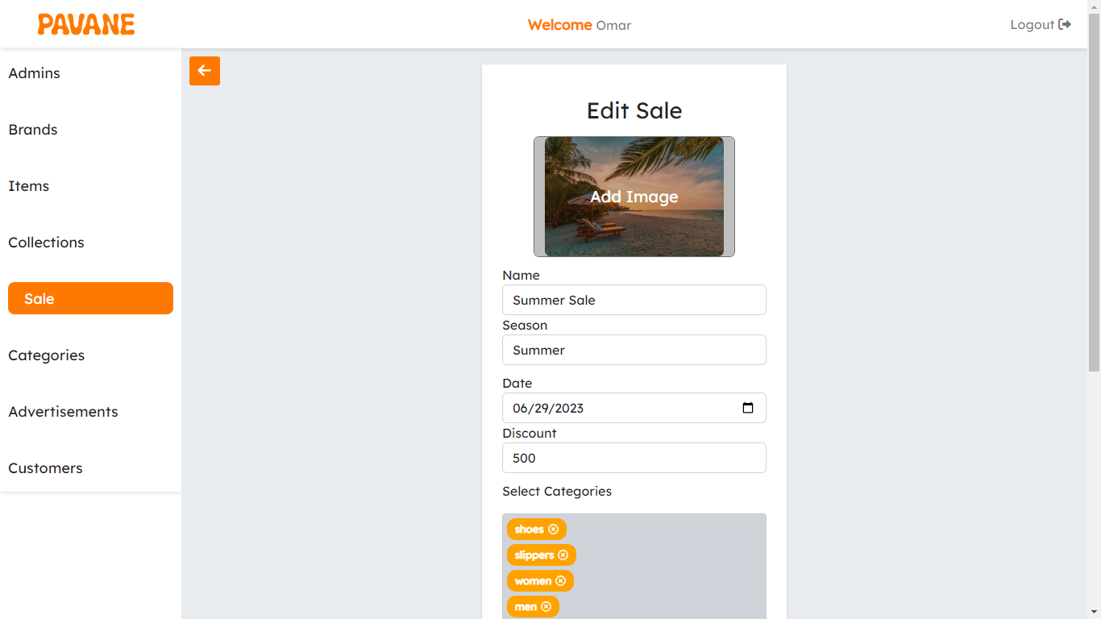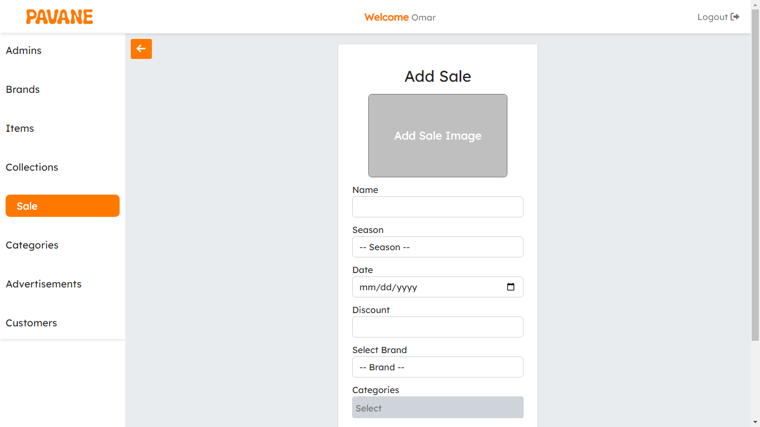

1. **Categories**

* List all categories in the system, and search for categories by name.
* Pagination to keep the performance and user experience up.

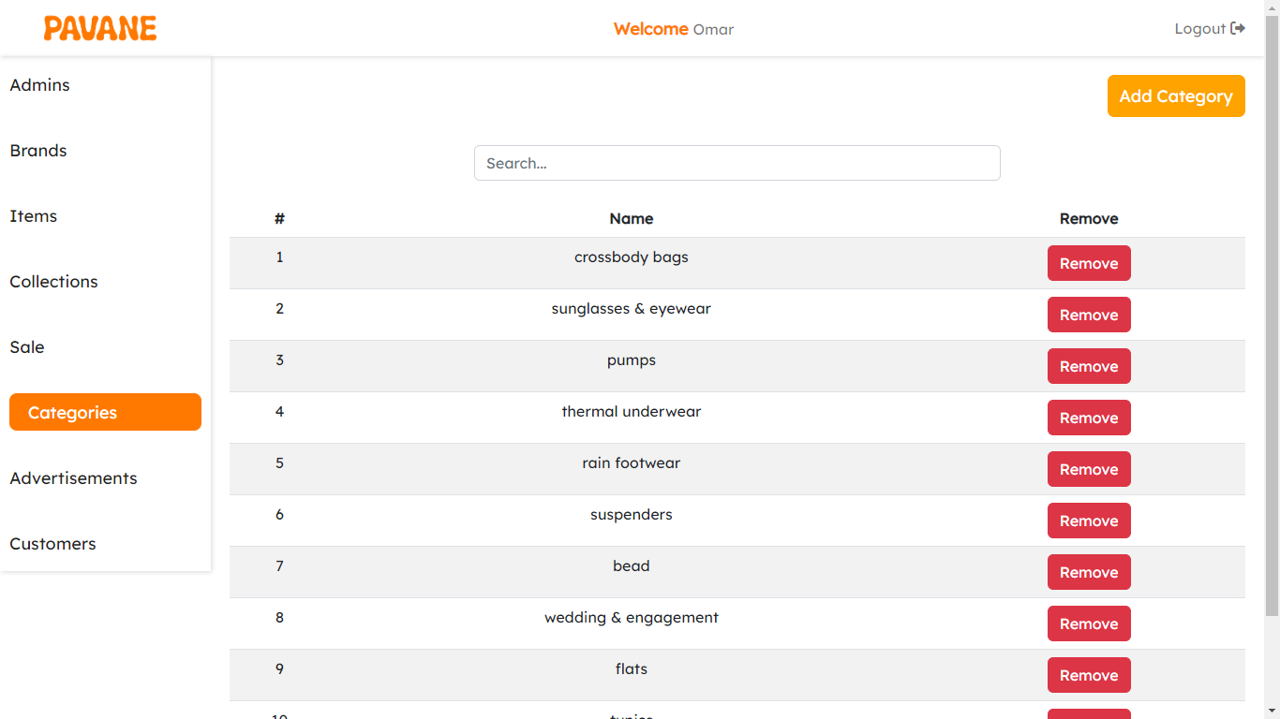

* You can add a new category to the system: add a name and add an image to the new category.

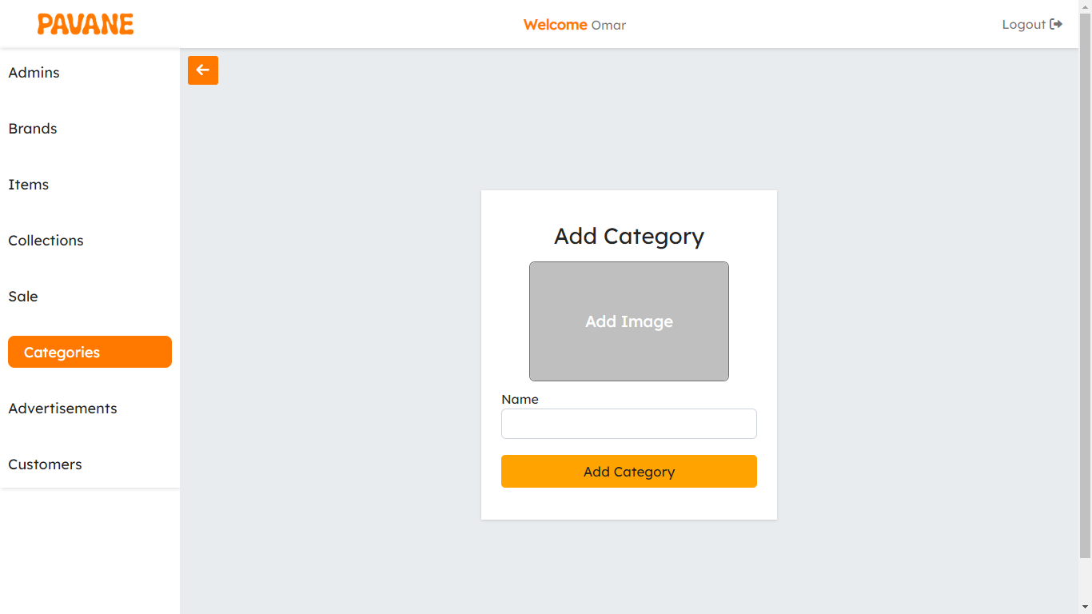

* View a specific category.
* Edit category data and delete the entire category.

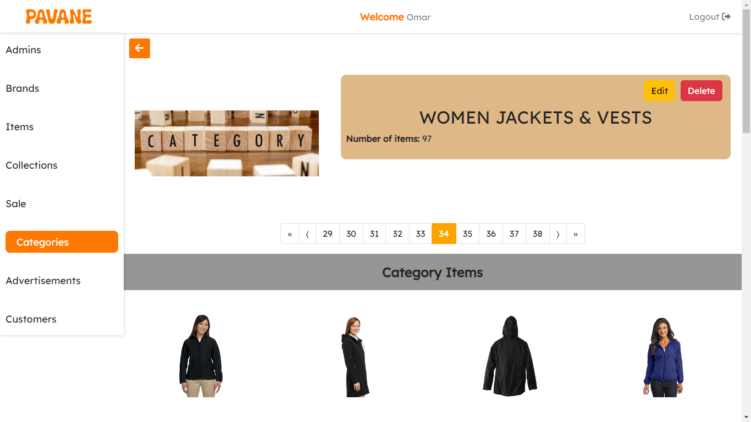

1. **Advertisements**

* List all advertisements in the system in a carousel way.

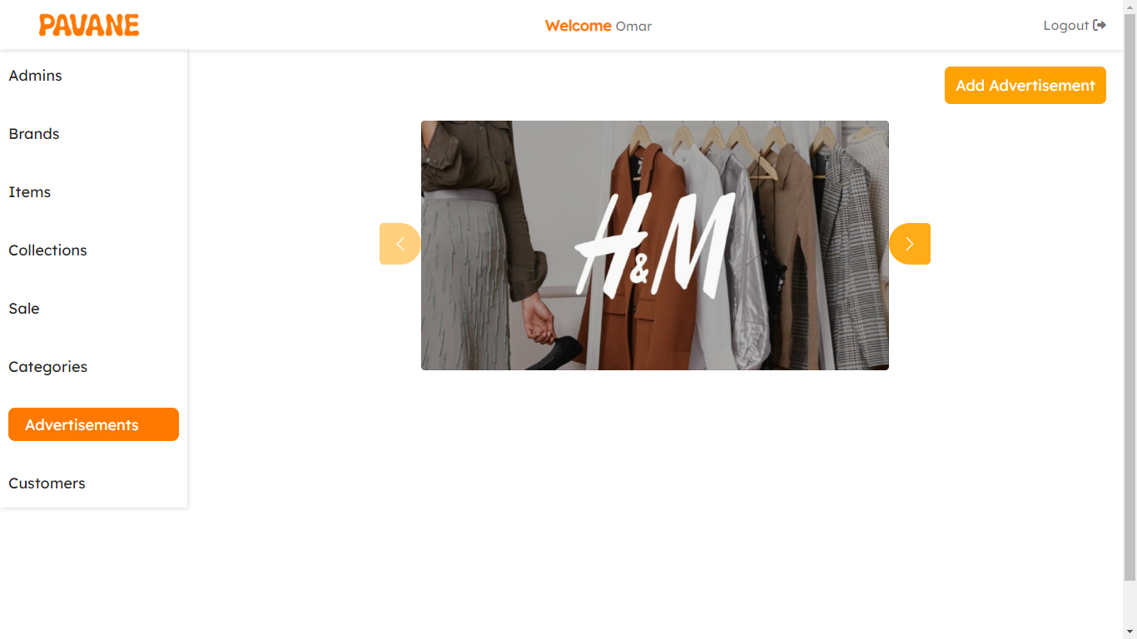

* 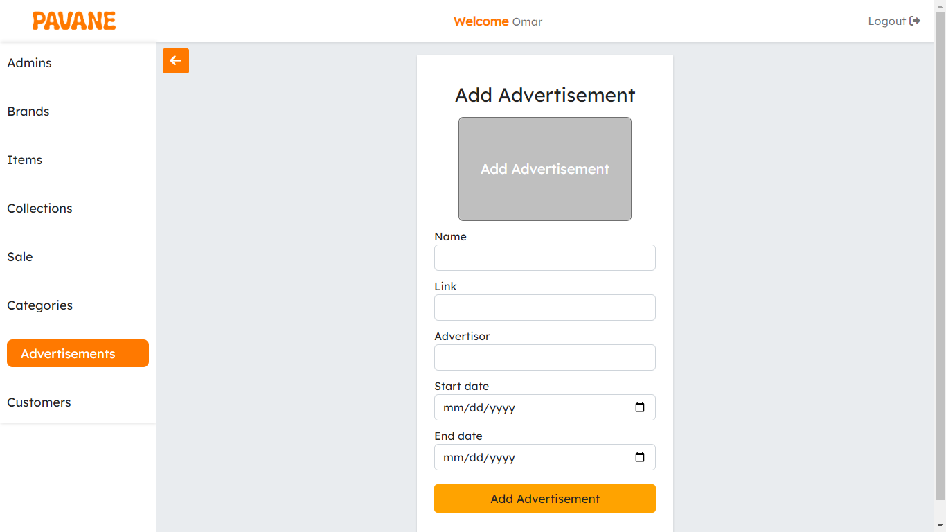You can add a new advertisement to the system: add a name, link, advertiser, start date, and end date, and add an image to the new advertisement.
* View a specific advertisement.
* 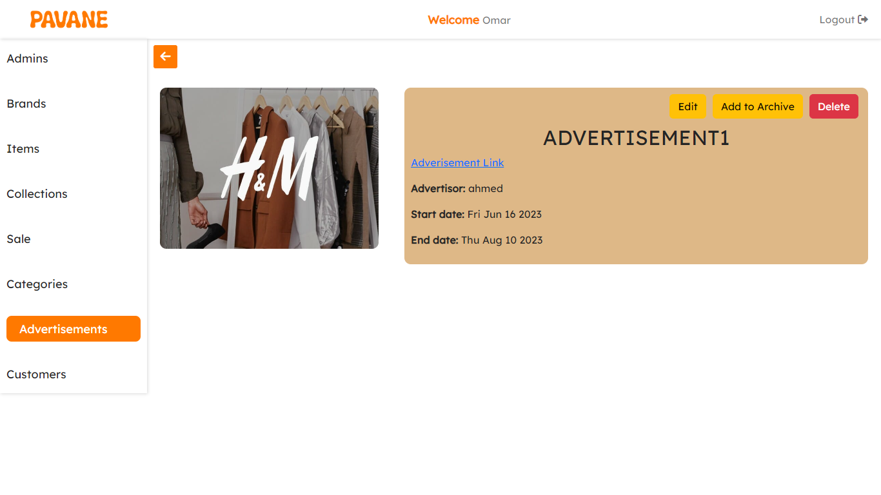Edit advertisement data, add to the archive, remove from the archive, or even delete

1. **Customers**

* List all customers in the system.

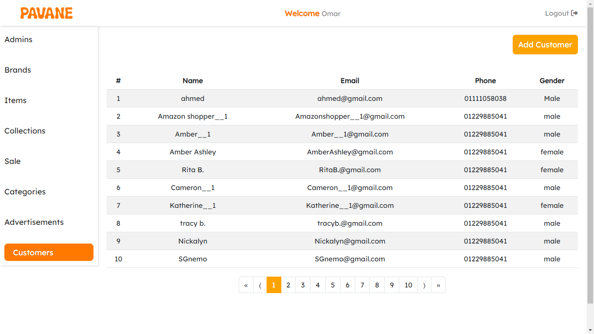

* You can add a new customer to the system: add a name, email, password, phone, gender, date of birth, and city, and add an image to the new customer.

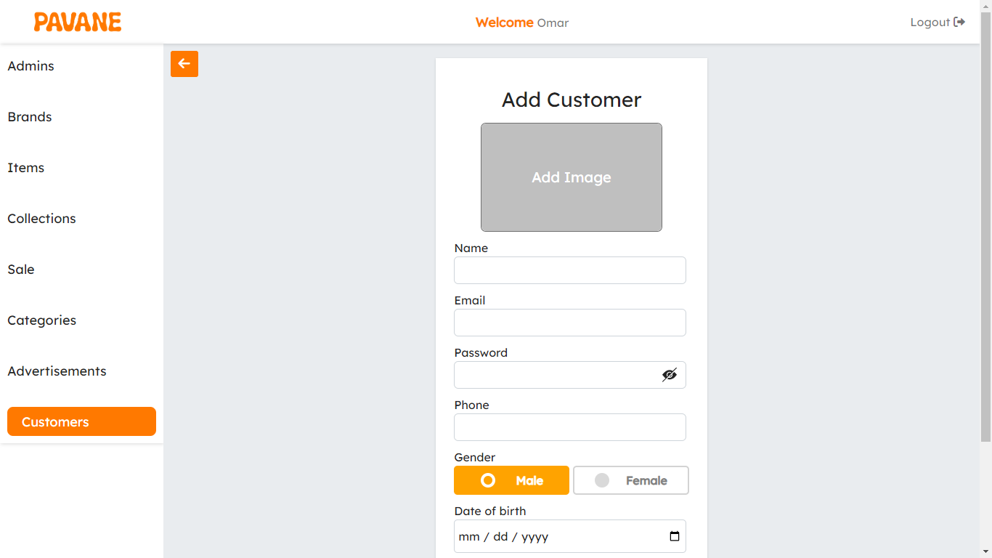

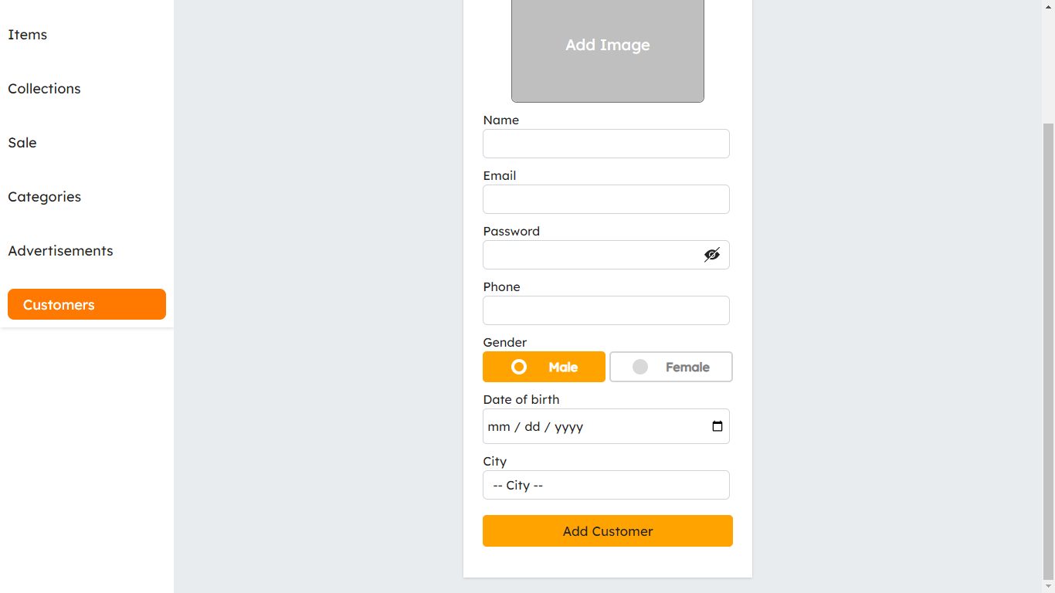

* View a specific customer, his liked brands liked collections, liked items, and Wishlist.
* Edit customer data, add to the archive, remove from the archive, or even delete the entire customer.

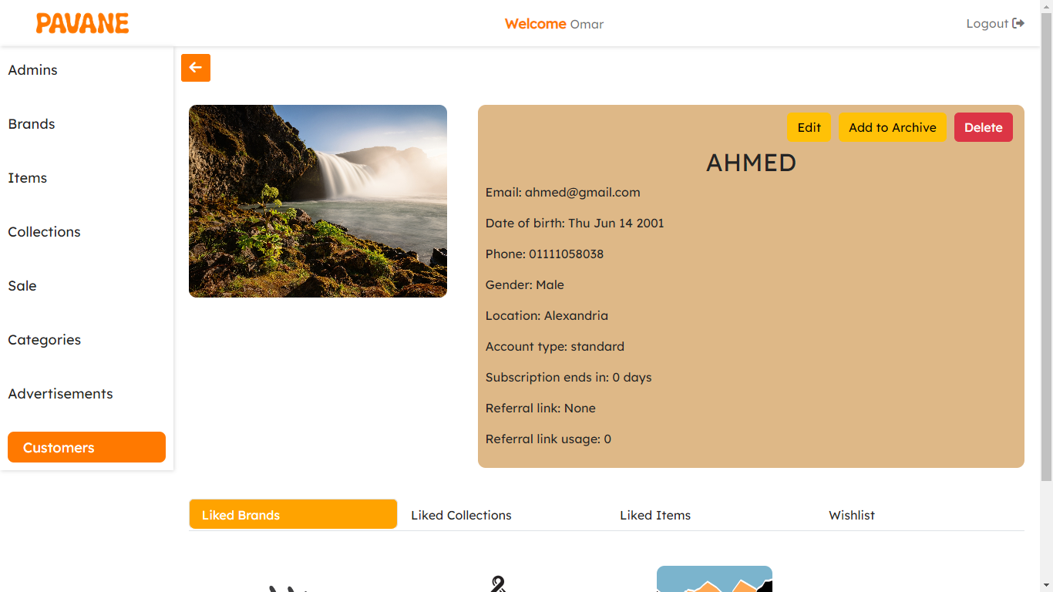

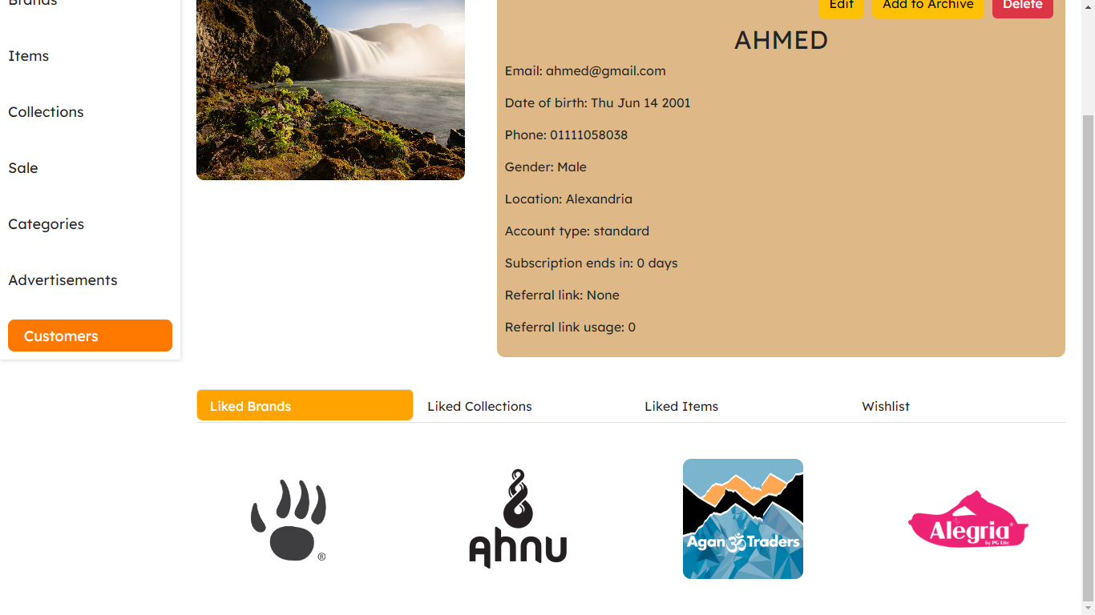

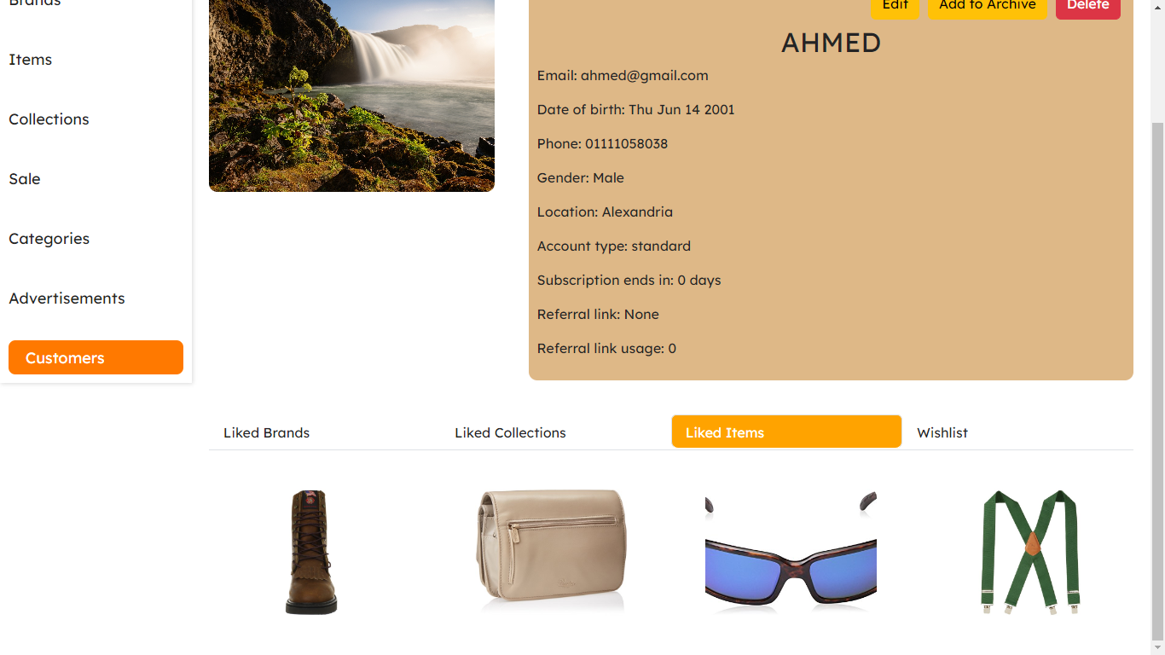

**5.3 Brand dashboard**

A brand dashboard, also known as a brand monitoring dashboard or brand analytics dashboard, is a specialized type of dashboard that focuses on tracking and analyzing various aspects of a brand's online presence and performance.

The purpose of a brand dashboard is to provide a centralized platform for brand managers, marketing teams, or business owners to monitor and evaluate the effectiveness of their brand strategies, marketing campaigns, and customer perceptions. It helps them understand how their brand is perceived in the market, identify areas of improvement, and make data-driven decisions to enhance brand awareness and reputation.

To use the brand dashboard, you need to log in with an email and a password.

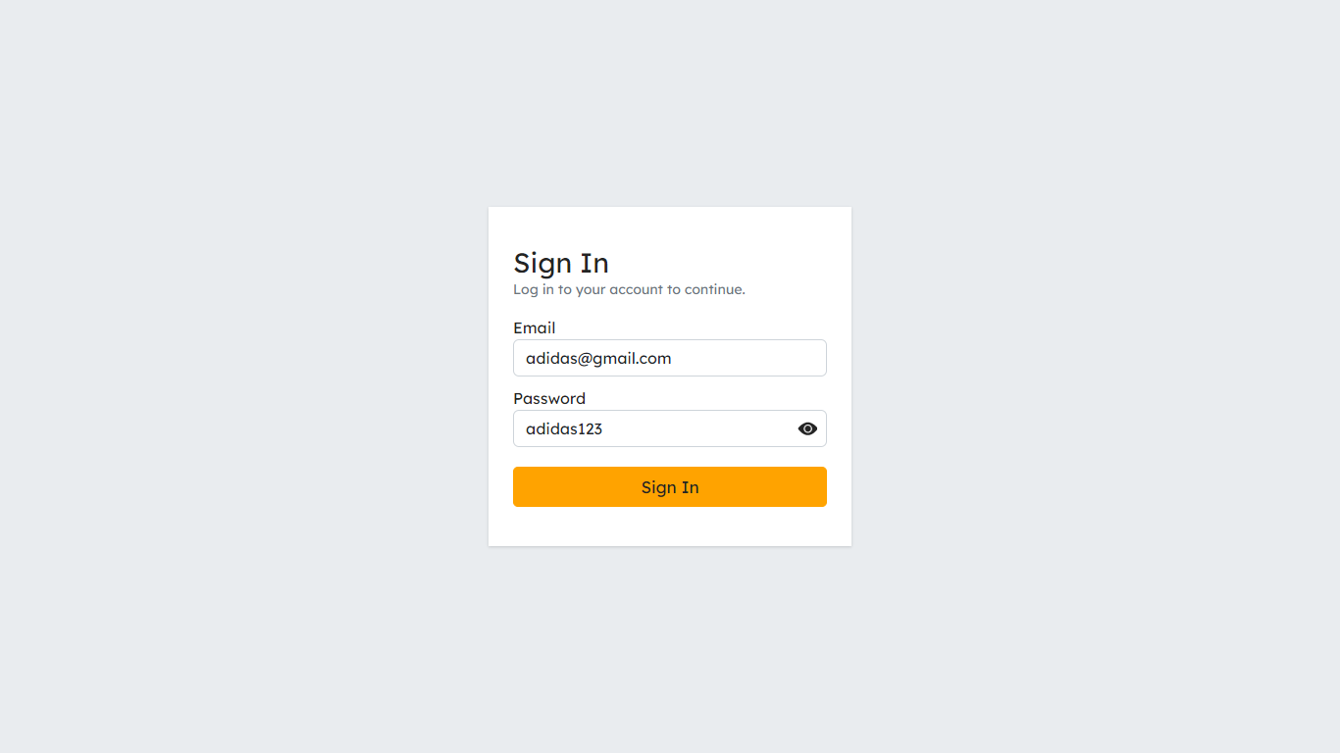

After the login you will find that there are many actions that you can take:

**Profile**

* You can view your profile and update profile data: name, email, phone, and categories.
* 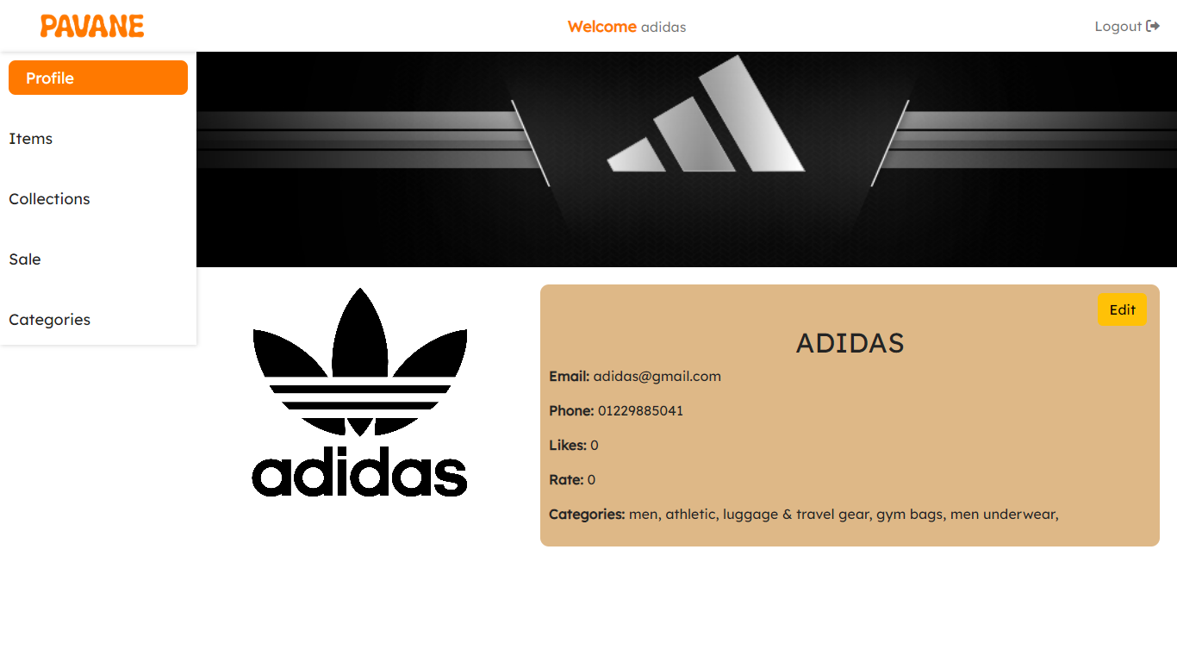You can view the number of likes, reviews, and your brand rating.

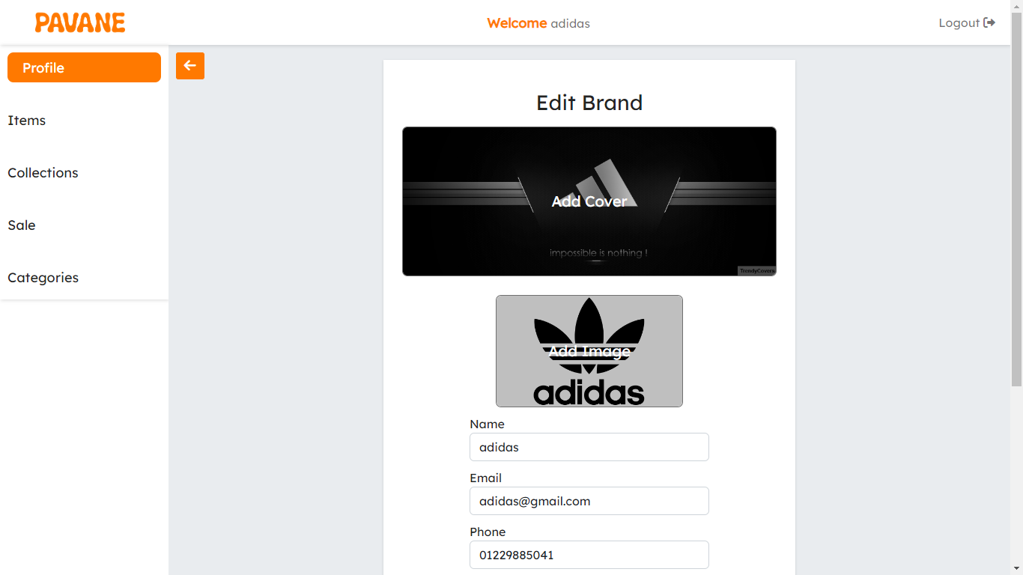

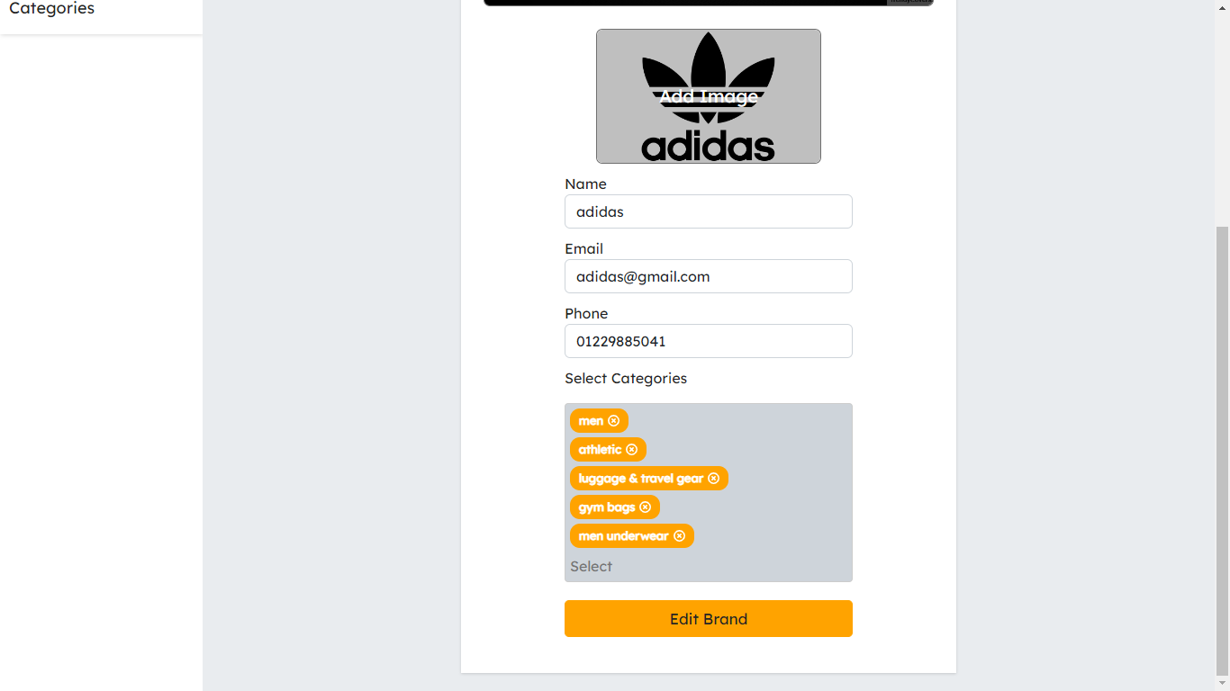

**Items**

* List all items in the system, and search for items by name.
* Pagination to keep the performance and user experience up.

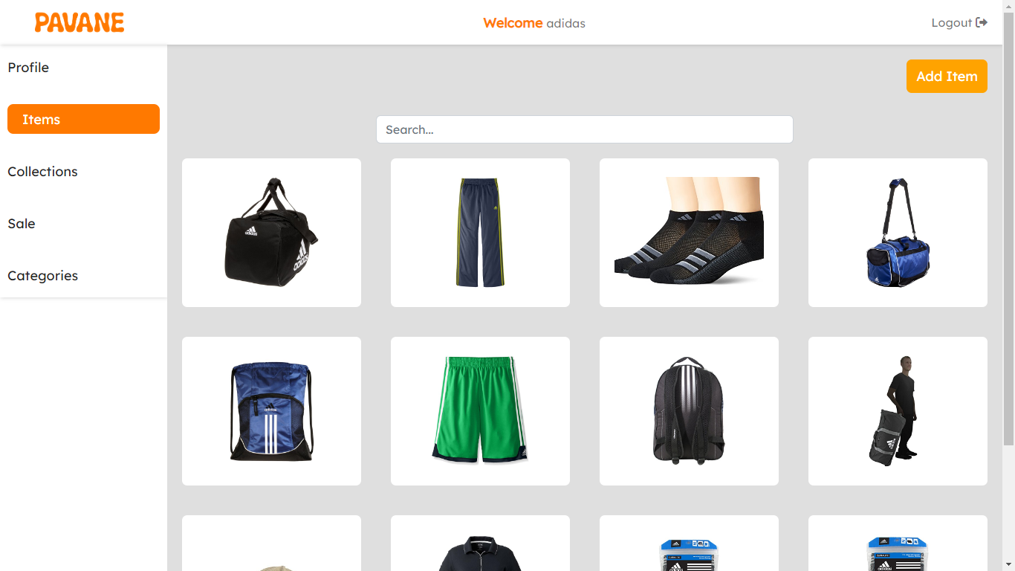

* View a specific item and view the customers' reviews on it.

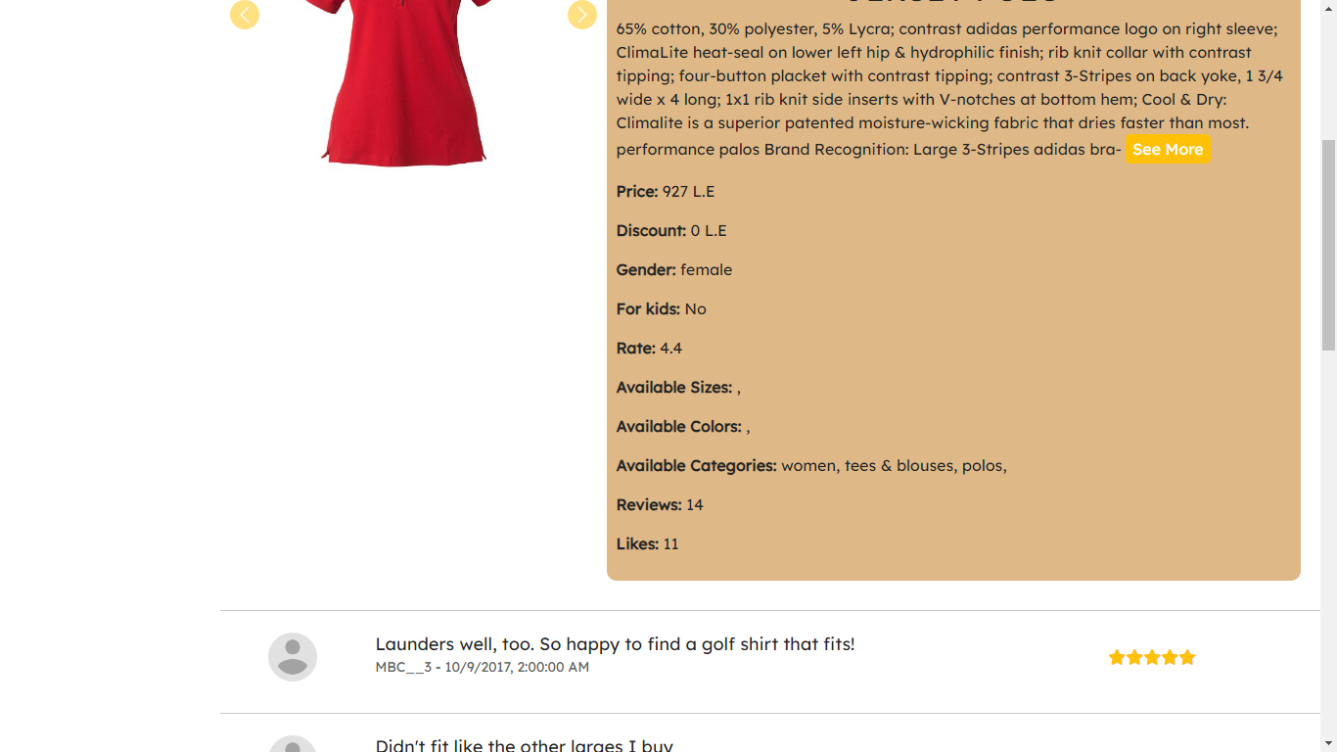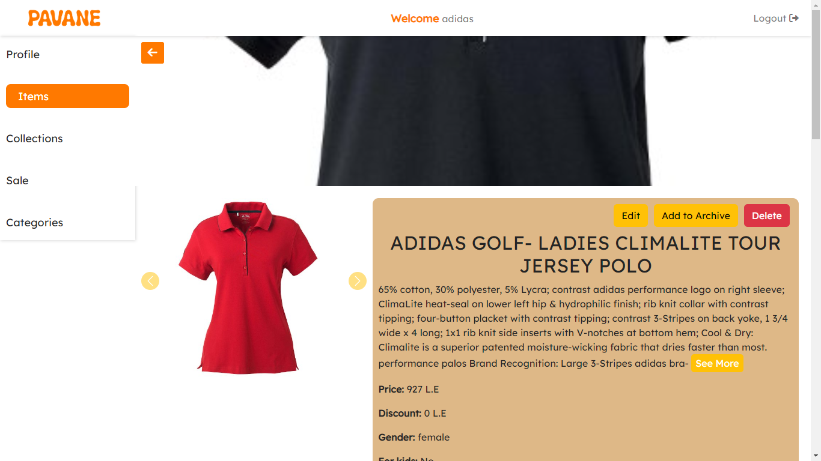

* Edit item data, add to the archive, remove from the archive, or even delete the entire item.

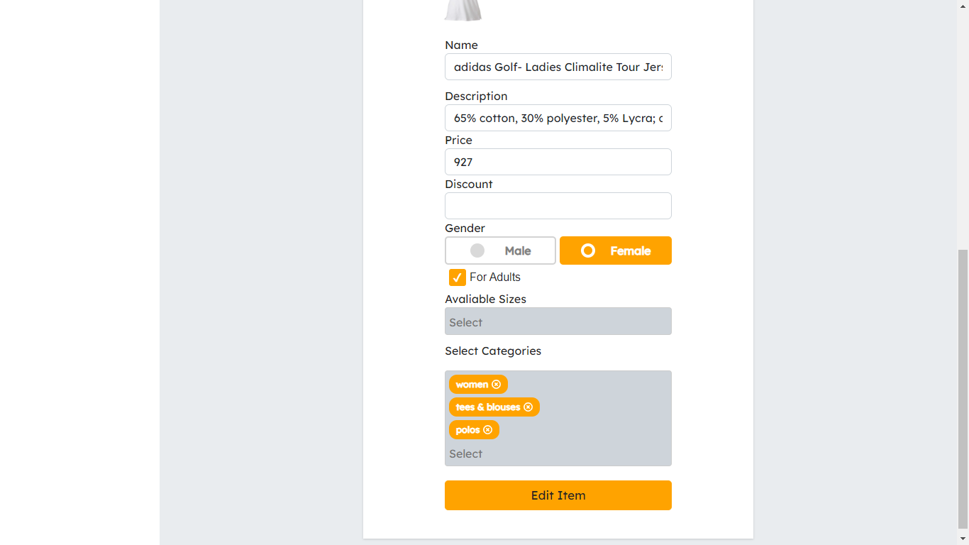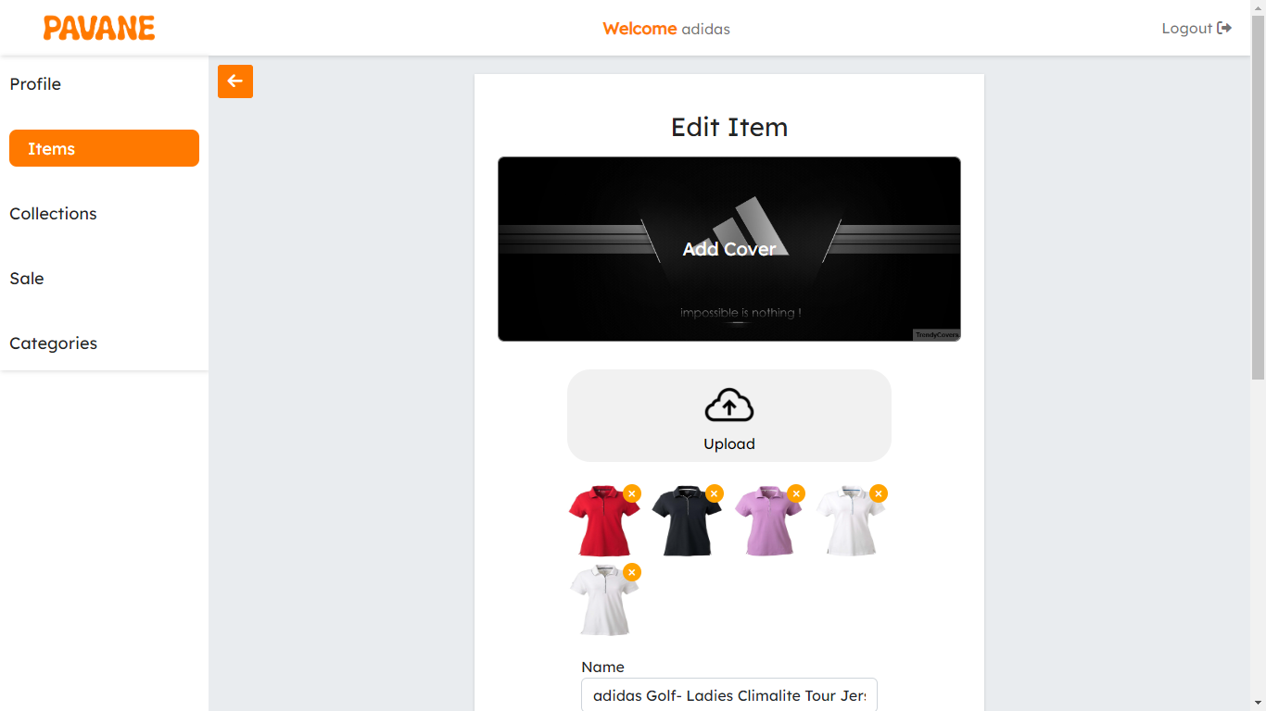

* You can add a new item to the system: add a name, description, price, discount, target gender of the item, whether is it for adults only or both adults and kids, sizes, colors, categories of this item, and which brand this item is in, add a cover image, and add multiple images to the new brand.

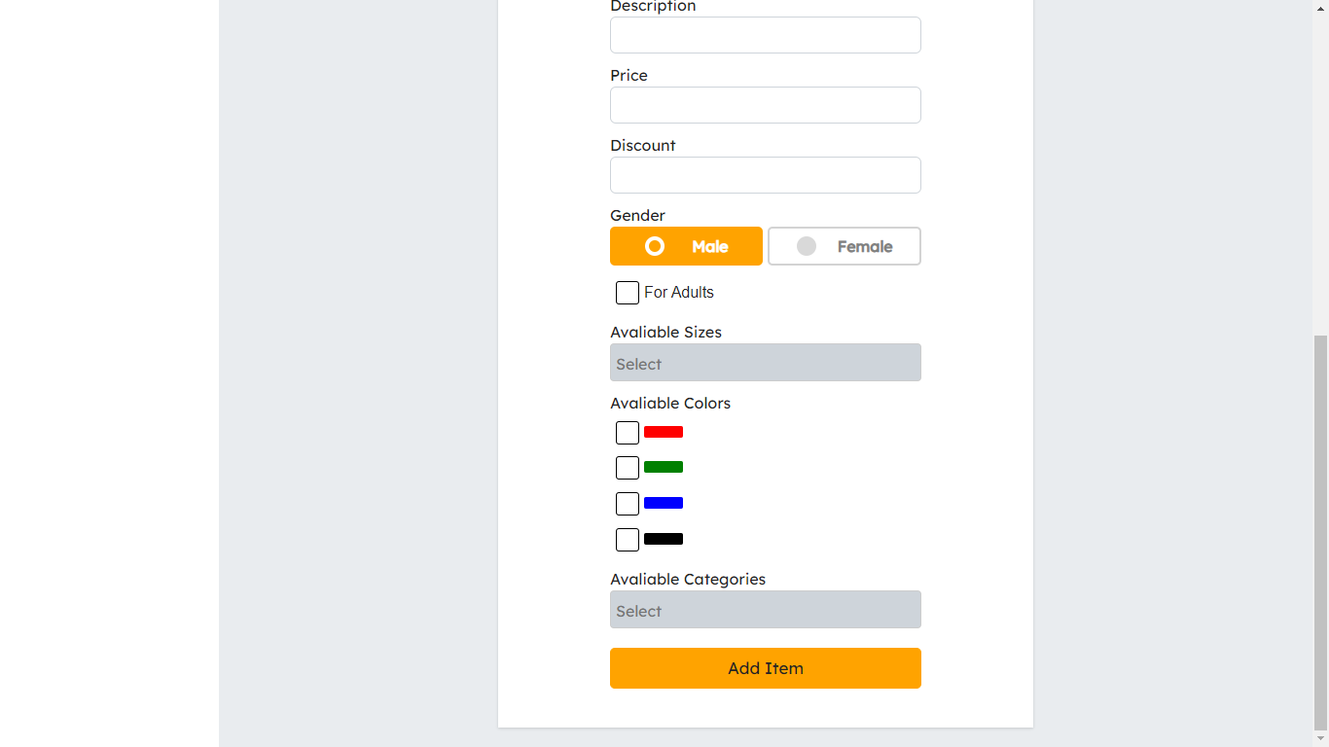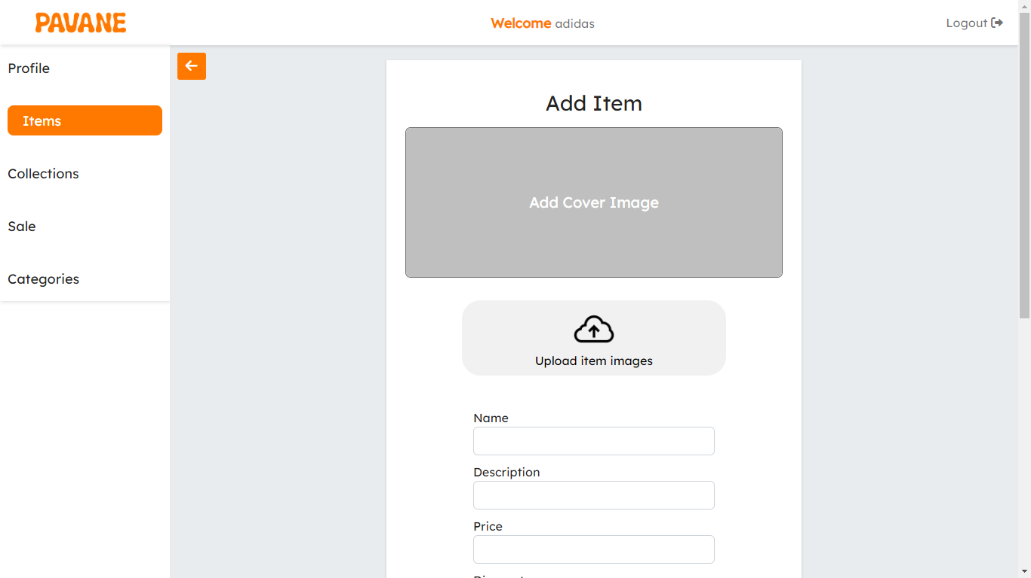

**Collections**

* List all items in the system, and search for collections by name.
* Pagination to keep the performance and user experience up.

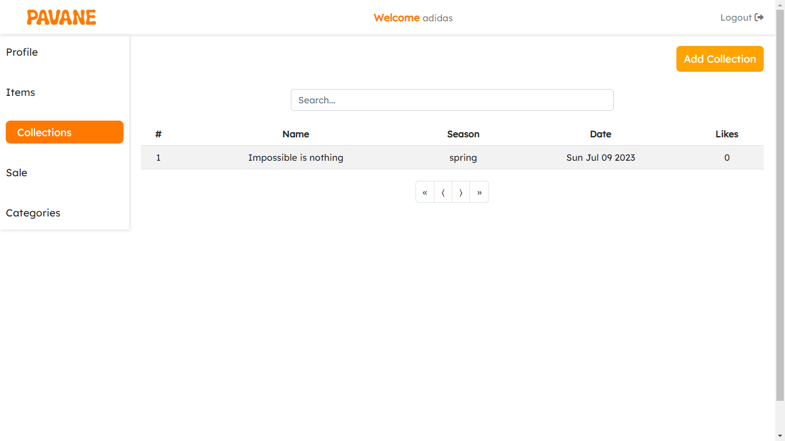

* You can add a new item to the system: add a name, season, date, discount, categories of this collection, and items in this collection, and add an image to the new collection.

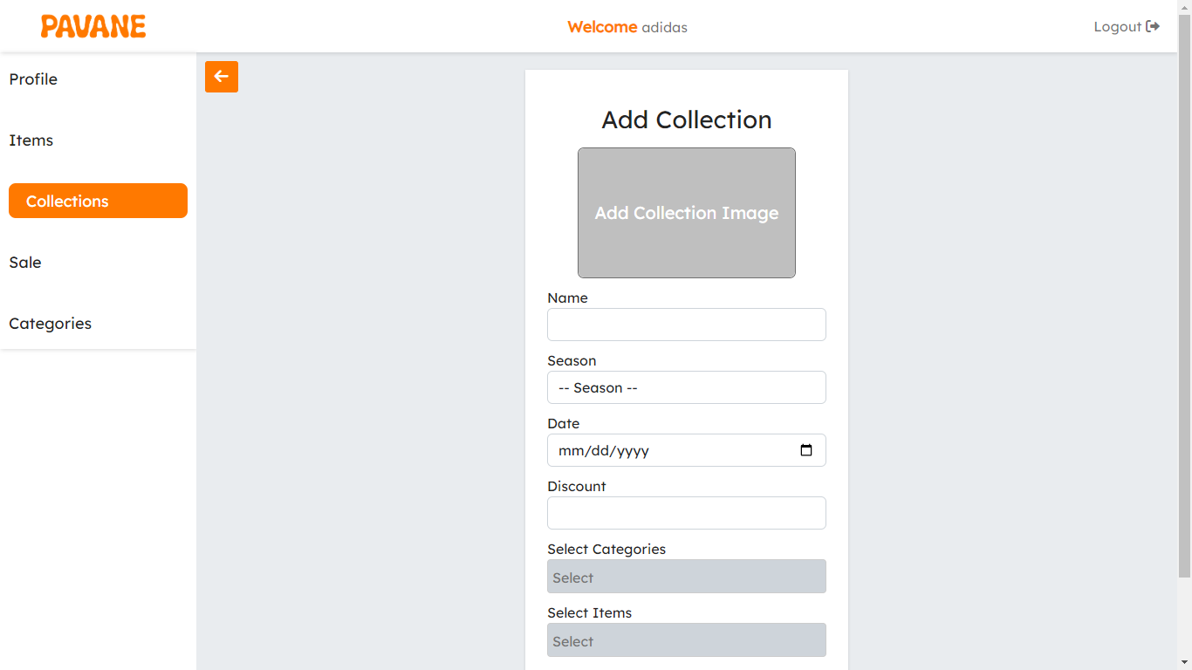

* View a specific collection and view its items.

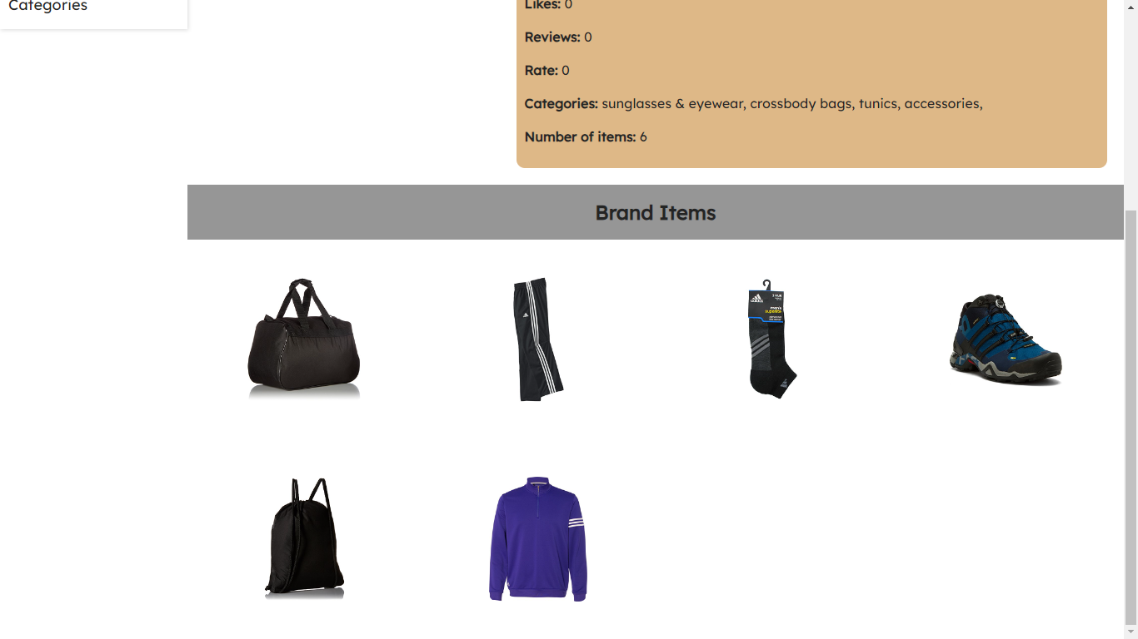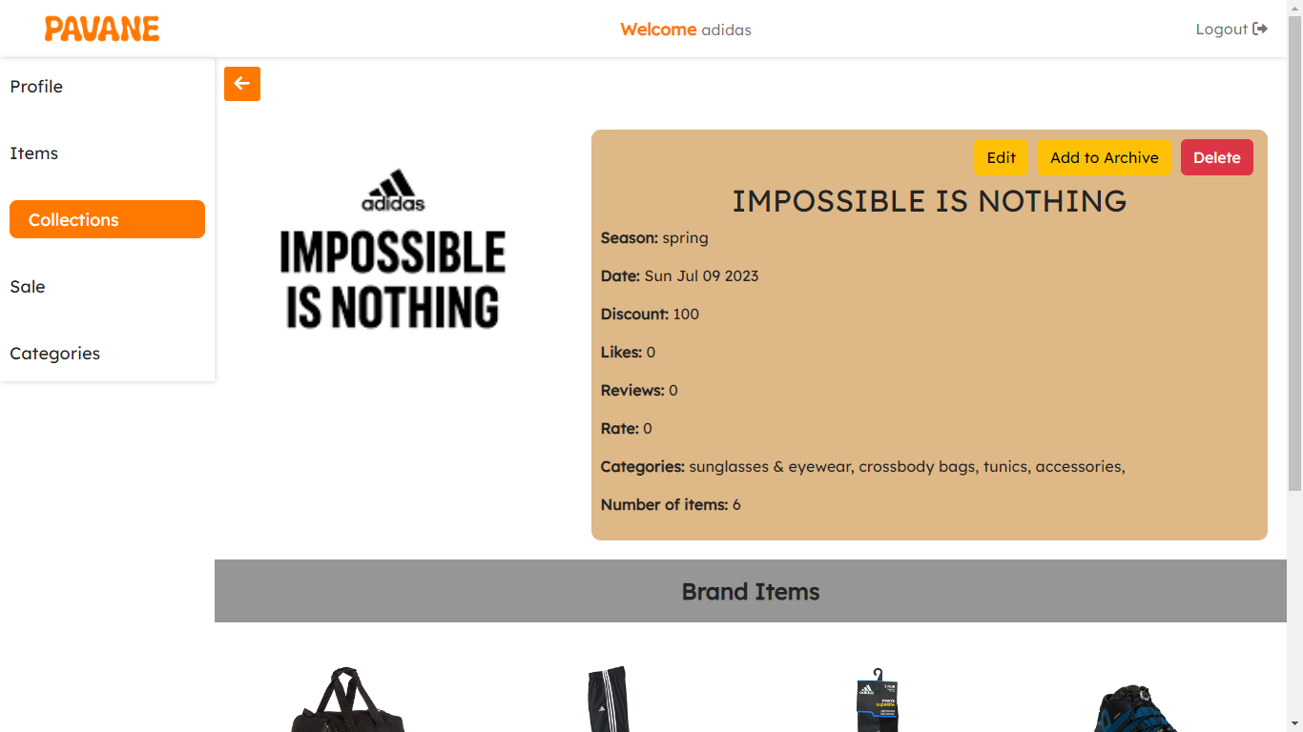

* Edit collection data, add to the archive, remove from the archive, or even delete the entire collection.

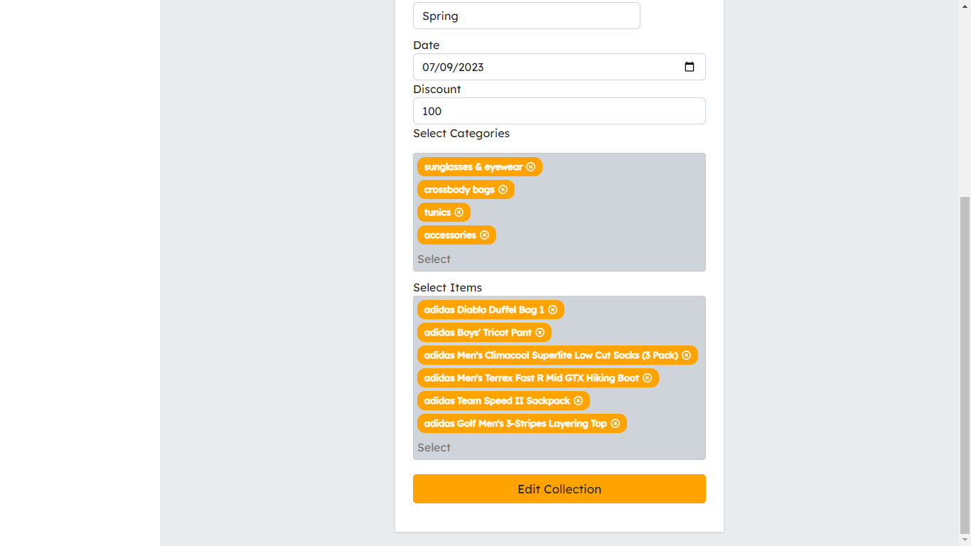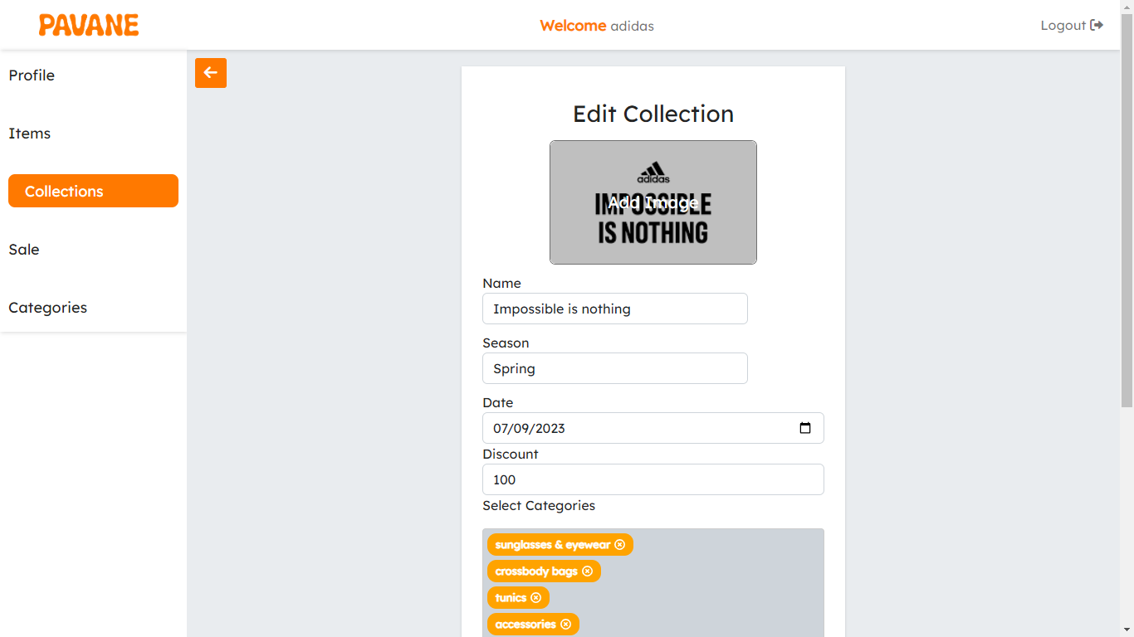

**Sales**

* The same as the collection the only difference is that the sale doesn’t have rates or reviews.

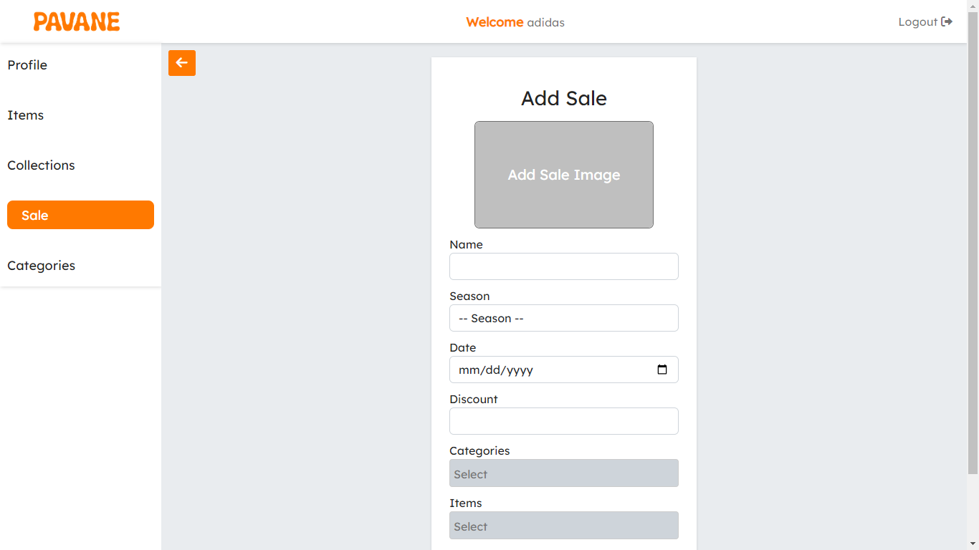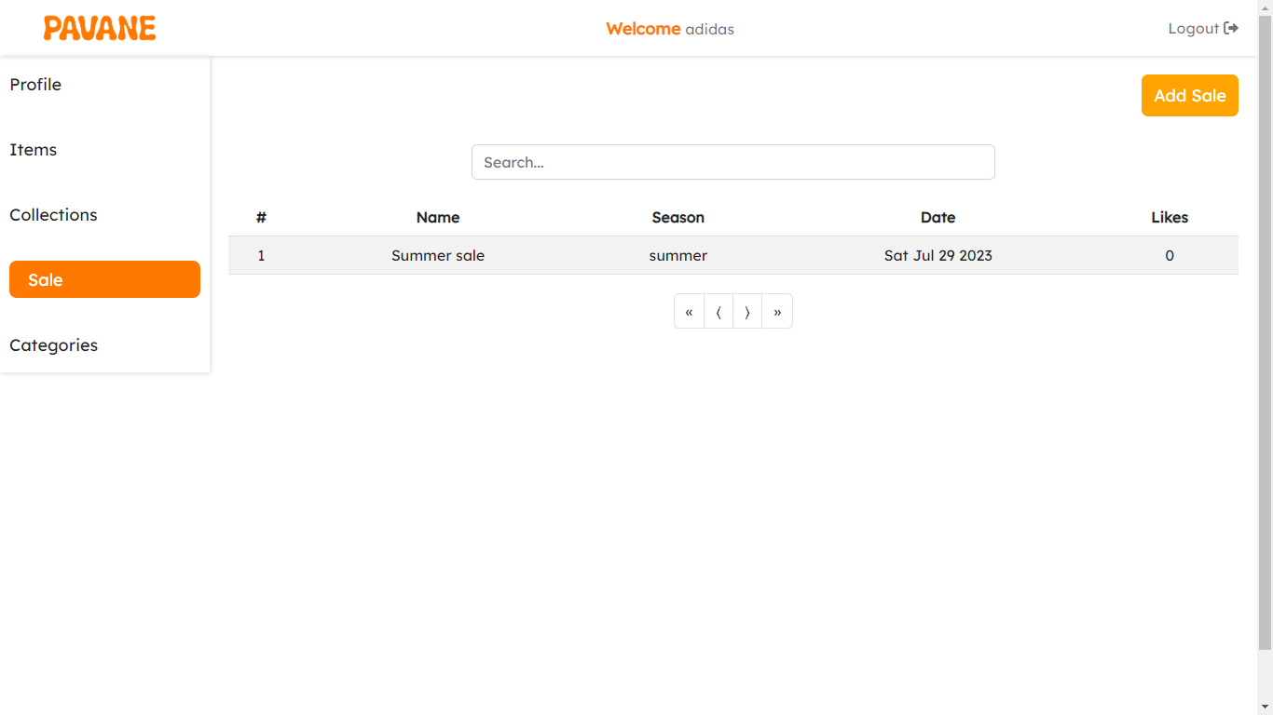

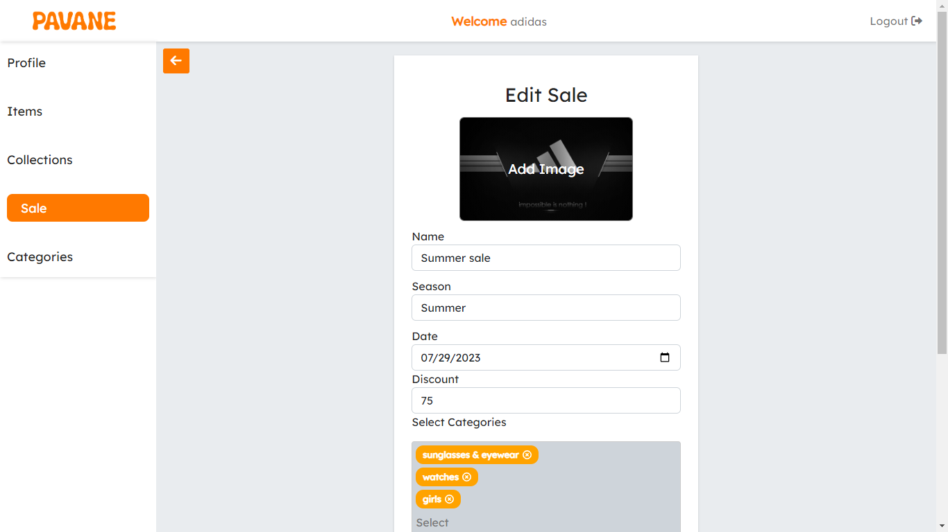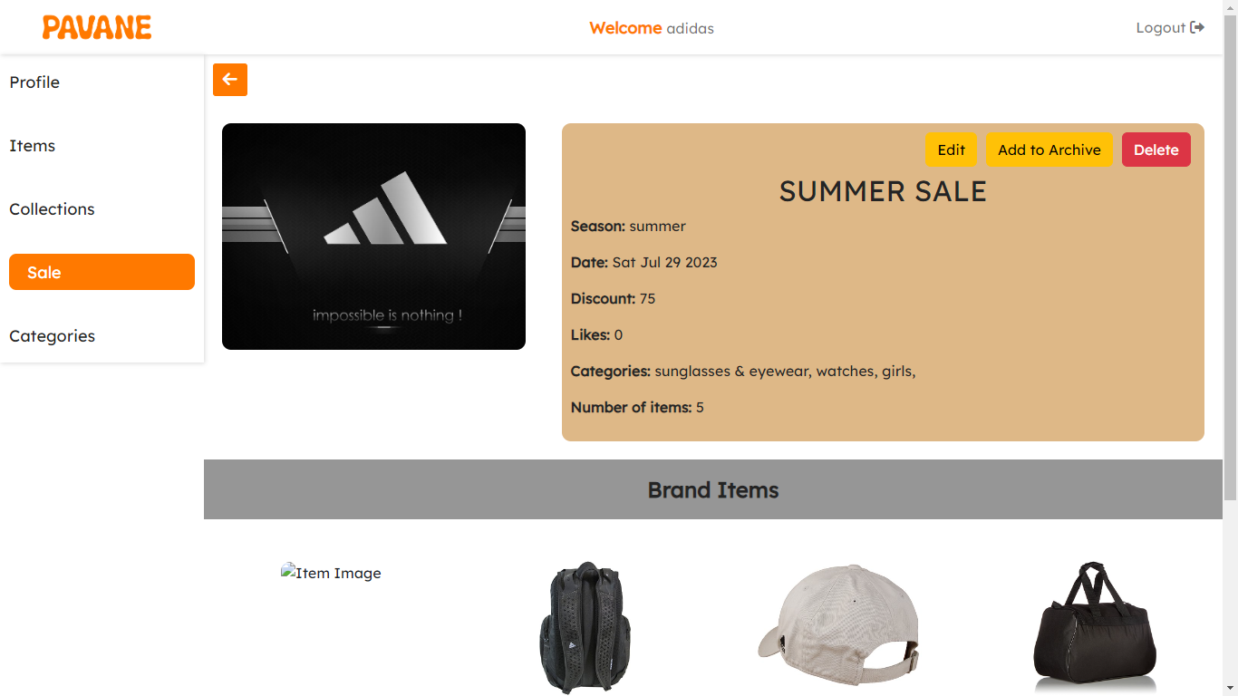

**Categories**

* List all categories in the system, and search for categories by name.
* Pagination to keep the performance and user experience up.

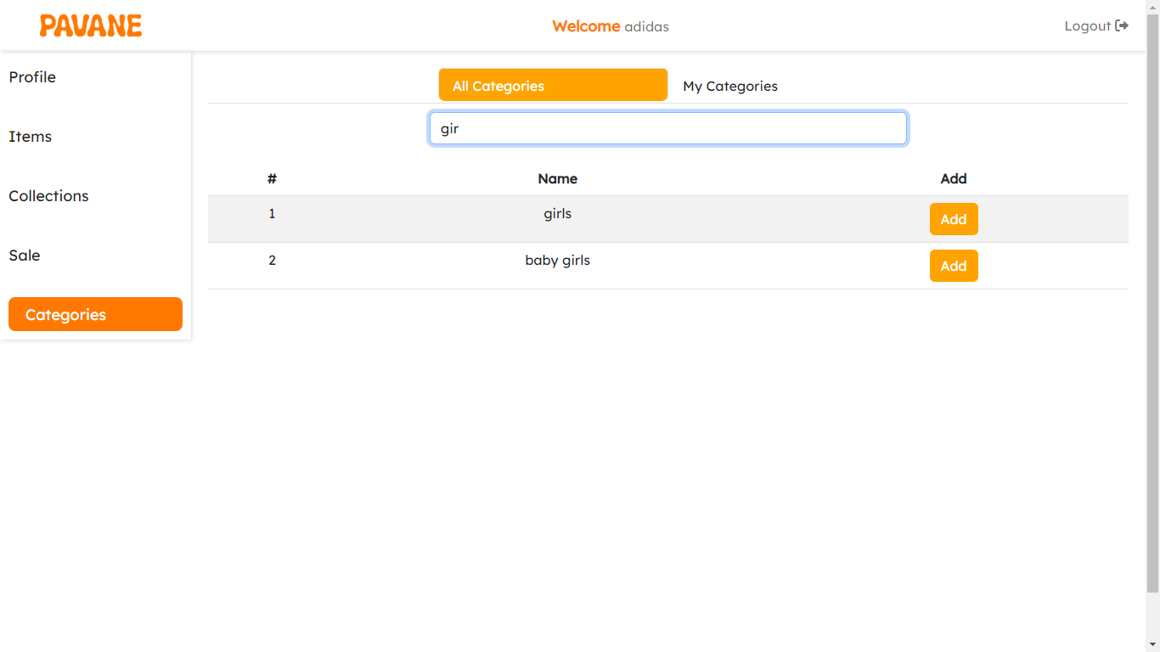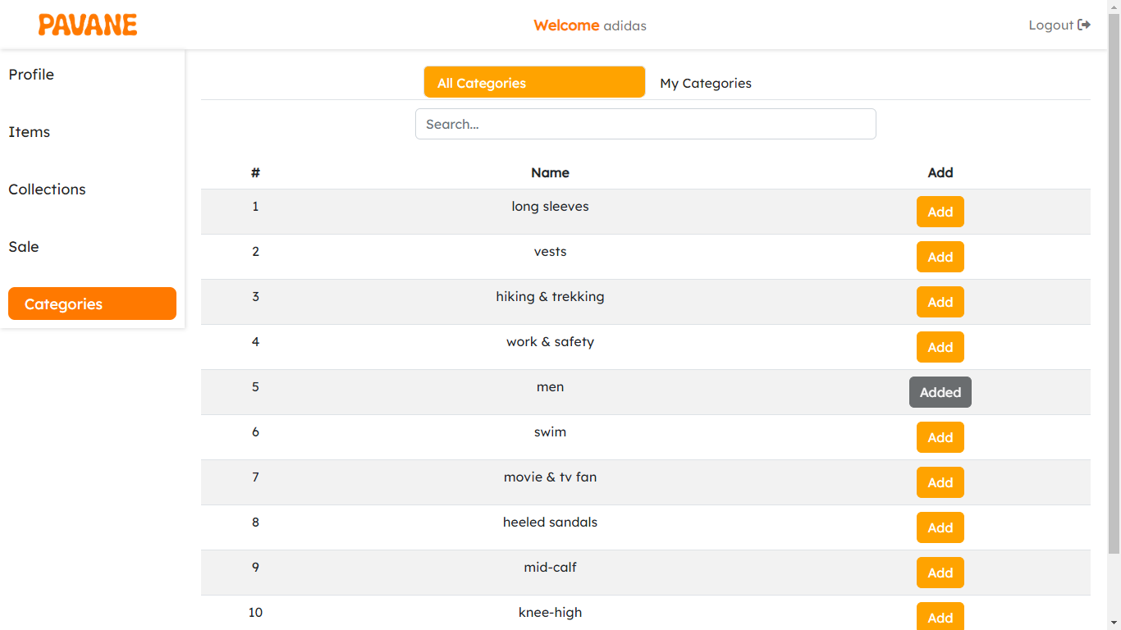

* You can add a new category to the system: add a name and add an image to the new category.
* Add and remove categories to and from your brand categories.

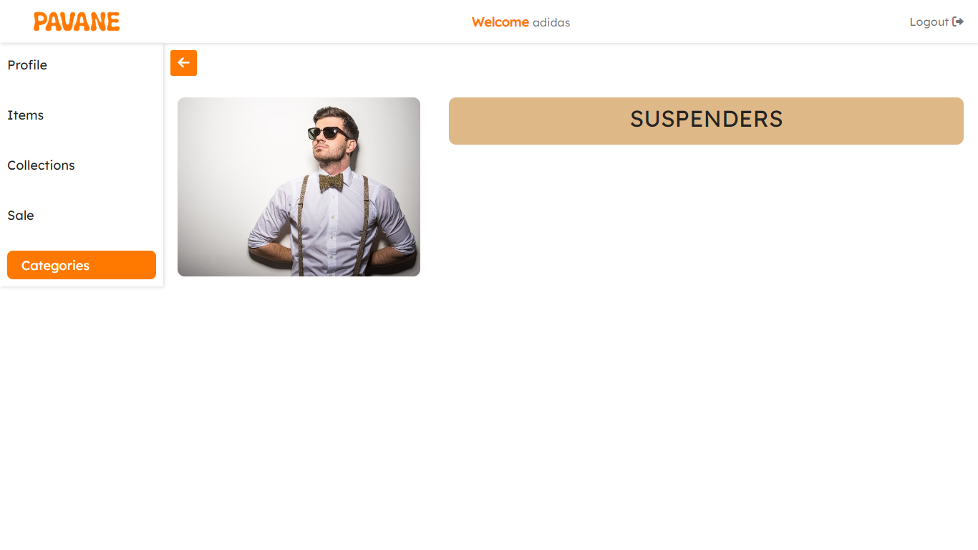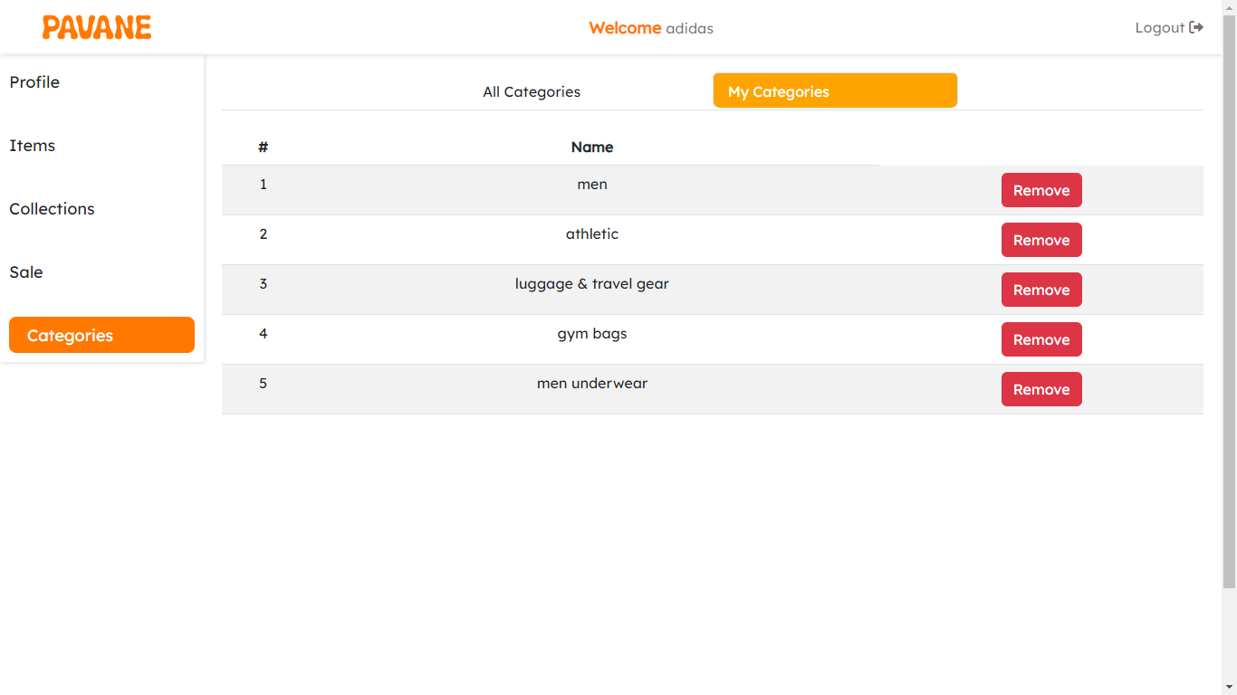

**5.4 Space for improvements**

As explained, Pavane dashboards are the main controller of the Pavane system. A brand owner can take control of all your brand, items, categories, collections, sales, and advertisements using the brand dashboard.

An administrator can take control of the system including brands, items, advertisements, and much more using the admin dashboard.

But some points of improvement can be worked on in the future:

Some common features and metrics that can be found in a brand dashboard include:

1. **Social Media Metrics:** Brand dashboards often integrate data from various social media platforms (such as Facebook, Twitter, Instagram, LinkedIn, etc.) to track metrics like follower growth, engagement rates, mentions, likes, shares, comments, and sentiment analysis of brand-related conversations.
2. **Website Analytics:** Brand dashboards may include website analytics data, such as traffic sources, page views, bounce rates, conversion rates, and other website performance metrics. This helps evaluate the effectiveness of online marketing efforts and user engagement on the brand's website.
3. **Brand Campaign Tracking:** Brand dashboards can track the performance of marketing campaigns, including metrics like impressions, click-through rates (CTRs), conversions, and return on investment (ROI). This allows brand managers to evaluate campaign effectiveness and optimize marketing strategies.

Dashboards provide a comprehensive and real-time view of a brand's online presence, reputation, and performance. They help brand managers and marketing teams gain insights, identify trends, and make informed decisions to strengthen brand positioning, improve customer engagement, and drive business growth.

**Part 6**

**Backend**

**6.1 Node.js**

A backend that serves as the backbone of an application, connecting all parts of the application, including the frontend and machine learning using the following points:

* **Authentication and Authorization:** This component manages user authentication and authorization processes. It includes user registration, login.
* Frontend **Integration:** The backend integrates with the frontend components, providing the necessary APIs and endpoints for the user interface to interact with it.
* **Business Logic:** The backend contains the core business logic of the application.
* **Data Storage and Management:** The backend interacts with databases or data storage systems to store and retrieve application data.
* **Machine Learning Integration:** send the recommendations data which generated by machine learning to customers in user interface.

In PAVANE we use variety of libraries such as bcrypt that encrypts users passwords to secure the users data from any attacks, Winston which is a full log system that helps in keeping track of all requests and saving them in a single file, json web token(jwt) which helps in encrypting user data and authenticate users when they do a request from the system.

When we started Pavane our schema design wasn’t clear, so we chose MongoDB.

Our machine learning was having a lot of changes on the schema which it might have a negative effect on the data we have and it’s normal to have changes in the data in the life cycle of the application, so it won’t be a good solution to let the brands reenter their data every time a change happens.

**6.2 Repository pattern**

The Repository Pattern is a common software design pattern used in backend development. It provides an abstraction layer between the application's business logic and the underlying data storage.

The Repository Pattern is a way to organize data access logic in an application. It defines an interface or contract for data operations (such as create, read, update, and delete) and provides an implementation that interacts with the underlying data storage, such as a database.

**Advantages of the Repository Pattern:**

* **Separation of Concerns:** The Repository Pattern separates the business logic from the details of data access. It encapsulates the logic for data retrieval, persistence, and querying, providing a clear separation between application code and data access code. This improves code organization, maintainability, and testability.
* **Code Reusability:** By defining a consistent interface for data operations, the Repository Pattern promotes code reusability. Different parts of the application can use the same repository interface, allowing for modular and reusable code across various components.
* **Data Abstraction:** The Repository Pattern provides an abstraction layer over the underlying data storage. It allows us to switch between different data storage implementations (such as MongoDB, SQL databases, or external APIs) without affecting the application's business logic. This flexibility makes it easier to adapt to changing requirements or future migrations.
* **Testability:** The Repository Pattern facilitates unit testing by allowing us to mock or substitute the repository implementations with test doubles. This enables isolated testing of business logic without relying on a real database, improving testability, and making the testing process more efficient.

One of the most powerful usages of Repository Pattern in PAVANE is that we have multiple queries with different filters on the same collection so by applying ‘‘don’t repeat yourself principle’’ this Repository Pattern will help us to use the same method for any search query on the same collection and also separating business model from the database communication.

**6.3 Backend system design**

System design plays a crucial role in the development of backend applications, including eCommerce systems. It involves creating an architectural blueprint that outlines the structure, components, and interactions of the system. Here's why system design is important:

**6.3.1 Use Case Diagram**

A use case diagram is a visual representation of the functional requirements of a system from the perspective of its users. It depicts the interactions between users (actors) and the system to achieve specific goals or tasks. Use case diagrams are important for the following reasons:

* **Requirement Understanding:** Use case diagrams help us understand the functional requirements of the eCommerce application and identify the various actors (such as customers, administrators) involved in the system.
* **Scope Definition:** Use case diagrams help define the boundaries and scope of the application by identifying the main use cases and user interactions. This ensures that we have a clear understanding of the system's intended functionality.
* **Communication and Collaboration:** Use case diagrams act as a visual communication tool that helps stakeholders, developers, and designers understand the system's behavior and functionality. They facilitate discussions and collaboration among team members, ensuring a shared understanding of the application's requirements.

1. **Actors:**

* **Customer**: The main actor who interacts with system.
* **Brand:** who adds the data of items and collections.
* **Admin:** who manages the system.

1. **use case:**

* **View Recommendations:** This use case allows customers to view the recommended items provided by the system.
* **Like Items & collections:** This use case allows customers to like the items which they want and that help to make recommendations very specific for him.
* 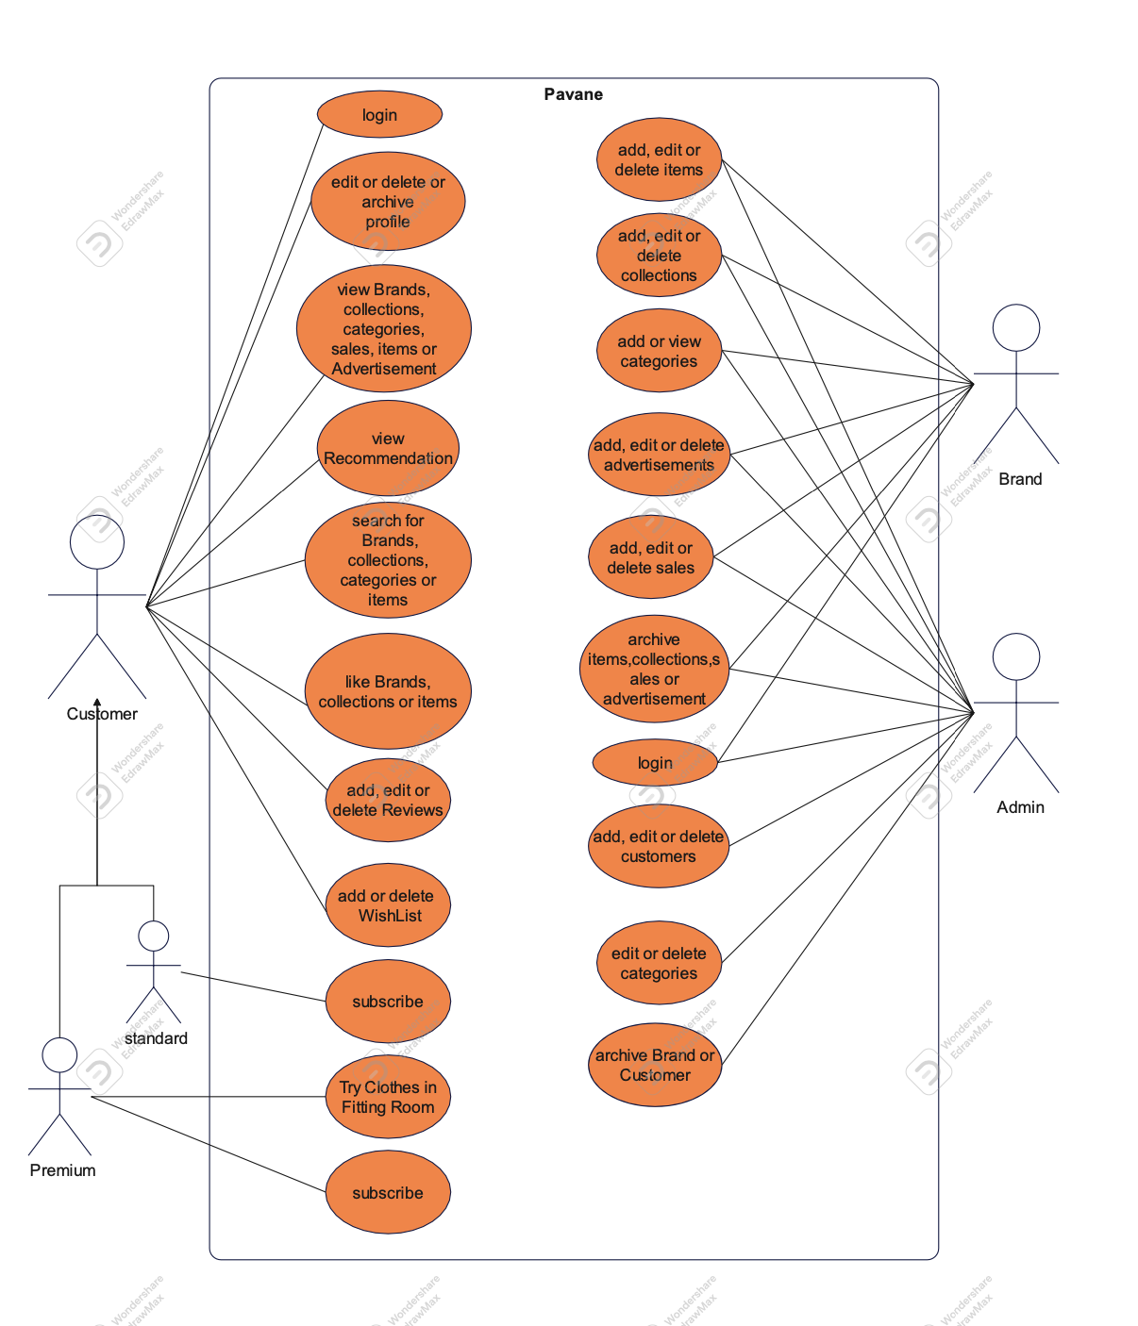**Subscribe to be premium:** This use case allows customers to change their account from standard to premium and could use fitting room.

**6.3.2 Class Diagram**

A class diagram is a visual representation of the classes, their relationships, and the attributes and methods they possess in an object-oriented system. Class diagrams are important for the following reasons:

* **Structural Overview:** Class diagrams provide an overview of the system's structure by illustrating the classes, their attributes, and the relationships between them. This helps in understanding the organization and interactions of different components within the eCommerce application.
* **Code Organization:** Class diagrams aid in organizing the codebase by providing a clear representation of the classes and their relationships. They assist developers in structuring their code and implementing the necessary business logic.
* **Identifying Abstractions:** Class diagrams help in identifying the appropriate abstractions and encapsulation of data and behavior. They assist in creating modular, reusable, and maintainable code by guiding developers in making design decisions.

**A class diagram includes the following components:**

* **Customer:** Represents a customer of the system. It may have attributes such as name, email, and liked items.
* **Brand:** Represents the provider of data for the system. It may have attributes such as image, category list and number of likes.
* **Item:** Represents an item that can be recommended or viewed by a customer. It may have attributes such as name, price, and category list.
* **Review Items:** Represents the rating and comment given by a customer to an item. It may have attributes such as customer ID, item ID, and rating value.

**The relationships between these classes:**

* Customer has a one-to-many relationship with Reviewing items, that a user can give reviews to multiple items.
* Item has a one-to-many relationship with Reviewing items, that an item can receive reviews from multiple users.
* Brand has a one-to-many relationship with items, that a brand can add multiple items.

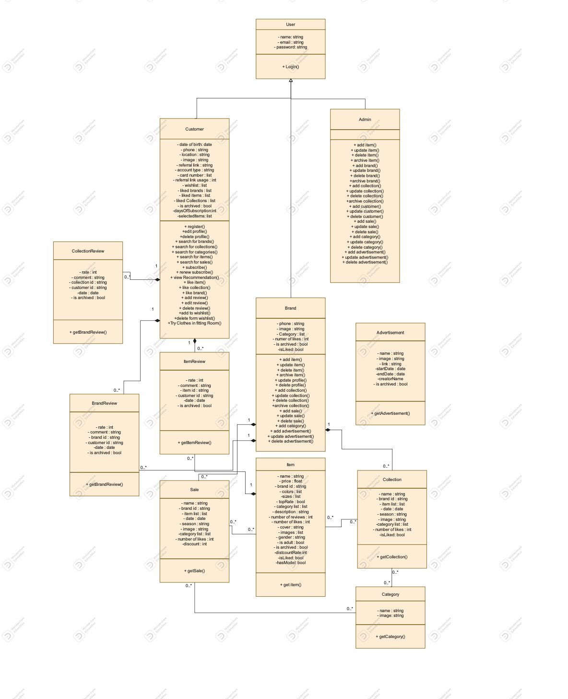

**6.3.3 Sequence Diagram**

A sequence diagram visualizes the interactions between objects in a specific scenario or use case. It represents the order of method invocations and the flow of messages between objects. Sequence diagrams are important for the following reasons:

* **Behavioral Visualization:** Sequence diagrams help in visualizing and understanding the dynamic behavior of the system. They depict how different objects collaborate to achieve a specific functionality, allowing us to identify potential issues, bottlenecks, or missing interactions.
* **Communication and Collaboration:** Sequence diagrams serve as a communication tool between stakeholders, developers, and designers. They provide a common language to discuss and refine the interactions and flows within the eCommerce application.
* **Verification and Validation:** Sequence diagrams aid in verifying and validating the design and logic of the system.

By visualizing the sequence of interactions, we can analyze the expected behavior and ensure that the system meets the desired requirements.

* Sequence helped us before writing the code to have full imagination of the flaw.
* In Pavane we have complex API similar to delete brand and sequence helped us in knowing what we should do and their order of actions. In this Api we start with using batch processing because mongo dB don’t support Data consistency enforce. We add brand Id in the batch and then remove it from the collection. When the time of batch processing come it is start remove items , collections and sales which related to this brand.

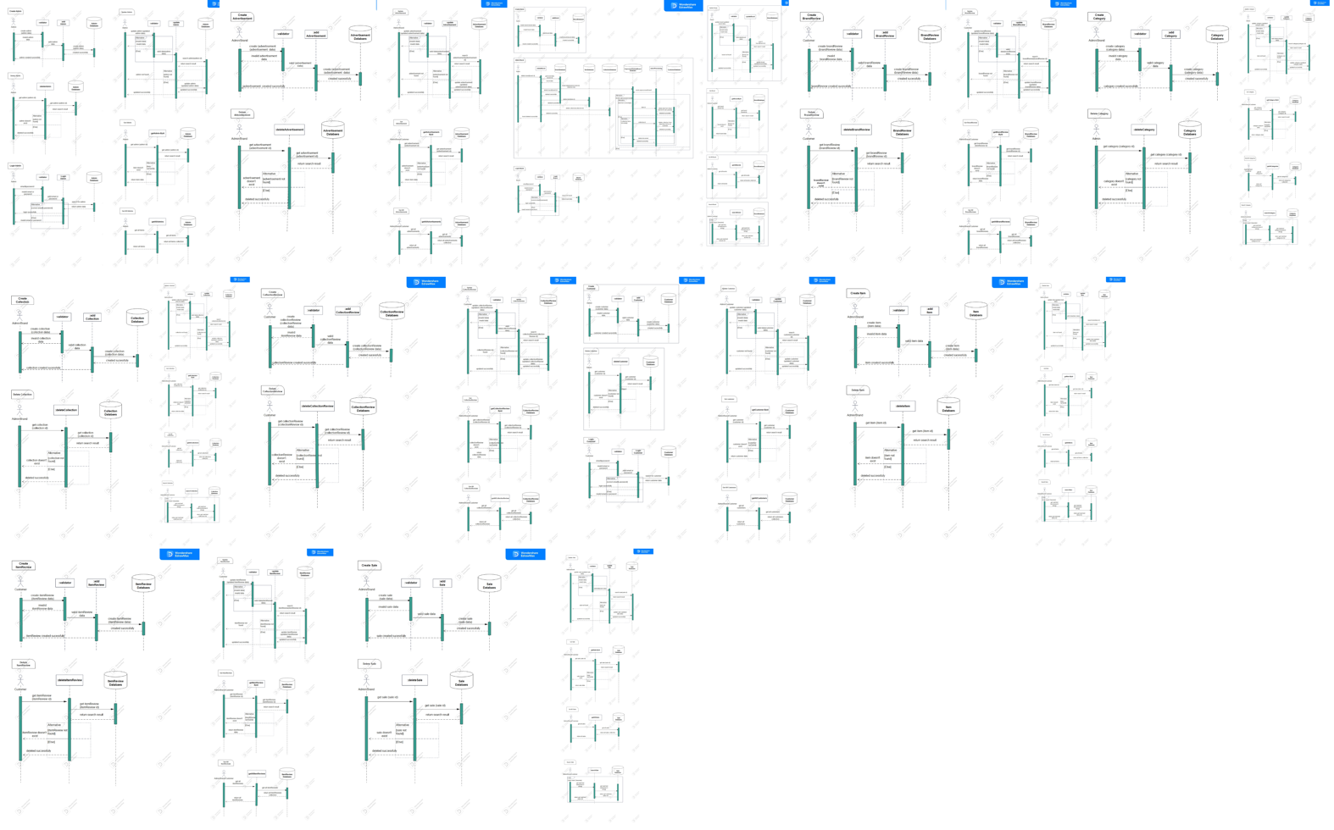

**6.3.4 Database Schema**

A database schema defines the structure, relationships, and constraints of the database tables and entities. It plays a vital role in backend applications.

* **Data Organization:** The database schema defines how data is structured and organized within the system. It ensures optimal storage of information related to items, customers, brands, and other entities in our application.
* **speed of retrieving data:** it’s Important for us in Pavane that our customers should surf in the app with high speed so we must a high performance.
* **Don’t repeat data:** in pavane we have expected that it will have a large amount of data so we use referencing to prevent repeating of data for example the data of brand inside item.

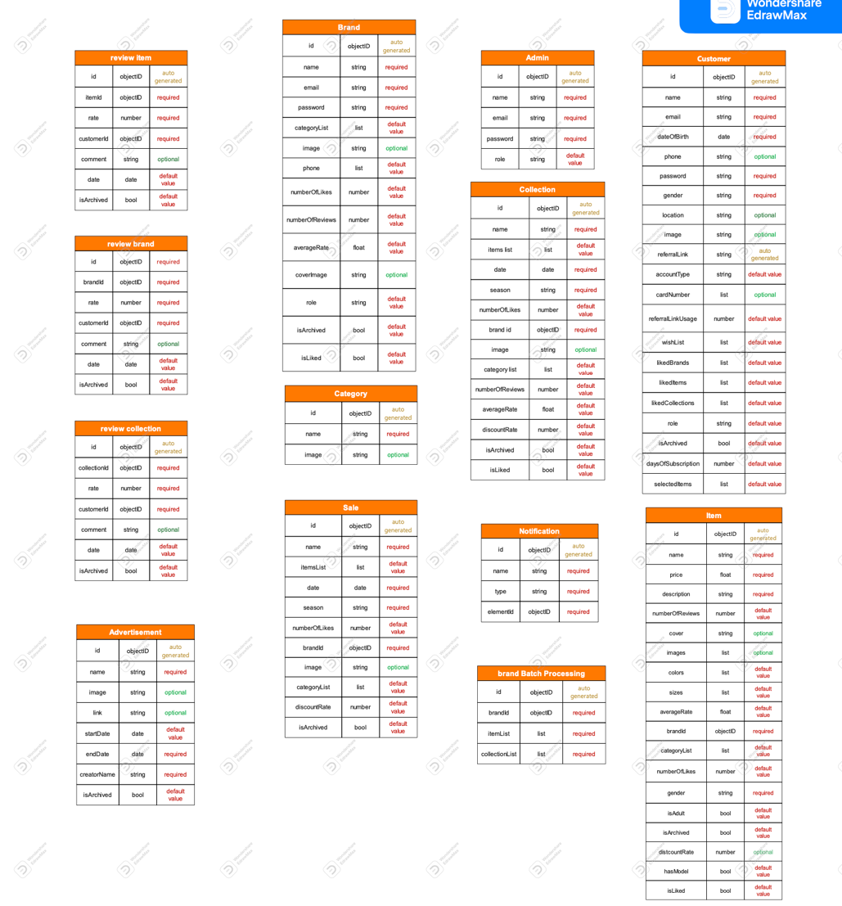

**6.4 API contract and API documentation**

In backend and frontend communication, API contracts and documentation play a crucial role. Here's why they are important:

**6.4.1 API Contract**

An API contract defines the agreed-upon format, structure, and behavior of the API endpoints. It specifies the request and response payloads, HTTP methods, parameters, and error handling. The importance of an API contract includes:

* **Interoperability:** The API contract ensures interoperability between the backend and frontend teams. It provides a clear understanding of how the API should be consumed and what data should be exchanged, ensuring smooth integration and collaboration between the teams.
* **Versioning and Stability:** An API contract allows for versioning and maintaining backward compatibility. It helps to define clear boundaries and expectations, ensuring that changes in the API don't break existing client applications. This promotes stability and avoids disruptive changes.
* **Testing and Validation:** The API contract serves as a reference for testing and validation. It allows both backend and frontend teams to verify that the API implementation aligns with the agreed-upon contract, ensuring consistent behavior and adherence to specifications.

In pavane we had a meeting between our Mobile application developer, frontend developer and the backend developer we discussed the main points of the integration between the frontend and backend in the API including:

* Response format
* All APIs
* Type of filters (We use for searching for a specific item (response query/ response params) ), we decided to use response query except for any ID we’ll use response params

**6.4.2 API Documentation**

API documentation provides detailed information about the API endpoints, their functionalities, parameters, request/response formats, and error codes. The importance of API documentation includes:

* **Developer Experience:** API documentation improves the developer experience by providing clear instructions on how to interact with the API. It helps developers understand the available endpoints, their usage, and the expected responses, reducing the learning curve and accelerating development.
* **Integration and Collaboration:** API documentation facilitates integration between the backend and frontend teams. It serves as a reference for frontend developers to understand the data structures, request formats, and response formats, enabling them to consume the API efficiently and effectively.
* **Third-Party Integration:** API documentation also supports third-party integration by providing the necessary information for external developers to interact with the API. Well-documented APIs attract developers and encourage them to integrate our eCommerce application with their platforms or services.

After API contract meeting of Pavane, we started documenting the API after having our meeting using Postman and we gave our frontend developer and mobile developer our documentation so that they work in parrel, so we speed up the development phase.

**6.5 Improvements**

We have some improvement which we can add them in the future:

* We can make item list in collection and sale embedding instead of referencing that will improve the performance of retrieve data.
* By looking at the previous point we can also make liked items, liked brands, liked collection and Wishlist embedding.
* In item data we can replace the brand Id with object of some data which using a lot of time like (brand id, name, image).
* Logger which provide machine learning with data of user interaction.

**Part 7**

**Fitting Room**

This section presents the requirements and specifications for the Fitting Room in the Pavane Project. The Fitting Room is a crucial component of the clothing platform, allowing clients to virtually try on outfits through mobile and web applications in a 3D environment. This section outlines the features and functionalities available to both Freemium and Premium users, including access to the fitting room, trying on items, managing outfits, receiving recommendations, and engaging with the platform. These requirements aim to provide an intuitive and seamless experience, enhancing users' shopping journey on the Pavane platform.

The Fitting Room plays a fundamental role in the Pavane Project, a clothing platform designed to transform the way users interact with fashion. This section outlines the specific requirements and specifications for the Fitting Room, focusing on its functionality and features for both Freemium and Premium users. By offering an immersive and personalized virtual try-on experience, the Fitting Room aims to increase user engagement and facilitate confident purchasing decisions. Subsequent sections delve into detailed functional and non-functional requirements, as well as design and implementation constraints that govern the development and deployment of this essential feature. By adhering to these specifications, the Fitting Room empowers users to explore a wide range of outfits and seamlessly visualize their style preferences, revolutionizing their online shopping experience on the Pavane platform.

**7.1 Clothing & avatars 3D models generation**

The Fitting Room comprises two main parts:

1. **3D Avatars:**

We have developed fixed 3D avatars representing different body types (thin, normal, and fat).

1. **3D Clothes martial:**

To enable users to try on various outfits, we generate 3D models of the clothes within a virtual environment. We also create different sizes for each item. All 3D modeling work is carried out using Blender.

**7.2 User interface**

The user interface of the Fitting Room is built using the Unity Engine, which provides a 3D environment. Upon entering the app, clients encounter the 3D avatar and a list of clothes to choose from and try on the avatar. Users can switch between different avatars to select the body type that best represents them and click on any item in the list to see it on the avatar. They can also see how different sizes of the same item are fitted on the avatar.

**7.3 Backend**

The Fitting Room consumes APIs from the PAVNE Node.js server, which, in turn, accesses the relevant data stored in the MongoDB database. The fitting room also consumes the recommendations created by the recommendation engine which is again injected into the MongoDB data store for every part of the system to use it.

**7.4 Clients privileges**

Although not yet available, here is how we plan to model our profit model.

* **Freemium Plan:**
* Limited access to the fitting room (3 times).
* Trying selected items only.
* Selecting an appropriate avatar from templates.
* **Premium Plan:**
* Unlimited access to the fitting room.
* Trying selected items.
* Selecting an appropriate avatar from templates
* Accessing and filtering outfits from preselected items
* Managing the outfit list (like, dislike, add, remove)
* Accessing recommended items and outfits
* Creating and sharing custom outfits
* Setting outfits to public or private
* Customizing and saving outfits

**7.5 Functional requirements**

In order to best describe the system, we have gathered a list of functional user requirements as follows:

* + 1. **Accessing the fitting room**
    - User authentication and authorization.
    - Handling freemium and premium plans.
    - Redirecting users to the subscription screen if necessary.
    1. **Trying on items.**
    - Accessing selected items and body type.
    - Loading default configurations if no configuration is stored.
    - Dressing the avatar to fit the selected item.
    1. **Managing outfits.**
    - Creating custom outfits and saving them.
    - Editing, saving, and overriding outfits in the user's list.
    - Accessing outfits grouped by brands or other users, and saving them.
    - Generating share links for custom outfits recommendations.
    1. **Recommendations.**
    - Accessing recommendations for items and outfits.
    - Adding recommended items and outfits to the user's outfit list.
    - Allowing users to like items or outfits
  1. **Non-Functional requirements**

**7.6.1 Security**:

Private data should be secured and be accessible only for authenticated and authorized user. Private data include (avatar, private outfits).

* + 1. **Portability**:

The fitting room should work properly for web and mobile users for the following operating systems:

- Android 9 or later.

- iOS 8 or later.

- Google Chrome, Edge, Firefox, Opera and Safari Browsers.

- Should adapt to all screen sizes.

* + 1. **Reliability:**

Mean time between failure (MTBF) = 5 minutes.

* + 1. **Availability:**

System should be available 99.9% in the year.

* + 1. **Usability:**

System should be easily used by any user without training or tutorials, any action should be with the least number of clicks and the minimum number of screens.

**7.7 Diagrams**

Below Are some diagrams further detailing the structure and Architecture of the fitting room and how data flows in the system.

**7.7.1 Use case diagram**

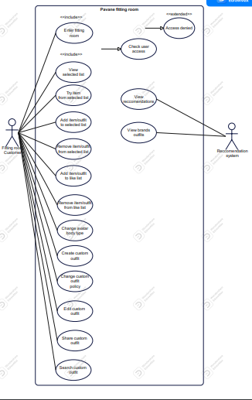

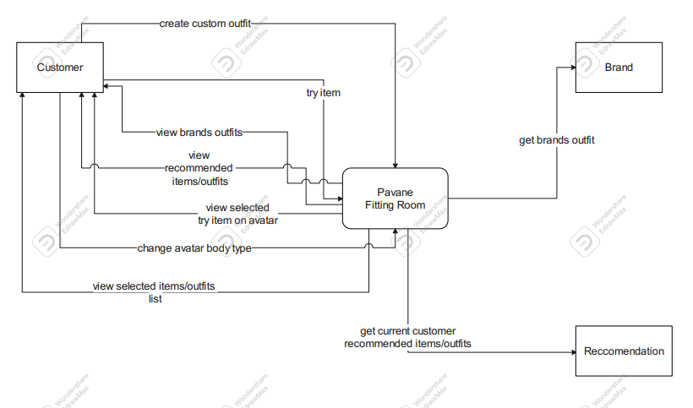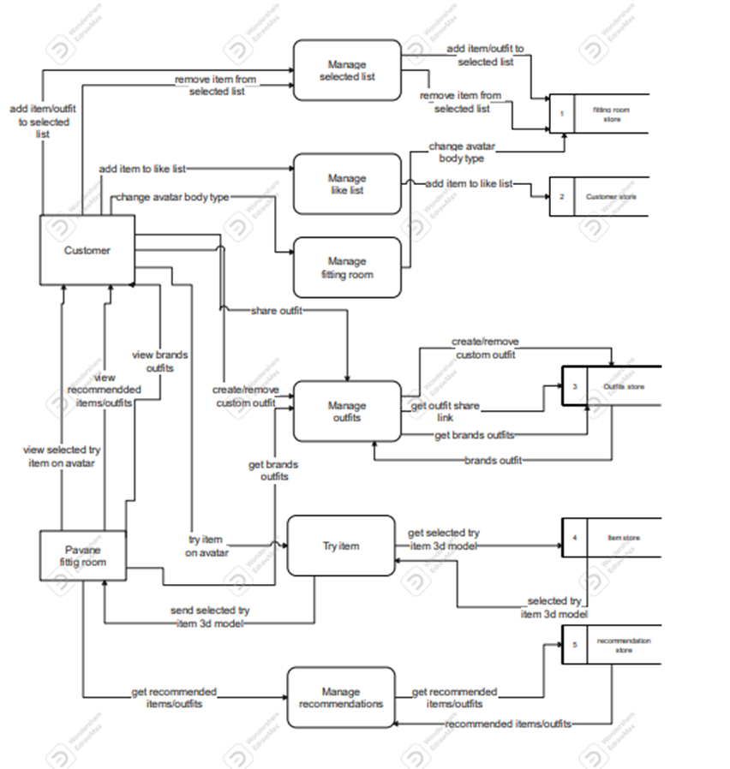**7.9.2 Dataflow diagram level 0 & 1**

**Part 8**

**Recommender System**

One of the ways to analyze how Pavane performs is to analyze the user consumption rate, the higher the consumption the better. Pavane focuses on showcasing the items rather than online shopping, so it is very important that the user keeps viewing items. A Recommender System that selects a group of items that are best suited for the user’s preferences increases the consumption rate of the user, because an item that he probably likes triggers him more to view it, rather than a random item.

**8.1 Data**

Data is a vital part of building a Machine Learning solution, A lot of effort and time has been put into gathering well-suited data for the task, which is Amazon Reviews Data.

**8.1.1 Data Source:**

Amazon Reviews Data [1] is a dataset collected from Amazon Products reviews. The reviews include features like product id, reviewer name and id, rating, review’s comment and date of the review. This dataset also includes the products’ metadata (ex: name, description, brand, etc.)

The Amazon Reviews Data includes reviews for a variety of Products categories, for example, Electronics, Books, Toys and Games, Software, etc. The Clothing, Shoes and Jewlery subset has been chosen as the dataset for Pavane. This subset originally included 32,292,099 reviews for 2,685,059 items dating from 1999 to 2018. A subset of 881,248 reviews for 17,012 items from 333,376 users from 2015 to 2018 was taken to populate the Database and to be used as the dataset for training the Recommender System.

**8.1.2 Data Analysis and Cleaning**

At first the Analysis has been performed on a much lighter version of the dataset. The Ratings Only version of the dataset (only includes the items’ ids, the customer ids, review date and the rating)

As mentioned earlier, the reviews dated from 1999 to 2018, but as shown in figure 1, most of the Reviews range from 2013 to 2018. It was decided that the subset used will be from 2015 to 2018. This is for many reasons, firstly, using the full date range will result in a huge dataset size which hits the Database Storage Limitations (512mb). Secondly, the data drift would be very large if old data were to be used. This is simply because Clothing Styles change rapidly from one year to another. So, a 4-year subset seems to provide a good balance between using a large dataset and maintaining the quality of the data used in training, to avoid “Garbage in, Garbage out”.

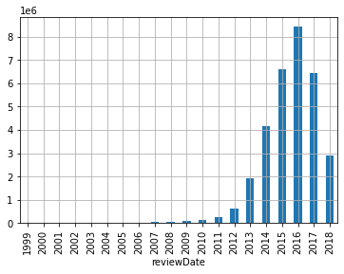

Figure 1: The Reviews dates ranging from 1999 to 2018,

demonstrating that the bulk of the Reviews starts from 2013

While investigating the Data, as demonstrated in Figure 2, it was noticed that most of the Ratings are 5 stars (around 60%), with a good portion of 4 stars ratings (around 17%) and the rest falls in the 3 stars and lower (around 23%). This Imbalance shows that users only care to rate an item if they only love it. This is not ideal for building a Recommender Engine, where it doesn’t necessarily indicate which items a user dislikes, yet it is still fine for indicating which items a user loves or likes. This information can be used to perform Collaborative Filtering and recommending for Users what they may like to view.

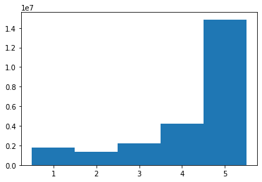

Figure 2: The ratings mostly are 5 stars.

As mentioned earlier, the data is too large to populate the database, so to reduce the dataset size, only items with more than 25 reviews are included. This increases the Confidence in the ratings of any item, where an item with a single 5 stars rating does not mean that the item is perfect. Also, to reduce the dataset size and increase the Confidence in the items’ ratings, any item which all its ratings are the same value (for example, 5 stars) must have at least 100 reviews. In the same way, any item with only two values ratings must have at least 50 reviews. This reduces the size of the data and increases the quality of the dataset.

Further Analysis has included the items’ metadata (Brand, description, categories, etc.). A set of 352 Brands has been selected. These Brands have the most items. Normal Data Cleaning has been done like removing duplicates and handling missing Data. Also, text features like items’ descriptions and items’ titles are formatted to remove unwanted characters.

As mentioned earlier, the Data is from Amazon. Amazon Customers view their products and buy them online. When it comes to clothes, it is tough to figure out if an item fits well or looks nice while buying online. But when it comes to shoes and accessories it is much easier, this can be seen in the data, as most of the items are shoes and accessories. On the opposite side, in pavane this is completely different, as users are meant to view as many items as possible, but they do not buy online. Ideally a different data distribution would fit Pavane more, but this dataset works fine.

**8.1.3 Feature Extraction:**

Two features have been extracted and have proven importance for improving the performance of the Recommender; these features are the creation date of the item and the Gender of both the user and the item. The item’s creation date was extracted from the reviews’ dates, where the date of the item is set to be slightly earlier than the date of first review for this specific item.

After cleaning the items’ categories, the item gender has been extracted from the categories. For example, if an item includes “men” category, then it is for males and the same goes for the “women” category. If an item’s categories include both or none then this item is said to be unisex. The items’ gender is used to extract the gender of users, where a user who reviewed mostly male items is a male and vice versa. This method works fine for most of the users, but has a small flaw, for example, if a woman keeps reviewing items that she has bought for her husband, then most of her reviews will be for male items thus she is considered a male. This does not affect the Recommender; in fact, it performs better because that woman would like to view more items for her husband.

Finally, before the Database is populated with the final dataset, final data preparation is done to make sure that the data follows the database design.

**8.2 Architecture Overview**

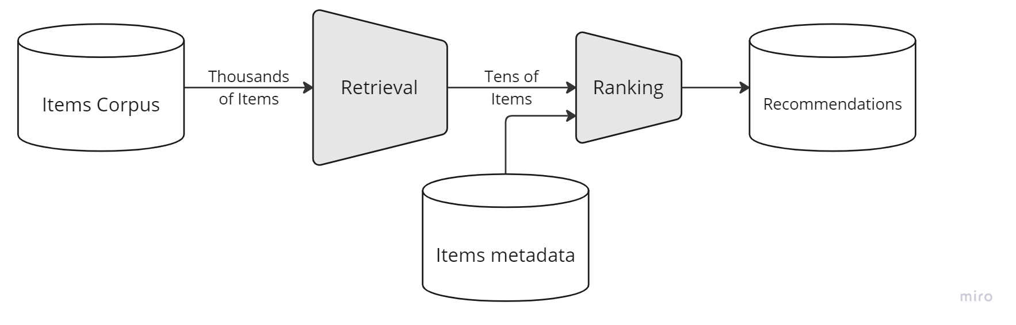

Figure 3: Two-stage Recommender System

demonstrating the narrowing of thousands of items to

tens then ranking them based on user preferences

As Figure 3 illustrates, the Recommender System is comprised of two Neural Networks, a Retrieval Network (Candidate Generation) and a Ranking Network. This two-stage architecture has been proven to perform greatly for Recommender Systems since Neural Networks were used in generating Recommendations. This Architecture is used in the largest projects like YouTube Recommender [4], eBay Recommender [5], etc...

Taking users’ reviews as inputs, the Retrieval Model retrieves a subset of items for each user that he would most probably interact with. So, this step's goal is to generate a set of tens of candidates from the available thousands of items in the Database. These candidates are intended to be generally relevant to the user, with high precision. The Retrieval Stage is intended to be general and broad, relying on Collaborative Filtering to generate a set of candidates quickly, with considering finer details.

The second stage aims to rank these generated candidates and arrange them based on their ranking score. The Ranking model considers finer details and features describing the user and the item in order to distinguish relative importance among candidates with high recall.

This two-stage Architecture allows for quick retrieval of items among thousands (theoretically, works fine also for millions of items) while being certain that these items are personalized to each user, thus contributing to a higher consumption rate.

**8.2.1 Retrieval**

As discussed earlier, the Retrieval Model aims to generate a set of Candidates from a large corpus of items. The Retrieval Model is a two-tower that computes embeddings for both the items and users at the same time. This two-tower architecture is discussed in the work of Covington et al. [4] and Wang et al. [5], discussing the Architectures of YouTube Recommender and eBay Recommender respectively.

**8.2.1.1 Label and Metrics**

For Candidate Generation the label is the positive interaction between a user and an item. Where each review is a positive pair between a user and an item. While most recommender systems use implicit feedback (click-through, views, etc.), these implicit feedbacks are not available in the data. So, the explicit interactions (reviews) are used as the label for the Retrieval Model.

Since the Candidate Generation expects only positive user-item pairs, reviews with 1- and 2-stars ratings are removed from the training set, because they are negative interactions. This has proven improvement in the performance of the Retrieval Model.

The Retrieval Task is a posed as an extreme multiclass classification, where the prediction problem becomes accurately classifying an item for a specific user query. The loss function used during training the Categorical Crossentropy, a loss function built-in Tensorflow.keras used for multiclass classification.

Finally, the performance metric used is the FactorizedTopK accuracy. It is a performance metric used in TensorFlow Recommenders(tfrs) used for evaluating the performance of Retrieval Models. This metric evaluates how well the model can identify the top K items that the user is most likely to be interested in based on interactions. This is done by comparing the model output for a certain query (user) against the ground truth, where the ground truth if a user likes that item the value of this pair is 1 and 0 if not. Then the precision among the Top K recommendations is calculated. This is illustrated in Figure [4] where:

* R: The relevance matrix of shape (batch size, number of items), where each row represents a query (user), and each column represents an item. R is a binary matrix, with 1 indicating relevance (positive pair) and 0 indicating irrelevance.
* F: The item factors matrix of shape (number of items, embedding dimension), where embedding dimension is the dimension of the items’ embeddings.



Figure [4]: Demonstrating how the FactorizedTopK Metric is calculated

The FactorizedTopK metric is only calculated during evaluation because it is extremely computationally expensive and would be wasting training time to calculate this metric each training step.

**8.2.1.2 Architecture**

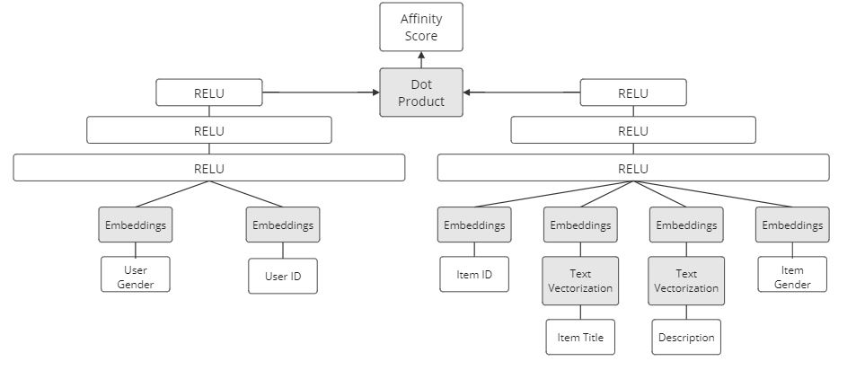

Figure [5]: Two-tower Retrieval Model Architecture.

As illustrated in figure [5], the Retrieval Model Architecture consists of two towers, the Query Tower (the users embeddings) and the Candidate Tower (the items embeddings). Removing the dense layers of both towers and only leaving the user and item ids corresponds exactly to the classic Matrix Factorization approach. Neural networks can model context features and combine them in a non-linear fashion (non-linear generalization of matrix factorization), which improves performance.

**8.2.1.2.1 Candidate Tower**

One of the main problems that Recommender Systems face is the sparsity of the data, where each user only interacts with a small number of items from the thousands available. This introduces a problem to train a Neural Network and accomplish high accuracy.

Another problem that Recommenders face is the “cold start” problem. The “cold start” problem is when a new item is introduced to the system but still users have not interacted with. This makes it nearly impossible to use Collaborative Filtering to recommend these new items to users.

Both problems are solved using Content-based Embeddings. Simply adding the embeddings of content features like the item’s title, description and categories makes the model more “aware” of the item and its features. So completely new items can be recommended to users based on their features even if there are no interactions recorded. Also, as mentioned in the work of Wang et al. [5] discussing how eBay Recommender is designed, using content features increases the performance even in extreme data sparsity cases.

The item’s title and description are both text features that need to be processed using Natural Language Processing techniques. Before these features are computed into embeddings, they first path through a Text Vectorization step that maps text to an integer sequence.

Finally, the embeddings are concatenated and feedforward through a 3-layers neural network, all with Rectified Linear Unit (ReLU) Activation Function.

**8.2.1.2.2 Query Tower**

The query tower is based on the same network idea. The users’ embeddings are generated then passed through a 3-layers neural network, all with Rectified Linear Unit (ReLU) Activation Function.

Most Retrieval Models include user specific features like the user’s demographics, age, etc. Unfortunately, for privacy reasons, the Amazon reviews data set lacks any user’s information. If such features were included in the data, they would probably increase the performance of the model, especially for new users.

Another lacking part in the data is the users’ sessions logs. Most Retrieval Models implement a session-based Query tower, where the Query tower includes embeddings for user activities (like clicks and searches). The embeddings outputs are then passed through a GRU layer before the dense layers, to help the model learn the behaviors of users based on the sequence of the logs.

**8.2.1.3 Experimentations and Training**

At the first stages of the project, a lot of achitectures has been experimented with. Starting with a simple Matrix Factorization method going to neural networks and using embeddings which was similar to the Matrix Factorization. Building a deeper network result in a slight improvement in performance. Many experiments have been done until the Two-tower Architecture was reached which improved performance. Relying on Hyperparameter Tuning using TensorBoard and Hparams, the architecture has been improved slightly. As illustrated in figure [6], going with a higher number of layers for each Tower, a lower embedding dimension and higher maximum number of neurons resulted in lowering the loss (please notice that this is an early stage, and the error is quite high)

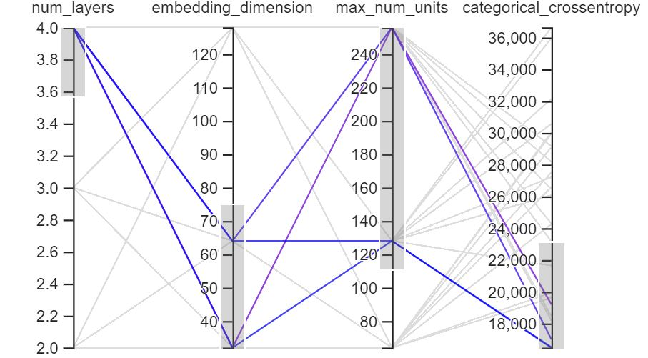

Figure [6]: Retrieval Model Hyperparameter Tuning using TensorBoard and Hparams

Adding the item Description and title is the magic step because it improves the model’s performance dramatically, going from an error above 18,000 error is reduced under the 1000. This proves that the sparsity is very high and context features are key in building a Recommender System with such data.

Also, the reviews are not shuffled during training, in fact, they are ordered by their date. This is because styles and trends change from time to time, so it is important to not allow the model to predict items from the past after training on relatively newer data. In fact, recommending can be treated as a Time Series Prediction of some sort. This is obvious when the task becomes recommending an item for a specific user at a given time t.

**8.2.2 Ranking**

The second stage in the Recommender is the Ranking Model. The Ranking stage takes the outputs of the retrieval model and fine-tunes them to select the best possible handful of recommendations. Its task is to narrow down the set of items the user may be interested into a shortlist of likely candidates. The Ranking Model also implements the two-tower architecture, but it includes more features to allow the model to fine tune the recommendations.

**8.2.2.1 Label and Metrics**

Since the reviews are used to train the Recommender, the rating is used as the label. As mentioned in the Data section, a 5-stars rating system is used to rate the items. This allows for the use of mean squared error as the loss function and root mean squared error as the performance metric.

The root mean squared error is not used as the loss function because it would be computationally expensive to calculate the root every step.

**8.2.2.2 Architecture (Deep and Cross Network)**

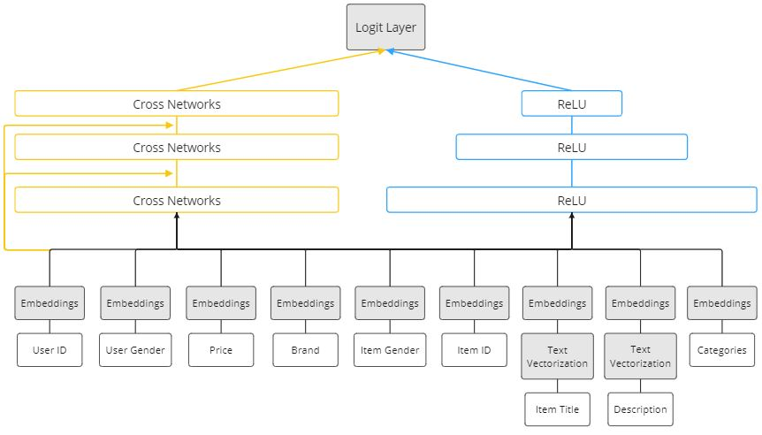

Figure [7]: Ranking Model using the Cross and Deep Networks.

Although the Ranking Model can be built using the two-tower architecture (where a network is built for handling queries and another for candidates and the outputs are concatenated and feedforward through the logit layer), the Cross and Deep Network [2, 6] is far more superior, even performing better than the previous Wide and Deep Network [3].

This architecture consists of three parts, the Embedding and Stacking Layer, the Deep Network and the Cross Network. As earlier mentioned, the Ranking Model uses far more features to fine-tune the recommendations. Text features are vectorized then embedded in the same fashion as the Retrieval Model. Categorical features and ids are only embedded. Numerical features are normalized. All these features form the Embedding and Stacking Layer, a layer where all features are processed and ready to be feedforward through the two networks.

The second part is the Deep Network, which is a normal deep neural network. The network starts wide then narrows down gradually, with dropout layers after each dense layer.

*xi+1 = x0 xiT wi + bi + xi*

Figure [8]: Cross Network equation, where the output of (i+1)

equals the inputs to the cross layer (x0) crossed with the

output of layer (i) transposed crossed with the (wi) weights

Added to the (bi) bias and (xi).

One of the behaviors of any Deep Neural Networks is the features combination that occurs at each neuron. This behavior, to an extent, can be seen as automatic Feature engineering done by the Network, especially in the first set of layers. Feature engineering has been proven to improve performance in large-scale recommender systems where there is extreme data sparsity. The main idea of the Cross Network is to amplify this behavior. The Cross Network has been introduced in the work of Wang et al [2] and later an improved version has been published [6]. As illustrated in figures [7, 8], at each layer of the cross networks the output of the previous layer is crossed with the input features (X0). This results in a high degree of interactions between features. TFRS provides a convenient way to integrate this Cross Layer, by simply instantiating an instant of the “dcn.Cross” Class.

Finally, the outputs of both networks are concatenated and feedforward through a single neuron layer where given the user and item it outputs the predicted rating.

**8.2.2.3 Experimentations**

Similar to the Retrieval Model, the training data is ordered by review date. At first a two-tower model was the ranking model with a 1 neuron layer as the output for predicting the ratings given a user and an item. This model performs badly, where the RMSE was more than 1.1. Considering a 5-star rating system, a 1.1 error is quite high.

Further experiments with the architecture have yielded better results, especially when using the cross network. It also outperforms the wide and deep network. Relying on Hyperparameter Tuning, it is obvious that a lower embedding dimension, applying projection and not stacking the Deep Network on top of the Cross networks yields better results. Similar to the Retrieval Model, using a 3 to 4 layers with layers size going from 256 and narrowing downs works great.

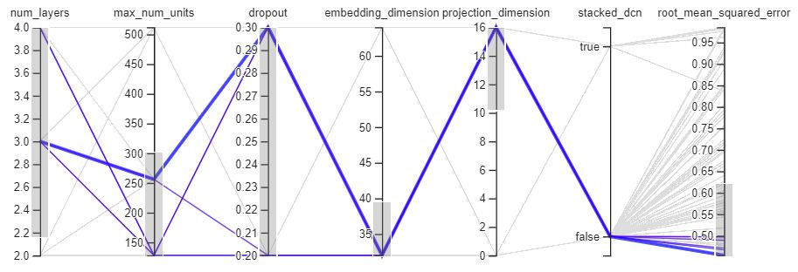

Figure [9]: Ranking Model Hyperparameter Tuning using TensorBoard and Hparams

The displayed results have been reached without using many of the context features, when adding more features, the RMSE goes lower than 0.35. Also, a lot of different methods of preprocessing were used to try to improve the performance. Generally, any text feature is vectorized before the embedding layer, categorical features are embedded directly not encoded and numerical features are normalized.

**8.3 Deployment**

In Pavane, recommendations are batch processed, where new recommendations are sent to users every week. This flow, as illustrated in figure [10], requires a schedule that starts a training cycle at the start of every week using reviews from the previous week. After the short training cycle is completed the Recommender Engine makes recommendations for all users. Finally, the recommendations are stored in a separate mongodb database.

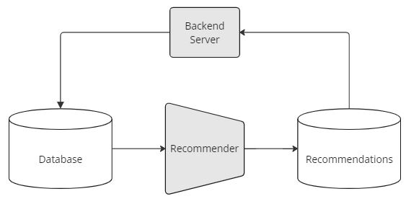

Figure [10]: weekly run training on new instances

And recommending new items for users

As mentioned earlier, the Recommender System is composed of a two-stage architecture. To efficiently run training and prediction cycles using these two models, the server resources are parallelized between these two models. Another approach was considered, where the two models would be deployed on two separate servers. The problem with this approach is that it would be over engineering the solution. This is because a data pipeline would be needed to transfer data from the Retrieval Server to the Ranking Server. This makes sense in extremely large systems where there are millions and millions of candidates and when recommendations need to be processed in real time. Obviously, the Machine Learning Server does not include any APIs, it simply runs by the scheduler.

**8.4 Pipeline**

In a market where new items are available every month and trends and styles change rapidly; it is important to maintain a means of Continuous Integration/ Continuous Delivery (CI/CD). Although the Recommender System uses Active Learning to learn from new data and maintain nearly the same performance, on the long run this may be a challenge and the need to build new Models will arise. Improvements in the field of Machine Learning and Data Drifts require deploying new Models. This continuous need can be met through building a Machine Learning Pipeline.

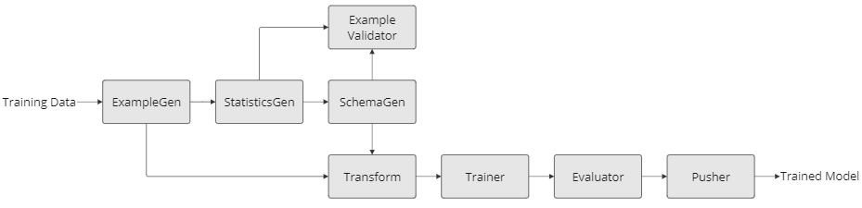Figure [11]: Illustrates the architecture of the ML Pipeline

A ML pipeline is a group of components that work sequentially (most of the time). The main task of a pipeline is to output a trained model given data and the Model code modules. As illustrated in Figure [11] the pipeline is composed of a set of components (stages) where components communicate using Artifacts (the output of a pipeline component is called Artifact). TensorFlow Extended is used to build the pipeline, which offers a wide range of libraries within the TensorFlow ecosystem while being orchestrated by Apache Beam.

The Pipeline starts by loading the data using the ExampleGen. The ExampleGen main task is to load data from the specified source, split and batch the data. Simply its task is to keep the feed of data whenever needed. Statistics can be derived from the data using the StatisticsGen. Given the output artifact of the ExampleGen, the StatisticsGen can perform an extensive statistical analysis in the data, for example calculating the mean, standard deviation, the distribution and much more for numerical features, and the unique values and their count for categorical features. The statistics artifact can be used to establish a schema of the data that will be expected in the pipeline in later runs using the SchemaGen. The SchemaGen output artifact includes the features, their data types, if they are required, if they have a specific range of values, etc. Both the schema and the statistics can be used in later runs. The Example Validator component task is checking if the schema of new data follows the original one or not. Also, it checks for statistical anomalies. If the data follows the original schema and no anomalies were found, the Example Validator outputs that the data is fine to use during training.

After the data is ingested into the Pipeline, and passed the checks for anomalies, the preprocessing stage starts in the Transform Component. The Transform Component is given a python module file that consists of the transformation functions. It is important to use TensorFlow Transform during this step because the transformation functions can be included with the model during serving. Then the processed data is passed to the Trainer Component which is tasked with training the model given the model Architecture in another python module.

After the training is done the Evaluator evaluates the model and checks if the performance has improved compared to the best performing model. If the model has improved, then it is saved using the Pusher Component. The Pusher Component can deploy the Model Automatically using TensorFlow Serving, but it has been decided to use a “Human in the Loop” Strategy. instead of automatically deploying the Model, it is further analyzed manually.

Since there are Two Models in the Recommender System, there are two Pipelines, one for the Retrieval Model and the other for the Ranking Model. Both of these Pipelines are deployed allowing for easy training of the model. The Pipelines also serve another purpose, which is to identify drifts and changes in Data.

**8.5 Space for Improvements**

**8.5.1 Data**

Although the models perform very well when trained using reviews, most of the large-scale recommenders like Google Play Store [3], YouTube [4], eBay [5], etc. rely on implicit feedback, like watching a complete video on YouTube or viewing a product on eBay. The improvement in performance using users’ activity logs is well documented. This is a limitation in the data used in the system, where it lacks the user sessions data. The user logs do not only allow for changing the labels of both Models, but it also allows for building Sequential Models based on the Sessions and activities. For example, this can be done by using GRU Layers in the Query Tower in the Retrieval Model.

**8.5.2 Item-to-Item Recommendations**

when a user views an item in Pavane, items with similar categories and items from the same brand appear on the screen. If the user clicks on one of these items, then it means that the second should be shown in the screen of the first item. If many users do the exact same, it simply increases the confidence that the second item should be displayed. This is called Item-to-Item Recommendation. Where a seed item (the first item) is viewed, then similar items should be displayed. If logs like this example are collected, then it allows for building an Item-to-Item Retrieval Model using the same Two Tower Architecture.

**8.5.3 Performance Metrics**

In a real-life scenario, Recommender Systems performs can be estimated by a variety of metrics. Based on the logs, a Recommender System’s performance can be estimated using the click-through rate of the recommended items. For a Retrieval Model, in general clicking on an item is positive feedback. In the same fashion, clicking on a recommended item is positive feedback during the model evaluation.

**8.5.4 Data Storage**

The previous points discuss how to improve the system using logs data. Handling this type of data, which is characterized by humongous volume and semi-structured formats, most of the time requires using Data Lakes and Warehouses. Simply using a Data Lake where all the data would be stored and using Data Pipelines to perform ETL and storing the data in Warehouses to be later consumed by the Models. The current system would suffer trying to handle such large sized data.

**Part 9**

**Conclusion and References**

**9.1 Conclusions**

In this project, we have designed a platform to display clothes where the user can enter and search for what he needs, and with the help of Machine Learning, we have designed and integrated the Recommendation System Model where it filters products for the user based on his own taste, and then the user can try these products in a 3D space environment that contains a model that simulates the human shape and the pieces of clothing that the user added to be able to see them on this model.

Currently, we have designed a version for the mobile phone only, but another version can be created that works on the browser.  
You can also work on the Machine Learning part, where we improve the Recommendation System Model in order to give better results and improve its speed as well.

**9.2 References**

1. Ni, Jianmo. “Amazon review data.” https://cseweb.ucsd.edu/~jmcauley/datasets/amazon_v2/. Accessed 1 Jul. 2023.
2. Wang, R., Fu, B., Fu, G., & Wang, M. (2017, August 17). *Deep & Cross Network for AD click predictions*. arXiv.org. <https://arxiv.org/abs/1708.05123>
3. Cheng, H.-T., Koc, L., Harmsen, J., Shaked, T., Chandra, T., Aradhye, H., Anderson, G., Corrado, G., Chai, W., Ispir, M., Anil, R., Haque, Z., Hong, L., Jain, V., Liu, X., & Shah, H. (2016, June 24). *Wide & Deep Learning for Recommender Systems*. arXiv.org. <https://arxiv.org/abs/1606.07792>
4. Google, P. C., Covington, P., Google, Google, J. A., Adams, J., Google, E. S., Sargin, E., College, M., Cambridge, I. R., Csiro, Madrid, U. A. de, & Metrics, O. M. A. (2016, September 1). *Deep Neural Networks for YouTube recommendations: Proceedings of the 10th ACM Conference on Recommender Systems*. ACM Conferences. <https://dl.acm.org/doi/10.1145/2959100.2959190>
5. “Building a Deep Learning Based Retrieval System for Personalized Recommendations.” 1 Mar. 2022, <https://tech.ebayinc.com/engineering/building-a-deep-learning-based-retrieval-system-for-personalized-recommendations/>.
6. Wang, R., Shivanna, R., Cheng, D. Z., Jain, S., Lin, D., Hong, L., & Chi, E. H. (2020, October 20). *DCN V2: Improved Deep & Cross Network and practical lessons for web-scale learning to Rank Systems*. arXiv.org. https://arxiv.org/abs/2008.13535
7. GitHub: https://shorturl.at/BJKT6



**Scan to access GitHub repository**